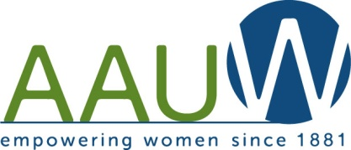Our Mission: To honor women and girls, empowering them through education,

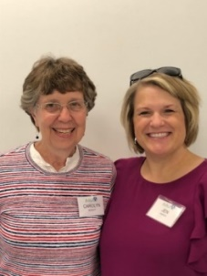 service and leadership development.

Co-President’s Message

November is always a time to count our blessings. That is especially important this year with the health challenges, as well as our heightened

awareness of systemic racism. We are grateful for all of you, our branch of AAUW. We are so enriched by the relationships we have made and the things we continue to learn from each other,

Thanks again to Jenni Braaten and Barb Hunter for another great meeting on Zoom in October. We heard a detailed presentation from Lori Volz, Austin Public Schools Director of Finance and Operations, about the need for a yes vote on the upcoming referendum. Be sure to support our schools!!

REMEMBER TO VOTE BY OR ON NOVEMBER 3!!!!

Our November meeting will be a Zoom presentation by Debby Irving, author of Waking Up White, sponsored by our school district, the library, and Congregational Church. See details in Program Co-Chairs’ article below. Don’t miss it!

As we go into our seventh month of this challenging pandemic, we hope you are all doing well and are figuring out ways to keep healthy and still observe the upcoming family holidays.

This quote seems to fit our situation:

“Life doesn’t get easier or more forgiving, we get stronger and more resilient.”  
― Steve Maraboli,

Carolyn Bogott and Jen Lawhead

Co-Presidents, Austin Chapter – AAUW

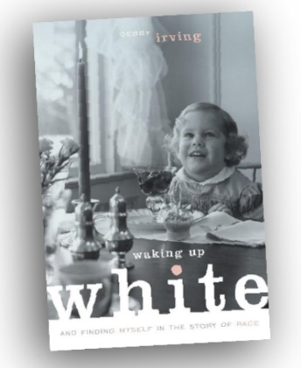**November Meeting**

At our last board meeting we thought we would do something different for November. Some of you may have heard or read the book *Waking Up White*, written by Debbie Irving. On Tuesday, 11/10/2020 from 6:30 - 8:30 p.m. there is a *Waking Up White* Zoom event with the author Debby Irving discussing white privilege. This is sponsored by ISD 492, Austin Public Library, Austin Area Foundation & Austin Congregational UCC. We hope many of you join us for this educational event.

            To Register for this event please fill out the form at

<https://forms.gle/sCW7MkhsoZjeYDn9A>

Jenni Braaten and Barb Hunter

Program Co-Chairs

**Member Update**

Our friend and long -time member, and branch public Policy Chair, Evelyn Guentzel, has been having difficult health challenges. She has been working to live with rheumatoid arthritis for some years having had several joint replacements. After an elbow replacement on August 28 she was doing well, in rehab at Comforcare when she developed a series of infections, not necessarily related to the surgery, but not defined. (No cases of Covid at Comforcare! However, she has not been able to have visits.) Evelyn was hoping to be home about October 24. She knows she won’t be actively involved anywhere for some time. Please think about sending her a card of encouragement.

2007B Oak Tree Lane, Austin, Mn 55912

And if anyone is interested in taking over the Public Policy position, let us know!!!

**Scholarship Winners Announced!**

We are please to announce we have awarded Riverland student scholarships to Valerie Barthels and Melissa Lindberg this year! Valerie is a Veteran of the Navy and is enrolled in the Industrial Maintenance and Mechanics program. Melissa is enrolled in the Radiography program looking to pursue a new career path after many years as a production professional.

**Small Groups**

**Evening Book Group**

Evening Book Group will meet via Zoom on Monday, November 16th at 7 PM. Peggy Benzkofer will be leading discussion of *The Book of Longings* by Sue Monk Kidd. Please use the link below to join the discussion! In December, we will be discussing *Red Shirts* by John Scalzi.

Join Zoom Meeting AAUW Evening Book Group – Monday, November 16th at 7 PM:

<https://us02web.zoom.us/j/88901560083?pwd=NkwrN1p2SFQvQTNXbko3Wkt4QW1GQT09>

Meeting ID: 889 0156 0083

Passcode: 305554

**AM Book Group**

Morning Book Group will meet at 9:00 a.m. on Thursday, November 19.  Theresa Becker-Ersland will lead discussion of the book *What the Wind Knows* by Amy Harmon. One of the meeting rooms is available at First Congregational Church.  Please come with masks and we will practice social distancing.

**Great Decisions**

After consideration of the situation of how to use the video material and have Zoom discussions, it has been decided not to meet this year. The plan is to resume at some point in 2021 as the situation allows.



**AAUW Meeting Minutes**

October 13, 2020 at 6pm

**Members Present:** Carolyn Bogott, Catherine Haslag, Barb Hunter, Annie Warner, Jennifer Lawhead, Rae Dawn Rao, and Nicole Cizik, & Jennifer Braaten.

**Secretary’s Report**

Catherine will continue to post the minutes in the monthly newsletter.

**Treasurer’s Report**

Nicole reported that we still have a few outstanding dues that need to be collected. No other updates to report.

**Monthly Programs**

Carolyn will check to see if AAUW can participate in the *Waking Up White* discussion with Debbie Irving via Zoom for the November event. A link will be provided for members to register for this event. Registration is required for those who wish to attend.

Nicole proposed sharing favorite holiday memories/recipes via Zoom for the December event. Members could also be encouraged to wear an ugly teacher’s sweater for the event. Barb and Jennifer B. will solidify these details and send out more information to members.

Jennifer B. is working with the Human Rights Commission to bring Dr. Christopher Lehman from St. Cloud State University to speak in Austin in January. He discusses how Minnesota is connected to slavery and related social justice issues. This may be an event AAUW is interested in participating in. Jennifer B. will keep us posted on this event.

**Other Business**

The AAUW Scholarship recipients at Riverland Community College are Valerie Barthels in the Industrial Maintenance and Mechanics program and Melissa Lindberg in the Radiography program. Carolyn will ask Peggy Benzkofer to organize members to send cards to the recipients over the next year.

Additional information will be coming regarding who members can support for Pillars of the Community for this coming year.

Jennifer and Carolyn adjourned the board meeting at 6:25p.

Respectfully Submitted,

Catherine Haslag

Secretary

*Mission Statement*: AAUW advances equity for women and girls through advocacy, education and research.

*Vision Statement:* AAUW will be a powerful advocate and visible leader in equity and education through research, philanthropy, and measurable change in critical areas impacting the lives of women and girls.

**Southern Highlights Editor:** Rae Dawn Rao [rao_raedawn@yahoo.com](mailto:rao_raedawn@yahoo.com) **Minnesota State Website:** <http://www.aauwmn.org> **Association Website:**  <http://www.aauw.org> **Association e-mail: info@aauw.org**



______________________________________________________________

AAUW Southern Highlights

1001 22nd Ave. SW

Austin, MN 55912

507-358-7237