Our Mission: To honor women and girls, empowering them through education,
service and leadership development.

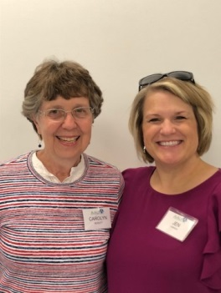
Co-President’s Message
Growing Connections
Our theme word for this year is “connections”. Lots of old connections were renewed and new ones made at the ice cream social August 12. For those of you who missed that great time, you will be contacted about tickets to sell for the House Tour and about scheduling your time to work on September 29. This is our big fundraiser, so please help us make it a great success! Thanks to Jenni Braaten and Kerry Bartlett for their work on the Ice Cream Social. And thanks to Carolyn Rugg and Rae Dawn Rao for their work getting the house tour organized.
As we look toward this next year of AAUW Austin, we will be making connections in many ways with our community, in friendship, in knowledge, in ways to cooperate toward a goal, and in how we relate to those who differ from us. Let’s keep in mind this quote:

“I am a part of all that I have met.” -Lord Tennyson

Carolyn Bogott and Jen Lawhead
Co-Presidents, Austin Chapter – AAUW

September Program
We will be kicking off a fun filled year in the Austin Branch of AAUW on Tuesday, September 10 with the annual potluck at Christ Episcopal Church beginning at 6:30 pm. Barb Hunter and Jenni Braaten have an exciting program line up that they will be sharing as well as small groups activities. Please bring a dish to pass and be ready for a fun evening catching up with each other. We look forward to seeing all of you!
Jenni Braaten & Barb Hunter

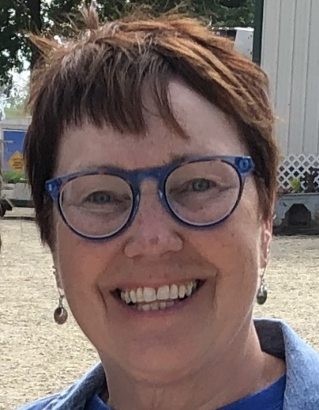
Member Spotlight – Jeanne Poppe
Jeanne Poppe has lived in Austin since 1983 when she met her husband Bob Vilt (deceased 7/13/17). They are the parents of three children.
After 28 years at Riverland Community College, Jeanne retired in June from her job counseling students. Previously she worked as a family counselor and a paralegal.
Jeanne served two terms as the Second Ward councilor on the Austin City Council from 1994-2002. In 2002 she ran unsuccessfully for the MN House. Her campaign was successful in 2004 when she was elected to represent Austin and the surrounding area of District 27B. She is currently serving her eighth consecutive term. She chairs the House Agriculture and Food finance and policy committee.
Jeanne has been a member of AAUW for a number of years but laments that she is not a regular attendee of meetings! She values belonging to an organization that supports, encourages, educates, and inspires women of all ages!
“Raising and supporting women who are engaged in the world is important for all of us. I once had a bumper sticker that read “Women hold up half the sky!” On our own we sometimes underestimate our power and strength. I’m thankful AAUW keeps us connected and focused on making a difference in the world. Locally our AAUW chapter is active and engaged, with many ways to participate. I’m happy to belong to such a vibrant and valuable group!”
And we are happy to have you as a member, Jeanne!
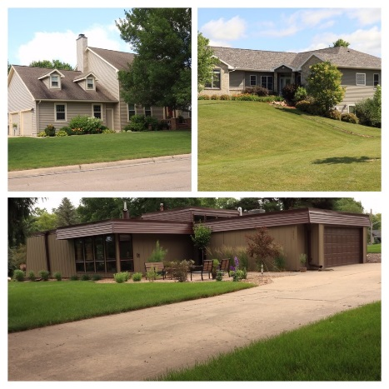
2019 Home Tour Set for September 29th!
All hands on deck! The Austin AAUW Tour of Homes is quickly approaching! Note the date was moved up a week from the original schedule due to a conflict with the Austin Symphony Orchestra. We are excited about the Mason, Johnson, and Vaupel homes that will be featured on the tour from 1-5 PM on Sunday, September 29th! For greater detail on the homes, please see ticket information. Also, new to the tour this year, refreshments will be offered to ticket holders on the deck of Sonia Larson’s home from 2-5 PM on the tour day. Thank you Sonia for your gracious offer of hospitality!
This tour is one of our main fundraising efforts that supports our commitment to AAUW’s mission of supporting education for women through scholarships awarded to Riverland students.
So how can you help?! First, all members are asked to try to sell four tickets to the home tour. If you have not received your tickets yet, you can either pick them up at the September potluck or reach out to Rae Dawn or Carolyn to arrange pick up at another time. Please turn in the ticket money and/ or any unsold tickets to Rae Dawn or Carolyn BEFORE the tour on September 29th. We can use those unsold tickets to sell at the door on the day of the tour.
Second, please sign up for a shift to work at one of the homes on the tour day. Volunteer duties are mainly to talk about various home features to the ticket holders and guide them on their way through a home. This year we are featuring an on-line volunteer sign up form through Signup Genius. Thanks to those who have already signed up, we are well on our way! We are still in need of more volunteers. Please take a moment to review your schedule that day & sign up to help where you can. Note you will still have plenty of time to tour the homes before or after your volunteer shift. Below is the website to find the volunteer sign up:
https://www.signupgenius.com/go/8050E4BA4A62DA7F85-aauw
Lastly, please help to advertise this event! Talk it up to your friends, neighbors & co-workers as you sell your tickets! We also have a Facebook event set up for the home tour. Please check out the event and mark that you are ‘interested’ or ‘going’. Like the event! Share the event! The social media platform is a free and effective way to get this information out there in the Austin community. If you would like a flyer (or 20!) to hang up at a business location you frequent, please contact Rae Dawn or Carolyn. Thanks to all to help make this event a great success!

Small Groups
PM Book Group
We will be meeting at the home of Angie Ruhter on September 16th at 7 PM to discuss The Monuments Men by Robert M. Edsel with Bret Witter. Please RSVP to Angie at ajruhter@gmail.com. We will meet at 7 PM on October 21st to discuss A Grand Old Time by Judy Leigh.
AM Book Group
Morning Book Group will meet September 19, at 9:00 A.M. at Perkins to discuss John Sandford’s book, Deep Freeze, with Bonnie Ripple. “Class reunions: a time for memories—good, bad, and, as Virgil Flowers is about to find out, deadly—in this New York Times bestselling thriller from John Sandford.”
First Friday
First Friday luncheon will again be at Bella Victoria at 11:30 on Friday, September 6th. Come, join us by RSVPing to Dorothy Krob at sdkrob@live.com. Reservations must be in by Thursday, September 5th at noon.
Travel Group
The Travel Club will be meeting on September 11th at 1:00 PM at the home of Jan Cook. We will be planning out this next year and there will be a sign-up sheet for programs, hosting, etc. We have a couple of ideas for the year, but if anyone else has ideas or suggestions for the year, please be ready to share them with the group, or if you want to discuss them with me first, feel free to call me.
Thank you. I look forward to seeing everyone at Jan’s on Sept. 11th.
DedaRae Graber
Great Decisions
Great Decisions meets September 23, at 1:00 P.M. at Riverland, Room C107. The discussion topic is CYBER CONFLICTS. “Cyber conflict is a new and continually developing threat, which can include foreign interference in elections, industrial sabotage and attacks on infrastructure.”

PUBLIC POLICY
Evelyn Guentzel

September, always a time of new beginnings. For women, 2019 marks 99 years of celebrating the achievement of our right to vote. It was a hard fought journey to the 19th Amendment to the United States Constitution in 1920. We do not always know or remember who spoke for us; this is an interesting reminder:
“A human being who was a man had the right to vote, a human being who was a woman had the same right” (Sinclair Lewis, SUFFRAGENT).
In about 1915, Lewis joined his wife, Grace Hegger, at numerous rallies as they made their way to a movie theater in Hempstead, Long Island. Lewis took to the stage to encourage men to support women’s suffragists. Finally, 1920 arrived. Then, Sinclair Lewis wrote MAIN STREET (1920) and ANN VICKERS (1932); both books were tributes to women.
September 8 is Women’s Pay Equity day. The Raise the Wage Act would increase the minimum wage from $7.25 to $15.00 an hour and that the minimum wage increase would be based on changes in overall wages. It also ends unfair exclusion of tipped workers, people with disabilities, and youth. The Senate must play its role to ensure economic security for women and all workers. The House has passed the RWACT.
AAUW’s EQUITY EXPRESS shares important information about the hurdles to successful salary negotiations and overcoming them. Face your fears.
Minnesota has played an active role in extending pay equity to local governments since 1984. Minnesota cities are subject to the Equal Pay for Equal Work Law. The Minnesota Department of Management and Budget, Human Resources and Benefits Department is our resource. Cities are required to maintain equitable pay relationships and every three years, to submit additional reports.
This is September from an AAUW Policy Perspective. Enjoy the coming year’s programming, book groups, Great Decisions, Travel Group and all the ways Austin Branch provides enrichment for your lives.

How Much Do You Really Understand About Our Own Racism and White Supremacy?
Dorothy Krob lent Peggy Benzkofer and Carolyn Bogott the book, Waking up White and Finding Myself in the Story of Race by Debby Irving and found it extremely enlightening and meaningful. Dorothy commented that she wished every teacher could read it. That inspired Carolyn to go to Superintendent David Krenz with a gift copy of this book and to discuss it being used by the school district. He was very receptive to the idea that we really “don’t know what we don’t know” about what our brown and black community members go through everyday in this society. David Krenz decided to use this book with the administrative staff. Jennifer Lawhead reports that the books were passed out and were well received. Discussions are to follow.
Our AAUW evening book group has this book on its list. We hope many members will read this challenging book.
The Congregational Church with the leadership of Carolyn Bogott and Vickie Spyhalski, is pursuing the possibility of having, author Debby Irving come to Austin to speak. They are securing partners in the community to bring this about. Stay tuned!
It is time for Americans citizens to discuss race and try to come to understand what has gone on and what continues to go on that we “good people” are not aware of because of our position of privilege just by being born white.
Read this book and watch for more opportunities to stretch your understanding.

Our Branch Again Supports Scholarship Recipients Throughout the School Year
At our July AAUW officers retreat it was decided to continue asking members to take a month to support our scholarship recipients with a note of encouragement or a gas or coffee card. We all remember that as students we were stressed and needed encouragement. This is a way we can let out recipients know others are cheering for them as they pursue their studies.
A sign-up sheet will be available at a future meeting, as well as the contact information for the scholarship winners. Thanks for your participation!

BOARD MINUTES OF AUSTIN, MN BRANCH AAUW

A meeting of the board of the Austin, MN Branch of AAUW was held at 4:30 p.m. on July 10, 2019, at the Austin Public Library. Members of the board in attendance included Carolyn Bogott, Jennifer Lawhead, Jenni Braaten, Barb Hunter, Nicole Cizik, Rae Dawn Rao, Carolyn Rugg, Kerry Bartlett, Evelyn Guentzel and Peggy Benzkofer.
As an introduction, members were asked to give their name and a word that represented what they were feeling.
Nicole presented a proposed budget which shows a positive balance of $4,615. The budget will be presented to the entire membership.
Jeni and Barb presented the programs planned for our 2019-2020 year.
They include:
September 10 Pot Luck Christ Episcopal Church
October 10 Tori Miller, Victim’s Crisis Center
November 12 Speakers on Islam
December 10
January 25 Mary Kunesh Podein Austin Country Club
Equal pay/Violance against women
February 11 Chief McKichan of APD
March Dinners in members’ homes
April 14 Mark Raymond, Austin Public Schools
May Dinner
We have 51 paid up members with two people not renewing. Board members took names of people to contact about rejoining.
Discussed Women’s History Month speakers at Austin High School with several board members making suggestions. The notable woman column will continue in Austin Daily Herald. Members supported continuing the mentoring of scholarship winners. Several vacancies will be coming up on the Pillars of the Community committee.
Carolyn Bogott talked about the book Waking Up White and suggested that there could be a special meeting to discuss it. The evening book group has it on the list and all members are invited to attend.
A discussion of the house tour was held. The tour will take place on September 29th. Rae Dawn and Carolyn Rugg are the chairs and one house chair is still needed. Tickets will be $15 each and each member will be expected to sell four. Every member will need to help to staff the houses and ask friends to help as well. There will be an on-line sign up to participate.
A new fund raiser – Story Show – will be held on January 11. People will tell their stories centered around a common theme. Jenni Braaten and Jennifer Lawhead are the chairs.
Thanks to Carolyn Bogott and Jennifer Lawhead for providing delicious snacks for our meeting.
Respectfully submitted: Peggy Benzkofer, Secretary

AAUW
July 1 - August 31, 2019
Period: 7/1/19 - 8/31/19
Opening Balance: |  | $12,706.68
Income:
Dues received | 487.50
Total Income: | $ 487.50 | $13,194.18
Disbursements:
Dues Paid - National | 383.50
Dues Paid - State | 72.00
Ice cream social | 28.44
Total Disbursements: | $483.94
Closing Balance 9/31/19 |  | $12,710.24

Mission Statement: AAUW advances equity for women and girls through advocacy, education and research.
Vision Statement: AAUW will be a powerful advocate and visible leader in equity and education through research, philanthropy, and measurable change in critical areas impacting the lives of women and girls.

Southern Highlights Editor: Rae Dawn Rao rao_raedawn@yahoo.com Minnesota State Website: http://www.aauwmn.org Association Website: http://www.aauw.org Association e-mail: info@aauw.org

______________________________________________________________

AAUW Southern Highlights
1001 22nd Ave. SW
Austin, MN 55912

