Our Mission: To honor women and girls, empowering them through education,
service and leadership development.

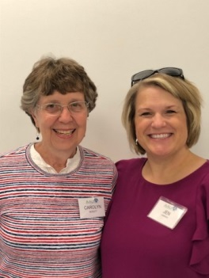
Co-President’s Message
The annual Fall potluck was enjoyed by all in attendance. It was another chance to renew old connections and make some new ones. Thanks to Jenni and Barb for arranging the details for it.
September was a busy month for those involved in preparing for the tour of Homes. Special thanks go to Carolyn Rugg and Rae Dawn Rao for chairing this event so masterfully. Thanks also go to Sue Grove and Sonia Larson for finding the homes and to the head hostesses (Vickie Spyhalski, Sharon Hyland, Marsha Kuehne, Sandy Folk, Kathy Kester, and Carolyn Bogott) for each house for working out details with the home owners. The refreshments at Sonia’s home was a wonderful addition. Thanks for that, as well. And, of course, it couldn’t have happened if all you in the membership did not buy and sell tickets and do the hosting at the homes. Your work is much appreciated!
In October, we have the opportunity to learn about the sad topic of domestic abuse in Austin with Torri Miller of the Crime Victims Center. This may give us some ideas about other connection in the community that we should be making.
We also will meet our scholarship recipients at the October meeting and you will have a chance to sign up for a month to provide encouragement to them throughout the year, with a note or gas card, etc.

“I love those connections that make this big old world feel like a little village.” – Gina Bellman

Carolyn Bogott and Jen Lawhead
Co-Presidents, Austin Chapter – AAUW

October Program
The October program will feature Tori Miller of the Austin Crime Victim's Center through Mayo Clinic Health System. We had Tori scheduled to come talk with us last February but due to the inclement weather, we had canceled our meeting that evening. She will be providing us with an overview of services offered with her agency as well as an overview of domestic violence in the Austin area. Please join us in welcoming and learning about this important issue on Tuesday, October 8 at 6:30 pm at Riverland West building in room B116 (aka, Catherine Haslag's classroom).
Jenni Braaten & Barb Hunter

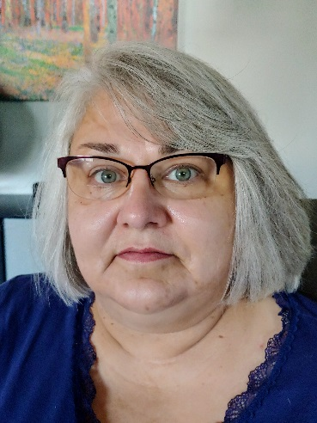
Member Spotlight – Kim Quealy
Welcome to Kim Quealy, our newest branch member!
Kim says, “I wanted to join AAUW because it sounded like a good way to be involved in my community and to get to know other like-minded women. I have lived in Austin for a lot of years and when the kids were small, I was involved in their activities etc., but now have time to do more. Jenny Braaten did a good job of selling me on the organization, and the kind of activities she described appealed to me, from the speakers to the camaraderie with other women. I was born and raised in Eau Claire, WI. I graduated from the University of WI Stout in Menomonie with a major in Vocational Rehabilitation and a minor in Psychology. After I married, we lived in Des Moines for a few years where I worked for Easter Seal of Iowa. We moved to Austin in 1992 right after my son was born. I worked for Lutheran Social Service of Minnesota in Adams for several years and have worked since 2004 at Quality Case Management in Austin. I am looking forward to the Great Decisions group and other upcoming activities.” We look forward to getting to know you Kim!

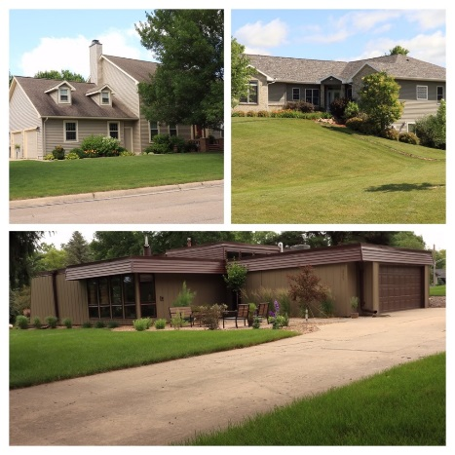
2019 Home Tour Tomorrow -September 29th!
Thanks to all that have come together to work on making this year’s tour a reality! Carolyn summed up the contributions well. Tomorrow is the day! Have a great time showcasing these homes and AAUW to the Austin community! We will report on the outcome of the tour in the November newsletter. Cross your fingers the rain turns off during the tour tomorrow!
~Rae Dawn Rao & Carolyn Rugg, Co-Chairs of AAUW Home Tour

Small Groups
PM Book Group
We will be meeting at the home of Barb Hunter on October 21st at 7 PM to discuss A Grand Old Time by Judy Leigh. Please RSVP to Barb at hunterbarb41@gmail.com. We will meet at 7 PM on November 18th to discuss Art of the Wasted Day by Patricia Hempl.
AM Book Group
October 17, we will meet at Perkins Restaurant at 9:00 A.M. and Evelyn Guentzel will lead the discussion of The Moment of Lift by Melinda Gates.
First Friday
First Friday will be at Piggy Blues on October 4th at 11:30. Please RSVP only to Dorothy Krob at sdkrob@live.com.
Travel Group
The Travel Club is traveling to St. Ansgar for lunch on Wednesday, October 9th. It should be a fun adventure. If you are interested in joining us, please contact me ASAP. Thank you.
DedaRae Graber
Great Decisions
Great Decisions meets October 28, at Riverland, C10. The topic is U.S. and MEXICO.
PUBLIC POLICY
Evelyn Guentzel

September14, 2012 “Eighteen years ago today (enacted in 1994), the landmark Violence against Women Act (VAWA) was signed into law. It was founded on the basic premise that every woman deserves to be safe from violence, and since its passage we have made tremendous strides towards achieving that goal. But we still have much work to do.” --Vice President Joe Biden, who drafted the original Violence against Women Act on September 13, 2012.
This month, Torri Miller, of the Crime Victims Center, will share information about “Domestic Abuse in Austin.” We welcome the opportunity to learn about important local concerns and issues.
AAUW has long supported “freedom from violence and fear of violence in homes, schools, workplaces, and communities. Our national leadership has actively participated in lobbying members of Congress to reauthorize the act which is due this year. We are still waiting on the Senate to give its support to this reauthorization. AAUW has protested the “political maneuvering” that has stalled the bill. The act is credited with contributing to dramatic decreases in the reporting of domestic violence, and yet, as we are about to learn, the violence persists.

AAUW
September 1 -September 30, 2019
Period: 9/1/19 - 9/30/19
Opening Balance: |  | $12,710.24
Income:
Total Income: | $ - | $12,710.24
Disbursements:
Science Fair Mentoring donation | 200.00
Riverland scholarship funding | 3,000.00
Total Disbursements: | $3,200.00
Closing Balance 9/30/19 |  | $9,510.24

BOARD MINUTES OF AUSTIN, MN BRANCH AAUW

A meeting of the board of the Austin, MN Branch of AAUW was held at 5:30 p.m. on September 10, 2019, at Christ Church. Members of the board in attendance included Jennifer Lawhead, Jenni Braaten, Barb Hunter, Rae Dawn Rao, Carolyn Rugg, Evelyn Guentzel and Peggy Benzkofer.
As an introduction, members were asked to give their name and a connection that they were experiencing. Peggy stated minutes of the last meeting were published in the newsletter. There was no treasurer’s report.
The scholarship recipients will be announced at the October meeting. Bonnie Rietz has asked that she be replaced on the committee to determine the recipients. Members will again be asked to support the recipients with a note and/or a gift certificate. Peggy will prepare a sign-up sheet.
We have 56 paid up members which is four less that last year and ten less than two years ago.
A discussion of the house tour was held. The tour will take place on September 29th. There will be an article in the Sept. 26th Herald and Sue Grove and Carolyn Rugg will be featured on a program on KAUS. Posters were passed for distribution. There are still people needed to help.
A new fund raiser – Story Show – will be held on January 11. Bonnie Rietz, Tom Cotter and Miguel Garate have agreed to tell their stories. More people are needed and some suggestions were made. It will be held at Riverland.
After the board meeting the annual pot luck was held.
Respectfully submitted: Peggy Benzkofer, Secretary

Mission Statement: AAUW advances equity for women and girls through advocacy, education and research.
Vision Statement: AAUW will be a powerful advocate and visible leader in equity and education through research, philanthropy, and measurable change in critical areas impacting the lives of women and girls.

Southern Highlights Editor: Rae Dawn Rao rao_raedawn@yahoo.com Minnesota State Website: http://www.aauwmn.org Association Website: http://www.aauw.org Association e-mail: info@aauw.org

______________________________________________________________

AAUW Southern Highlights
1001 22nd Ave. SW
Austin, MN 55912
507-358-7237

