Our Mission: To honor women and girls, empowering them through education,
service and leadership development.

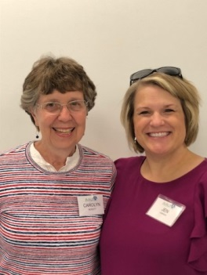
Co-President’s Message
What a great meeting we had in November learning about the Islamic faith! John and Alisen Emery explained the role of women in this faith, which is not what we have thought it was. They clarified the contrast between foundations of Islam and the cultural traditions that have changed the original teachings. (Similarities are seen here with Christian foundations differing from cultural practices.) We had such a good turn- out from the public for this program. Good work, Barb Hunter and Jenni Braaten!
Be sure to put our AAUW January events on your calendar. Both the January 11 Story Show fund-raiser and the January 25 luncheon look to be outstanding events!!! (Look for details in the rest of this newsletter.) Hope to see you at the holiday get-together on December 10 at 5:30 (note time change!!) at the Coffee House on Main. Our gifts this year are monetary donations for the Salvation Army.
As we are entering the busy holiday season, our theme of connections may apply in three areas:
- The importance of connecting with our community by giving time and talents (ringing bells for the Salvation Army or giving to a local charity, etc.)
- The importance of connecting with yourself by giving time to self- care (a walk at the nature center, reading a book you love…)
- The importance of spending quality time with the people you love, building deeper connections there.

‘We don’t accomplish anything in this world alone…and whatever happens is the result of the whole tapestry of one’s life and all the weavings of individual threads from one to another that creates something.’ - Sandra Day O’Connor
Carolyn Bogott and Jen Lawhead
Co-Presidents, Austin Chapter – AAUW
Upcoming Programs

December

Please join us for our holiday meeting at 5:30 PM on Tuesday, December 10th at the Coffeehouse on Main. Kyle Keenan has once again graciously agreed to open for us that evening so that we may purchase a hot beverage to enjoy with holiday treats. This year we ask members to bring donations for the Salvation Army. Please note the change in meeting time. We are looking forward to seeing you and hope for good weather.
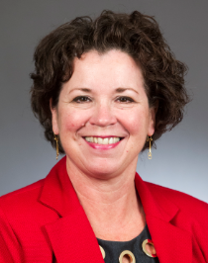
January
The January luncheon will take place on Saturday, January 25 at 11:30 am at the Austin Country Club. This has been a favorite event of members for the past several years and fun to meet on a weekend when there is more time to connect. More details on the luncheon options will be forthcoming in January. This year the guest speaker will be Mary Kunesh-Podein. She is a Minnesota State Representative from New Brighton serving Anoka, Hennepin and Ramsey counties in MN. Mary is a member of the Standing Rock Sioux Tribe where her mother and grandfather were also registered members. She is the current Vice-Chair on the Education Policy and Finance Division, Ethics Board and the Health and Human Services Finance Division. When the legislature is not in session, Mary is also a media specialist at Robinsdale Middle School. Mary has worked tirelessly advocating for women's rights in the MN Legislature including the task force on missing and murdered indigenous women created, violence against indigenous women and girls. Likewise, she has authored or co-authored numerous bills on educational funding in MN including some with special consideration to the native people of the state. She will be joining us to discuss her advocacy work in MN and areas in which there is work yet to be done. Please mark your calendars for this luncheon with this special guest speaker.
Jenni Braaten & Barb Hunter
Program Co-Chairs

Austin AAUW Presents ‘The Story Show’ January 11th!
Each year the Austin AAUW branch has sponsored two scholarships to Riverland Community College totaling $2,000. Since the Austin Assurance program was initiated, the AAUW board made the decision to earmark the scholarships given to Riverland for non-traditional students who would not qualify for the Assurance scholarship. Additionally, the board moved to increase the scholarship amount to $3,000 due to the rising cost of tuition. AAUW continues to raise funds for scholarships from the annual book sale in April each year and every other year with the fall house tour.
As the board considered additional fundraising options for scholarships, it was decided to try something new this year. Our neighboring city of Albert Lea has been putting on an event called "The Story Show" for the past several years. With the blessing of our Albert Lea counterparts, AAUW will be sponsoring this show in Austin on Saturday, January 11, 2020. The event consists of choosing a theme and having different people from the community tell a personal short story from their lives based upon the theme. We have chosen the theme of curiosity. So, each of the eight storytellers will share something from their life in which they were curious about or how curiosity influenced them. This is a wonderful opportunity for the literary art of storytelling, to build community and understanding as well as to fundraise. Here is the lineup of our storytellers:
Shari Mason - William Tauffic - Laura Helle (also an AAUW member!) - Miguel Garate
Chrystal Richter - Mark Van House - Sheila Berger - George Bass
The Story Show will take place at the Frank Bridges Theater at Riverland Community College on Saturday, January 11, 2020 at 7pm. The Austin High School Jazz One will be providing music for the intermission. Tickets will be $15. We are asking AAUW all members to sell two tickets, or more, for this event to be successful. Please consider attending this inaugural event which promises to be a fun evening of sharing. Special thanks to Peggy Benzkofer and Evelyn Guentzel who have been diligently assisting as editors of the stories on this endeavor. If you would like to join in the planning and behind the scenes work to put this on please let us know. It takes many hands to put this on such as selling tickets at the door on January 11 or helping with promoting the event beforehand.
Below are some links to past Story Shows in Albert Lea to get an idea of what to expect.
https://thestoryshow.org/story-tellers
https://www.albertleatribune.com/2019/07/story-show-in-memory-of-albert-lea-educator/
https://www.facebook.com/thestoryshow
https://www.albertleatribune.com/2019/07/story-show-in-memory-of-albert-lea-educator/

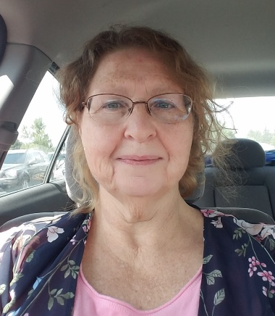
Member Spotlight – Pam Hollrah-Asleson
Pam is the daughter of a career military father, born in Hawaii (before it was a state.) She lived in California, Florida, Michigan, Montana, Minnesota, Ohio and Iowa. She graduated from high school in Red Oak, Iowa, and got her R.N. in Omaha. A nurse for over 40 years, Pam worked for 20 years at the Federal Medical Center in Rochester. The day she retired from there, eleven years ago, she married Jim Asleson (a farmer and Hormel retiree) and moved to Lyle. She has two children and five grandchildren.
Pam is a Certified Legal Nurse Consultant, which means she reviews medical records for court and she can train layers, judges and juries about medical terms. She has helped develop medical policies for The Cedars and Cedar Valley Services through her business, “R.N Consulting and Coordinating L.L.C.” Her other businesses include “Life Safety for You,” providing classes in First Aid and CPR/AED, and “Poet’s Heart, God’s Gift”, a public speaking consulting business. Also, she is an active poet. Her best-known work is “Little Child” about the loss of a baby. She has written a devotional poetry book called Yoked With Christ, and she participates in the “open mike” for poets at Sweet Reads.
Other areas of her service are the “Beyond the Yellow Ribbon Steering Committee” and “The Soldier and Family Readiness Group” (preparing for deployments and returns from deployments). Pam is a Distinguished Toast Master and meets with that group twice a month. She is co-chair for the 2020 Taste of Nations with the Welcome Center.
Pam is also the Director of the Hormel Institute “Mentor Connect”, a group which works to help international scientists learn about our culture through group events, as well as assigning volunteer mentors to be friends with a scientist and their family.
Pam joined AAUW so she could get to know educated women in this area and so she could grow and network with other women. Pam brings so many areas of interest and experience to our branch. We are so happy to count you as a member, Pam!
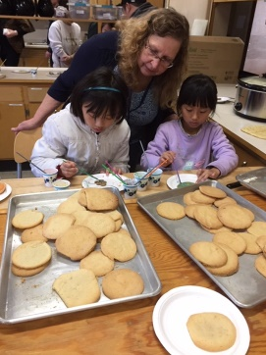
Volunteer Opportunity! We need you!!
Carolyn Bogott serves with Pam Hollrah-Asleson on the coordinating board for “Mentor Connect”. There is always a need for more volunteers to be friends with these international scientists and their families. Carolyn and her husband have been involved in this kind of support and friendship for 25 years. “Mentor” in this situation just means supportive friend. The commitment of time is variable, depending on the availability of your time and the scientist’s time. If you have an interest in this volunteer opportunity, contact Pam (phollrah-asleson@rncandc.com) .
Here is Pam working with the children of scientists at a recent Thanksgiving group event.
Small Groups
PM Book Group
We will be meeting at the home of Dorothy Krob on December 16th at 7 PM to discuss Onigamiising Seasons Of the Ojibwe Year by Linda LeGard Grover. Please RSVP to Dorothy at sdkrob@live.com. We will meet at 7 PM on January 20th at the home of Rae Dawn Rao to discuss The Secret History by Donna Tartt. Please RSVP to Rae Dawn at rao_raedawn@yahoo.com
AM Book Group
Thursday, December 19. Meet at Perkins at 9:00 A.M. to discuss DEATH IN VENICE, by Thomas Mann. Svitlana Pukhnata leads the group.
Travel Group
On December 4th, we will meet at the home of DedaRae Graber at 1:00 PM and share stories, ornaments, and any special memory of a Christmas past. On January 8, 2020, we will meet at the home of Ann Odegaard at1:00 PM. We are starting this new series of sharing something from a trip that was very special to an individual. Ann will be having this first program as well. Please feel free to join us any month.
First Friday
AAUW's First Friday luncheon will be at 11:30 on Friday, Dec. 6th at Bella Victoria’s. RSVP BY Thursday to Dorothy Krob at sdkrob@ive.com.
Great Decisions
The group reconvenes Monday, February 24 to begin discussing the 2020 series. More details to follow.

The Future of Our Branch is At Stake! Officer Nomination for 2020-2022
We need to be thinking about the future of our branch. Several of the current officers have served faithfully for several terms of office over the years. They are ready to mentor new people, but, understandably, they are not ready to serve again.
Barb Hunter has graciously agreed to work on a nominations committee. She will need two more people to help her on this. If you could help her, please let her know. And if you are willing to serve as an officer, step forward. Your leadership is needed!

Membership
Our Austin AAUW branch currently has 59 members. We continue to be a vibrant group wrapped around a common value of equity for women in all aspects of life such as education, democratic representation, workplace employment opportunities and pay equity. Our membership roster has been slowly declining in numbers over the past few years and new members are the key to keeping the mission of AAUW alive. Please consider inviting someone you know who may be interested in becoming a member of AAUW. Prospective members are always welcome to attend any of AAUW's functions to get a feel for our group. We have added three new members this year and perhaps you have seen them at one of AAUW's functions. If not, please welcome Kim Quealy, Amy Wagner, and Angela Loecke when you see them at a meeting. We are excited to have them join us!

Jenni Braaten and Kerry Bartlett
AAUW Membership co-chairs

SUPPORT FOR OUR SCHOLARSHIP WINNERS
We were introduced to our scholarship winners at the October meeting. It was wonderful to meet Jessica Lemickson and Ebise Walga and to hear Jessica’s story (Ebisa Walga came a little late and there was no opportunity to hear from her directly). We are again providing simple support for them each month in the form of an encouraging note and/or gas card. Please get in touch with me if you wish to participate. I will also have a sign up at the December meeting. Thanks! Peggy Benzkofer

Pillars of the City Committee Has a New Member
Congratulations to Peggy Benzkofer on her appointment to the “Pillars of the City” Selection Committee. She joins AAUW Austin Branch member, Catherine Haslag, in this work. You will recall that our branch has been concerned that women were not being honored as” Pillars” in equal numbers with men. And we had a big effort to have members nominate women last year. We felt we were successful when Bonnie Rietz was named a Pillar in July. Our work is not over!
We encourage members to nominate other women for this honor. At our December meeting, copies of information on Pat Piper and Edna Schraffel will be available if you would like to nominate them. And we encourage you to nominate others whom you feel should be recognized. The nomination form is on-line and straight-forward to complete.

AAUW
November 1 - November 30, 2019
Period: 11/1/19 - 11/30/19
Opening Balance: |  | $12,147.41
Income:
Dues received | 75.00
Total Income: | $75.00 | $12,222.41
Disbursements:
Dues Paid - National | 59.00
Dues Paid - State | 9.00
Meeting speaker - Islamic resource center | 200.00
Total Disbursements: | $268.00
Closing Balance 11/30/19 |  | $11,954.41

Mission Statement: AAUW advances equity for women and girls through advocacy, education and research.
Vision Statement: AAUW will be a powerful advocate and visible leader in equity and education through research, philanthropy, and measurable change in critical areas impacting the lives of women and girls.

Southern Highlights Editor: Rae Dawn Rao rao_raedawn@yahoo.com Minnesota State Website: http://www.aauwmn.org Association Website: http://www.aauw.org Association e-mail: info@aauw.org

______________________________________________________________

AAUW Southern Highlights
1001 22nd Ave. SW
Austin, MN 55912
507-358-7237

