Our Mission: To honor women and girls, empowering them through education,

service and leadership development.

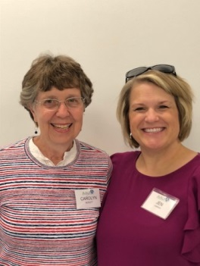Co-President’s Message

February 2019 will live on in our memories because of all the cold and snow and cancellations. We were so sorry to have to cancel the excellent program about victims of domestic violence. We will look forward to rescheduling that program for next year.

We also had to reschedule the judging of the Women’s history projects presentations at Austin High School. Many thanks go to Sue Grove, Peggy Benzkofer, Bonnie Rietz, Janet Gilbertson and Ellen Stark for being willing to take part in this activity. The Austin High School Women’s History Assembly will be on March 12 at 2:00 in Knowlton Auditorium. The speaker is Laura Lee, a newscaster with KAAL. Branch Members are invited to attend and sit in the front middle section.

During March, we look forward to the potluck dinners in members’ homes. This is a chance to put into play this year’s theme of curiosity and learn about other branch members. I am sure you will each find inspiration in hearing about the lives of other fine women.

“It's worthwhile to make an effort to learn about other people and figure out what you might have in common with them. If you allow yourself to be somewhat curious - and if you get into the habit of doing that - it's the first step to being open minded and realizing that your points of view aren't totally opposite.” Viggo Mortensen

Carolyn Bogott and Jen Lawhead

Co-Presidents, Austin Chapter – AAUW

**March Program**

Unfortunately, we had to cancel our February program due a snow storm. Tori Miller from the Crime Victims Crisis Center was going to be talking to us about the services provided and highlight some of the domestic violence issues in Austin. We will scheduled Tori again for a future monthly program.

For the March program, we will have the popular "dinner in the homes" again. This provides a more intimate setting to really connect and get to know AAUW members on a more personal level. In order to enjoy this fun event, we need volunteer members who are willing to host 4-6 women for dinner in their home on the evening of Tuesday, March 12.  Here's the good news, if you host the dinner you do not have to cook! Each guest will bring a dish to pass. For example, one person will bring a salad, another person the vegetable, another the main dish and another the dessert. An additional volunteer will help coordinate the menu for the group. So, we are seeking members willing to open up their homes to host, members willing to cook and members willing to do the meal planning.  If March 12 does not work for you, Sue Grove has offered to host an alternate night and if there is interest we could look at potential dates.  Please email either Jenni Braaten ([jennibraaten@hotmail.com](mailto:jennibraaten@hotmail.com)) or Barb Hunter ([hunterbarb41@gmail.com](mailto:hunterbarb41@gmail.com)) to sign up. With good food, good conversation, and amazing AAUW women, it promises to be a great evening of fun and connection for all!

Jenni Braaten & Barb Hunter

Program Committee co-chairs

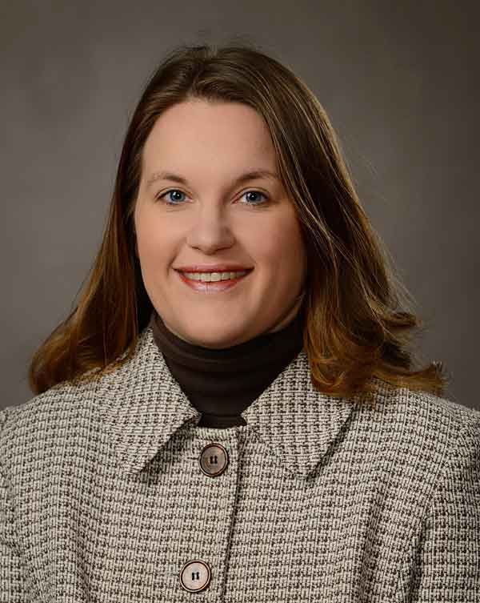**Member Spotlight – Nancy Schnable**

Nancy is from a farming background with participation in 4-H, FFA, band, and sports to round out her young years. She graduated from University of Wisconsin River Falls with a BS in Agriculture Marketing and Communications, with a minor in Animal Science. For the next 12 years she worked in the hospitality industry as a hotel manager in Door County, WI, Green Bay, WI, Elkhart Lake, WI, and finally Rochester, MN. In 2013 , she became the Executive director of Discover Austin.

Nancy lives on a hobby farm just north of Hayfield. She has been married to “Mr. Mc Dreamy aka Andrew” for 12 years and they have two sons, Anthony, 8, and Ethan, 7. The boys are active in sports and chess, so the family spends “a lot of time sitting on bleachers and driving to events.”

Nancy enjoys gardening and being outdoors, as well as traveling, both within the US and abroad. In the summer her family spends time at their lake home.

Nancy says, “I joined AAUW because it is a fun, adventurous and positive group of people that are always trying to make the world a better place... I am proud to say I am a better person for being surrounded by these amazing women!  I really enjoy the First Friday Lunch group- if you haven't joined us- I hope to see you next time!”

We are so happy to have you in our Branch, Nancy!

**C:\Program Files\Microsoft Office\MEDIA\CAGCAT10\j0185604.wmfPlans for House Tour for Fall 2019 Are Underway**

We are so happy to announce that Carolyn Rugg and Rae Dawn Rao have agreed to co-chair the 2019 House Tour. Sue Grove and Sonia Larson are again working on getting homes to be toured. If you have suggestions please contact one of these “dynamic duos”!!! The date of the tour will be set soon.

**Small Groups**

**PM Book Group**

We will be meeting at the home of Peggy Benzkofer on March 18th at 7 PM to discuss the Pageturner’s selection *Stars Over Clear Lake:* A Novel by Loretta Ellsworth. Please RSVP to Peggy Benzkofer at pjbenzko@gmail.com. We will meet at 7 PM on April 15th at the home of Rae Dawn Rao to discuss *As Bright as Heaven* by Susan Meissner.

**AM Book Group**

Morning book group will be discussing *Mrs. Boxfish Takes a Walk* by Kathleen Roomy on March 21st at Perkins at 9 AM. Lois McConnell will lead discussion.

**First Friday**

First Friday luncheon will be at Torge's on Friday, March 1st at 11:30. Please RSVP to Dorothy Krob by Thursday morning at [sdkrob@live.com](mailto:sdkrob@live.com).

**Travel Group**

The Travel Club will meet on Wednesday, March 13th, at the home of Lois McConnell at 1:00 P.M.  Our February Meeting was cancelled because of a snow related issues.  Therefore, the March Program will be similar to the February Program.  Members will be sharing information on various Minnesota cities or towns.  Sandy Folk will be talking about Angle Inlet, Janet Gilbertson will be talking about Brainerd, and Annie Warner will be talking about the various statues in Austin.  We are learning a great deal from each other……and always in a nice, relaxed atmosphere. We welcome new members to join us.  Please let me know (433-7897), by Tuesday afternoon, March 12th, if you are planning to attend.  Thank you.

DedaRae Graber

**Great Decisions**

Great Decisions will meet at 1 PM at Riverland, room TBD, on March 25th.

|  |  |  |  |  |
| --- | --- | --- | --- | --- |
| **AAUW Monthly Financial Report** | | | | |
| **February 1, 2019 - February 28, 2019** | | | | |
|  |  | |  | |
| **Period: 2/1/19 - 2/28/19** |  | |  | |
|  |  | |  | |
| **Opening Balance:** |  | | **$10,134.34** | |
|  |  | |  | |
| **Income:** |  | |  | |
|  |  | |  | |
| January luncheon | 301.75 | |  | |
|  |  | |  | |
| **Total Income:** | **$ 301.75** | | $10,436.09 | |
|  |  | |  | |
|  |  | |  | |
| **Disbursements:** |  | |  | |
|  |  | |  | |
| January luncheon (refund) | (4.11) | |  | |
|  |  | |  | |
| **Total Disbursements:** | **-$4.11** | |  | |
|  |  | |  | |
| **Closing Balance 2/28/19** |  | | **$10,440.20** | |
| **Closing Balance 1/31/19** | |  | | **$10,134.34** | |

***Hope to see you there!***

***2019 AAUW State Convention***

***Celebrating Grand Rapids AAUW’s 70th Anniversary***

***Friday, April 26 and Saturday April 27, 2019***

***Timber Lake Lodge & Event Center, Grand Rapids, MN***

*Mission Statement*: AAUW advances equity for women and girls through advocacy, education and research.

*Vision Statement:* AAUW will be a powerful advocate and visible leader in equity and education through research, philanthropy, and measurable change in critical areas impacting the lives of women and girls.

**Southern Highlights Editor:** Rae Dawn Rao [rao_raedawn@yahoo.com](mailto:rao_raedawn@yahoo.com) **Minnesota State Website:** <http://www.aauwmn.org> **Association Website:**  <http://www.aauw.org> **Association e-mail: info@aauw.org**



______________________________________________________________

AAUW Southern Highlights

1001 22nd Ave. SW

Austin, MN 55912