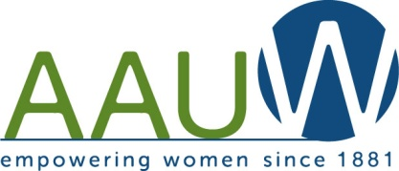
Our Mission: To honor women and girls, empowering them through education,
service and leadership development.
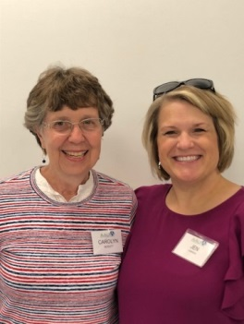
Co-President’s Message
Our November meeting featured another outstanding program. Many thanks to Jenni Braaten for arranging for John Emery of the Islamic Resource Group and his wife to tell us about Islam. We had a great turn out and thanks to all who came and brought guests. Among the many things we learned was that although Middle Eastern Moslems are in our news often, the countries with the most Moslems are Indonesia, Bangladesh, India and Pakistan. And the tenets of Islam are very similar to those of Judaism and Christianity. Too bad zealots in all three religions twist the real meaning of the faith.

Our December meeting will be our annual Christmas gathering at Coffee House on Main. Thanks to those who signed up to bring treats” to share! Remember to bring a donation for the Parenting Resource Center. (See separate notice) This social time will be an occasion for us to learn about one another and our diverse lives. Find someone you’ve been curious about and spend some time hearing her story. This is another way to carry our theme of curiosity.

“Be curious. Read widely. Try new things. What people call intelligence just boils down to curiosity.” Aaron Swartz

Carolyn Bogott and Jen Lawhead
Co-Presidents, Austin Chapter – AAUW
December Program
Please join us for our holiday meeting on Tuesday December 11th at 6:30. This special meeting will be held at The Coffeehouse on Main. Kyle Keenan has graciously agreed to be open that evening so that we may purchase our favorite drinks to enjoy with holiday treats. We always like to do something for others at our December meeting. This year we would like to help out female inmates at our local facility. They would appreciate our assistance in their read a book to a child program as well as personal items. Please feel free to bring sanitary hygiene items, books, or a monetary donation. We look forward to seeing you!
Jenni Braaten & Barb Hunter
Program Committee co-chairs
Holiday Gathering Donations to go to Parenting Resource Center
As is our tradition, a charity has been chosen for us to honor at our holiday party. Here are some of the needs at the Parenting Resource Center:
1. Financial support for the “Read To Me Program”
This is where inmates take a predetermined number of parent education sessions and then are eligible to be recorded reading a children's book. The children's book and the recording are then sent to the child for Christmas. Donations go to purchasing books and postage.

2. Donations or financial support for the diaper program
Diapers are needed in the larger sizes, 3, 4, and 5, as well as baby wipes.

3. Donations or financial support for toys and games
“If AAUW members are cleaning out their toy rooms and have extra gently used toys, PG-rated DVDs, and/or Wii games we could really put them in good use. Our toys/ DVDs, etc. at the Seibel Center are at least 10 years old and many are breaking/ missing parts. The only things we could not take are Nerf guns/ other toy-like guns/ weapons and a doll house.”

Checks can be made out to PRC.
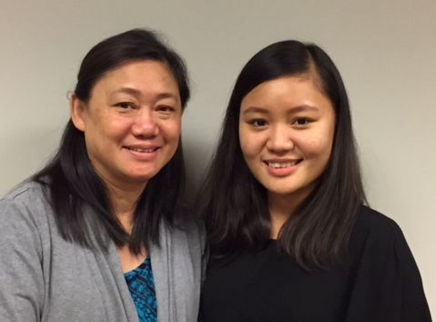
Member Spotlight –
Maylary and Austere Apolo
Two of our newest members are mother and daughter, Maylary and Austere Apolo. Maylary was born in Burma, now known as Myanmar. She is Karen American, from an ethnic minority group which has long sought their own state separate from Burma. When Maylary was 19, persecution of the Karen people grew and Maylary’s father, a Karen Baptist pastor, was under great suspicion. They fled to a Karen area of the country, making an extremely arduous and dangerous two month long journey by foot through jungle and mountains. That village also came under attack and the family had to flee to a refugee camp in Thailand. During her 20 years in refugee camps, Maylary was able to complete a teaching training course. She taught music and learned English, as well as marrying and having five children. She also took in three young women who wanted to study piano with Maylary.
Austere was one of the children born in the refugee camp in Thailand.
When Austere was 13, their family was able to come to this country, first to South Carolina. Maylary worked in a Chick-fil-A restaurant as her family struggled to learn a new culture and language. Austere says she was the only Asian in her school at first. It was a very trying time for their family.
A friend suggested that they move to Worthington, MN where there were other Karen people. Maylary worked as an interpreter in the court, school, and hospital. Austere graduated from Worthington High School and went on to complete a degree in Health Sciences at South Dakota State. An opportunity in Austin opened up for Maylary’s husband to work in business with the K’Nyaw Grocery store and Maylary found work at the Austin Office of the Immigrant Law Center of Minnesota. Austere was working for the Girl Scouts in Worthington, but got a transfer to the Austin Area. Recently, Austere has changed jobs and is working for IMAA, Intercultural Mutual Assistance Association, as a Community Health Worker and she has been accepted into a Master’s program in Public Health at St. Mary’s University.
Joining AAUW was good fit for Maylary as she also works in developing leadership skills for women in the 52 churches of the Karen Baptist Church in the USA. Austere “loved the message of AAUW” and it “aligned well with my Girl Scout work empowering girls, especially those of other cultures. “
We are so happy to have these new members. Welcome Maylary and Austere!!!

Small Groups
PM Book Group
We will be meeting at the home of Sue Grove on December 17th at 7 PM to discuss The Readers of Broken Wheel Recommend by Katarina Bivald. Please RSVP to Sue at sue.grove@riverland.edu. We will meet at 7 PM on January 14th at the home of Dorothy Krob to discuss A Gentleman in Moscow by Amor Towles and on February 18th at the home of Barb Hunter to discuss A Wrinkle in Time by Madeleine L’ Engle.
AM Book Group
Morning book group will not meet in December. We will discuss the Pageturners’ selection in January.
First Friday
First Friday will meet on December 7th at 11:30 at the Old Mill. In January, we will meet at 11:30 on the 4th at El Mariachi. Contact Dorothy Krob at sdkrob@live.com for reservations.

Travel Group
The Travel Club with be having our Annual Christmas Gathering at DedaRae Graber’s home on Wednesday, December 12th at 1:00 PM. We are encouraged to share anything special about Christmas. This may be a card, tradition, ornament, memory, or whatever you wish. Or if you just want to listen, that is fine too. Also, everyone is encouraged to bring a small treat for this special meeting. Please let DedaRae know if you are planning to attend (433-7897). Thank you.
We have decided to have each member select a certain city/town in Minnesota and share information on that city/ town with our group. In January, Ann Odegaard will be the hostess. Terry Ersland will be sharing information about Wabasha, Dorothy Krob will be sharing about Willmar, and Liz Richardson will be sharing about Duluth. Please let DedaRae is you plan to attend (433-7897). Thank you.
Great Decisions
No Great Decisions in December. Great Decision will meet on the 4th Monday every month starting in January. Room and time tba (hopefully 1:00 PM). If you want a book, contact Peggy.

Save the date!
2019 AAUW State Convention
Celebrating Grand Rapids AAUW’s 70th Anniversary
Friday, April 26 and Saturday April 27, 2019
Timber Lake Lodge & Event Center, Grand Rapids, MN

AAUW Monthly Financial Report
November 1 - November 30, 2018
Period: 11/1/18 - 11/30/18
Opening Balance: |  | $10,740.67
Income:
Total Income: | $ - | $10,740.67
Disbursements:
Meeting speaker | 200.00
Total Disbursements: | $200.00
Closing Balance 11/30/18 |  | $10,540.67

November Board Meeting Minutes
There was no quorum for the November board meeting and so there are no minutes.

Mission Statement: AAUW advances equity for women and girls through advocacy, education and research.
Vision Statement: AAUW will be a powerful advocate and visible leader in equity and education through research, philanthropy, and measurable change in critical areas impacting the lives of women and girls.

Southern Highlights Editor: Rae Dawn Rao rao_raedawn@yahoo.com Minnesota State Website: http://www.aauwmn.org Association Website: http://www.aauw.org Association e-mail: info@aauw.org

______________________________________________________________

AAUW Southern Highlights
1001 22nd Ave. SW
Austin, MN 55912

