Our Mission: To honor women and girls, empowering them through education,
service and leadership development.

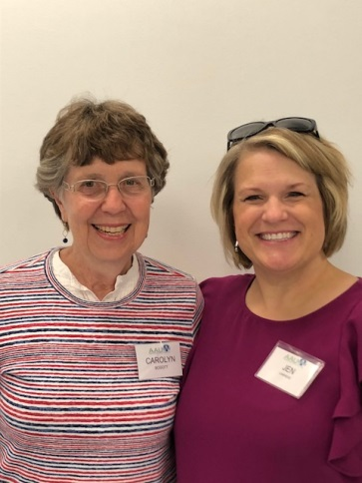
Co-President’s Message
Our 2018-19 Austin Branch AAUW year is off to a great start.
Congratulations to the Membership Co-Presidents on their successful new member drive, kicked off by the very enjoyable ice cream social! We have seven new members to enrich all of our activities.
Those who attended the potluck meeting enjoyed good food and good conversation.
We look forward to our October 9th meeting, with introductions to our Riverland College student scholarship recipients, plus the program by Fire fighter Mandee Marx.
At all of our monthly meetings this year, you will be encouraged to submit nominations to the Pillars of The City program, with the hope that we can get some women included in this city council sponsored leadership recognition. We will provide you with the background information on one or two women each month and explain how to make the nomination. You are encouraged to submit other nominations as well as the ones we suggest. Let’s flood the selection committee with women nominees!!!
Carolyn Bogott and Jen Lawhead
Co-Presidents, Austin Chapter - AAUW

Wisdom about curiosity for October:
“As I get older, the more I stay focused on the acceptance of myself and others, and choose compassion over judgment and curiosity over fear. “Tracee Ellis Ross
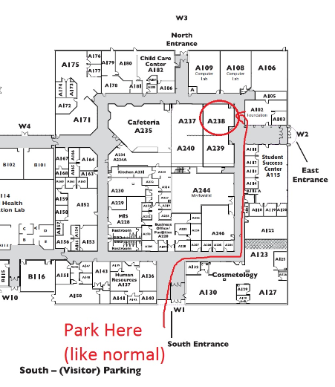
October Program
Our next meeting will be held on Tuesday October 9 at 6:30 PM at the Austin Riverland Community College, West Building Room A238. Our speaker will be Mandee Marx, a member of the Rochester Fire Department. She will speak on being a female in a male dominant career. Please join us for this interesting presentation.
~Jenni Braaten & Barb Hunter
Program Committee co-chairs
Member Spotlight - THERESA BECKER-ERSLAND
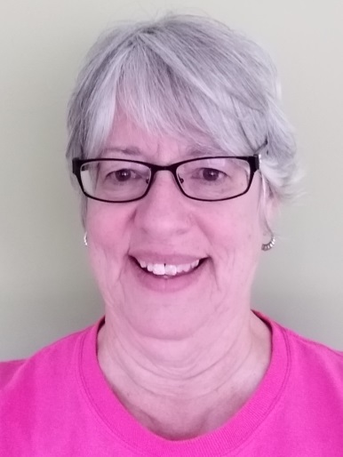
“I was raised in rural Wisconsin near Green Bay. Our family moved to Rochester when I was in eighth grade. I am the oldest of ten children. I graduated from Lourdes High School and then attended the College of St. Teresa, majoring in English and Secondary Education. After college I married Butch Becker and moved to Darlington, WI where our two oldest children were born, and I taught fifth and sixth grade at Holy Rosary Grade School. We moved back to MN in 1977 where I taught at the Southland Middle School and then at Queen of Angels Junior High. Our third child was born in Austin. Butch died in 1985. I married Dale Ersland in 1991 and started teaching Austin High School in 1994. At Austin Public Schools I served as a Language Arts teacher, department chair, High Potential Coordinator, and Curriculum Coach. I earned my Masters Degree through the University of Minnesota. Dale passed away in 2009. I retired in 2010, but continued to teach one or two classes, usually RCC Humanities, for one semester each school year until 2017-18. I married Mark Stier in 2015 and now live in Grand Meadow. I have seven grandchildren ages 11-22, the delights of my life, and 11 step grandchildren. I have served on the Friends of the Library Board and the Page Turner Selection Committee. My hobbies include reading, gardening, embroidery, and quilting.
I have been an on-and off-again member of AAUW since the late 80's or early 90's. That may sound strange, but at times life was too hectic to be a member of the group. I have always valued its mission toward supporting women's issues and education. Through the monthly programs and small groups of our chapter, I have found friendships, knowledge and stimulating discussions. I did help chair the House Tour during one of my membership years. I am eager to get acquainted with all of the current members.”
We are so glad to have Terri back as a member. She has much to offer all of us from her rich background. Welcome back, Terri!!!
Small Groups
PM Book Group
We will be meeting at the home of Judy Pesonen on October 15th at 7 PM to discuss The Bookman’s Tale by Charles Lovett. Please RSVP to Judy at rpesonen@smig.net. We will meet at 7 PM on November 19th at the home of Carolyn Bogott to discuss Educated by Tara Westover.
AM Book Group
Morning Book Group is discussing Little Fires Everywhere by Celeste Ng. The group meets at Perkins on October 18th at 9:00 AM.
First Friday
Our First Friday luncheon for October will again be at the Old Mill. I hope you will join me at 11:30 on Friday, October 5th. Please RSVP by Thursday, Oct. 4th before noon to sdkrob@live.com.
Enjoy the fall colors,
Dorothy Krob

Travel Group
The Travel Club is going to travel to the “Four Daughters Winery" on Wednesday, October 10th for lunch. After lunch we will drive to “Good Earth Village,” by Spring Valley and get a tour of this lovely Retreat Center. We will leave Austin at 10:30 AM and plan to return around 3:30-4:00 PM. To get more information, please email or call DedaRae (433-7897). We hope many of you can join us. Thank you.
Great Decisions
Great Decisions will meet at Riverland in Room C107 at 12:00 Noon on October 22nd. The discussion will be about “South Africa’s Fragile Democracy”.

AAUW PUBLIC POLICY
Evelyn Guentzel
DEEP ROOTS, STRONG BRANCHES
The September newsletter noted that AAUW has national initiatives and local branch programs generally relate to some aspect of these initiatives and in October our topic falls under the issue of Civil Rights. This month we will have the pleasure of hearing from Mandy Marx, a Rochester Fire Department Firefighter. She can address these issues as they relate to her employment.
Affirmative Action was a 1961 Executive Order signed by President Kennedy. It established equal opportunity for women and minorities and stressed gender, racial, and ethnic diversity in the workplace and in educational institutions.
Another initiative of AAUW has been to challenge the Gender Pay Gap which varies considerably from state to state. In Minnesota, the gender pay ratio is 82% of men’s pay, the national rank is 17%, and the equal pay laws are “moderate”. (in 2017 median earning for men was $55,812, while women earned $45,798). The goal is to pass federal bills advancing pay equity and to hold various agencies accountable. More details are available at our website.
Points of interest:
This week has been Banned Books Week which celebrates the freedom to read sponsored by The American Library Association Office. Last year there were 354 challenges to library school and university materials. Type “Banned Books” and you will be taken to the website which lists books that are on the list.
September 15 – October 15 is Hispanic Heritage Month.

Two Austin Branch Members have joined the AAUW Legacy Circle
Sue Grove was awarded her Legacy Circle pin at the State convention in April. And we have received word that Catherine Haslag has also joined this group and her pin will be awarded at a branch meeting. Legacy Circle honors those donors who have expressed their commitment to the mission of AAUW through a planned gift, such as a charitable gift annuity, or through a bequest. Legacy gifts are critical to supporting AAUW’s efforts, as AAUW continues to break through educational and economic barriers so women have a fair chance.
Catherine says of her gift, “I chose to join the Legacy Circle because it's an easy way to support the mission of AAUW. I obtained a better understanding of the lobbying efforts AAUW does for the benefit of women and the legal support they provide women when I attended the AAUW National Convention in 2017. I wanted to find a way to contribute to that effort. Sue Grove recently joined the Legacy Circle and that action inspired me to look into joining as well. Helping others is a primary value of mine. Leaving funds to the AAUW was an easy and effective way to support future generations of women after I am gone. “
The future of women and girls is enhanced by AAUW and by the generosity of two of our branch members. Please congratulate and thank Sue and Catherine for their commitment to the mission of AAUW.
Membership Update
On August 30, the Austin AAUW Branch hosted an ice cream social for prospective new members. Kerry and I are excited to share the new members who joined our branch that evening. Please help us in welcoming some truly amazing women to our branch:

Austere Apolo
Maylary Apolo
Theresa Becker-Ersland
Pam Hollarah-Aselson
Carolyn Rugg
Vickie Spyhalski
Nel Zellar

Please remember anyone who has an associate or higher degree is eligible to join AAUW. Prospective new members are always welcome to come to any AAUW branch meeting to get a sense of what a fun group of mutually supportive women we are! If you know of someone who may be interested in learning more about AAUW, please invite them to come to a meeting. As membership chairs, Kerry and I will help promote, and encourage our membership to grow but we cannot do it alone. At each monthly program meeting we will have membership applications available to any potential new member and we will be available to answer any questions about AAUW. So, please reach out to others you may know and invite them!
AAUW Monthly Financial Report
July 1 - August 30, 2018
Period: 7/1/18 - 8/30/18
Opening Balance: |  | $9,960.67
Income:
Dues received | 600.00
Book sale proceeds | 2,998.00
Total Income: | $ 3,598.00 | $13,558.67
Disbursements:
Dues Paid - National | 472.00
Dues Paid - State | 99.00
Total Disbursements: | $571.00
Closing Balance 8/30/18 |  | $12,987.67

AAUW Monthly Financial Report
September 1 - September 30, 2018
Period: 9/1/18 - 9/30/18
Opening Balance: |  | $12,987.67
Income:
Dues received | 565.00
Donation | 5.00
Total Income: | $570.00 | $13,557.67
Disbursements:
Dues Paid - National | 442.50
Dues Paid - State | 72.00
Riverland scholarship funding | 2,000.00
Total Disbursements: | $2,514.50
Closing Balance 9/30/18 |  | $11,043.17

Mission Statement: AAUW advances equity for women and girls through advocacy, education and research.
Vision Statement: AAUW will be a powerful advocate and visible leader in equity and education through research, philanthropy, and measurable change in critical areas impacting the lives of women and girls.

Southern Highlights Editor: Rae Dawn Rao rao_raedawn@yahoo.com Minnesota State Website: http://www.aauwmn.org Association Website: http://www.aauw.org Association e-mail: info@aauw.org

______________________________________________________________

AAUW Southern Highlights
1001 22nd Ave. SW
Austin, MN 55912

