Our Mission: To honor women and girls, empowering them through education,
service and leadership development.
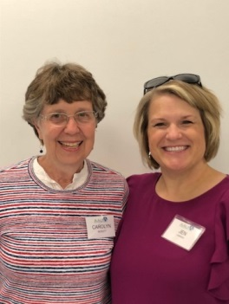
Co-President’s Message
REMEMBER TO VOTE ON NOVEMBER 6!!!
Our October program was really outstanding as we learned what it was like to be a female fire fighter. What an inspiration Mandee Marx was with her example of persistence to achieve a goal! Our meeting also included a chance to share some personal experiences of how we have been supported by other women.
We also met our scholarship recipients, Lucy Rodriguez and Libby Zafft. Your Branch Board has a new plan to continue our emotional support of these young women throughout the year. You will have an opportunity to sign up for a month to send either Libby or Lucy a note of encouragement. Your co-presidents took October and sent a Kwik Trip gift card to each along with the note. Other suggestions are cookies, coffee cards, etc., if you so choose, but the note of encouragement is the main point.
Our theme for the year is “Curiosity”. I think most of us have curiosity about the Islamic faith, especially since the attack of 9/11/2001 by Muslim fundamentalists. As educated women, we know that any faith has a wide range of commitment among its followers and that their beliefs differ widely. But educated or not, we fall prey to easy answers and don’t always pursue the more complex answers to our questions. Jenni Braaten and Barb Hunter have arranged a wonderful opportunity to find out some of the answers to those deeper questions. Come and hear the presentation by John Emery from the Islamic Resource Group in Minneapolis at our November 13th monthly meeting, 6:30 to 8 at Austin Public Library large meeting room. This meeting is open to the public and you are encouraged to bring family members and guests.
“A curious mind is the most important attribute any man or woman can possess.”
M. J. Rose

Carolyn Bogott and Jen Lawhead
Co-Presidents, Austin Chapter - AAUW

November Program
Barb Hunter and I are very excited for the upcoming November program! John Emery, from the Islamic Resource Group, in Minneapolis, will be coming to the Austin Public Library on Tuesday, November 13 from 6:30-7:30 pm. This will be a special evening of learning about the Islamic faith with attention to women's rights. John grew up in Minnesota and converted from Catholicism to Islam after spending years in the Middle East working in the military. Here is his official biography:
John Emery completed an intensive study of the Arabic language in the US Army. He served as a translator and interrogator for nine years, including services in the United States, North Africa, the Persian Gulf, and Guantanamo Bay, Cuba. John worked for Army Intelligence, Naval Intelligence, NSA, FBI, DIA, and other agencies. After his honorable discharge from the US Army, John completed his B.A. in Global Studies at the University of Minnesota. John is currently a speaker for the Islamic Resource Group, a Minnesota nonprofit dedicated to building bridges of understanding between Minnesota Muslims and the broader Minnesota community. As an American convert to Islam, John is actively engaged in promoting peace and understanding across faith communities.
He has also been interviewed on Minnesota Public Radio, by a KAXE television station and been featured in several articles. Please see below the various links to his interactions with the various media outlets. Likewise, we have a promotional flyer, (thank you Catherine Haslag!) which is attached for you to use wherever you feel it is appropriate. We have decided to open this program up to the broader Austin community as well as extending invitations to neighboring AAUW branches. It would be wonderful to fill the library meeting room for this event. Consider inviting a friend, relative, colleague or anyone whom may be interested in learning about Islam. It should be a night of learning for all!
https://www.mprnews.org/story/2017/10/26/former-catholic-clearing-up-misconceptions-about-islam

Jenni Braaten & Barb Hunter
Program Committee co-chairs

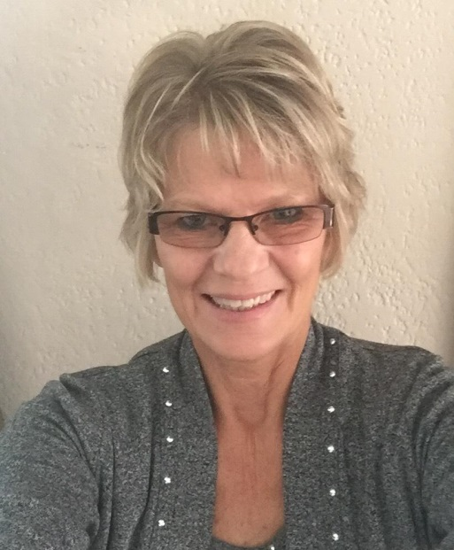
Member Spotlight - Carolyn Rugg
“Hi! My name is Carolyn Rugg and I am a new member of AAUW. I was introduced to this wonderful group by my co-worker and good friend, Kerry Bartlett, and was very interested in joining once I learned of their dedication to promoting equity and education for women and girls. Over the years I have been involved in many wonderful organizations, such as PTA, Relay for Life, and the Lions Club, and AAUW just felt right to become a part of also. Thank you Kerry for inviting me!
A little background on me: I grew up on a farm outside of Austin and graduated from Hayfield High School in 1975. I attended the University of Wisconsin at La Crosse and graduated with a BS in Recreation Administration. I worked in that field for a few years, as a park district supervisor in Lisle, Illinois, and later as the athletic director of Greenway Athletic Club in downtown Minneapolis. I then went through a phase of questioning what I wanted to do with my life, and eventually went to work for a graphic arts company in Minneapolis, which I continued until my daughter was born in 1992. I was a stay at home mom until 1995, when we moved to the beautiful lake town of Park Rapids, MN and I became employed in the business office of St. Joseph’s Hospital. That began a 21 year career at St. Joseph’s, where I worked in the business office, radiology scheduling and medical records. In 2017, I began to think about retirement and where I would like to be, and made the decision to move back home to Austin. I sold my house, quit my job and headed out, driving a 26 foot U-Haul with my 3 cats for company. It was a stressful time but it all worked out perfectly. I have a new job in medical records at Mayo Clinic, as I still have 3 years, 3 months and 6 days until retirement , and a very part time job at the YMCA, which will become my one and only job when I do retire. I bought an adorable house at the top of Skinner’s Hill, my cats are happy, and I am surrounded by family and friends. Maybe you know my parents, Bette and Bill Rugg, or my sister, Liz Husemoller. I miss my friends in the north country very much, but nothing can compare to being with family in good times as well as not so good. I am so thankful to be here!”
And AAUW is so happy to have Carolyn join us. Welcome!

Small Groups
PM Book Group
We will be meeting at the home of Carolyn Bogott on November 26th at 7 PM to discuss Educated by Tara Westover. Note this is a date change from the original schedule!!! Please RSVP to Carolyn at csbogott@charter.net. We will meet at 7 PM on December 17th at the home of Sue Grove to discuss The Readers of Broken Wheel Recommend by Katarina Bivald.
AM Book Group
Morning book group meets November 15 at 9:00 A.M. at Perkins. The discussion of ABERCROMBIE TRAIL, by Candace Simar will be led by Gerry Rustad. Candace Simar’s book is a fictionalized account of the Sioux Uprising of 1862, and is inhabited by the 19th century settlers of west central Minnesota.
First Friday
First Friday Luncheon will be held at Bella Victoria on Nov. 2nd at 11:30. Please RSVP to Dorothy Krob at sdkrob@live.com by noon on Thursday, Nov. 1st.

Travel Group
The Travel Club is going to meet at the Mower County Fairgrounds on Wednesday, November 14th at 1:00 PM. Sue Grove will be giving us a guided tour of the Mower County Historic Society Buildings as we “Travel Back in Time in Mower County.” This will be another interesting experience.
We encourage everyone attending to please bring and donate $3.00 or more for our tour. Also, be sure to dress appropriately for the weather. If you have any questions, contact DedaRae Graber. Please let me know by Tuesday, Nov. 13th if you plan to join us.
Thank you. I hope to see many of you on Nov. 14th.
DedaRae Graber
Great Decisions
GREAT DECISIONS will meet November 22, at Riverland Community College at 12:00 noon in Room C107. The topic is GLOBAL HEALTH: PROGRESS AND CHALLENGES.

AAUW PUBLIC POLICY
Evelyn Guentzel
The following is AAUW’’s Diversity Statement:
“In principle and practice, AAUW values and seeks an inclusive membership, workforce, leadership team, and board of directors. There shall be no barriers to full participation in this organization on the basis of age, disability, ethnicity, gender identity, geographical location, national origin, race, religious beliefs, sexual orientation, and socioeconomic status.”
Quite a challenge when we consider the diversity in our American culture. In each of these categories we can identify issues which confront us every day, and as AAUW members we generally seek to understand them and to consider them in the light of inclusivity. Each of these categories encourage us to reach for deeper insights.
In November, we will have the opportunity to hear from John Emery, a Chaska Muslim working to build bridges and……………….to dispel stereotypes”. Mr. Emery will address the subject of Islam and how it is “compatible with the values of Western and American society.” Mr. Emery is an Islamic Resource Group speaker and has presented to a variety of organizations.

AS AN ASIDE TO THIS REVIEW:
“The American Association of University Women advocates for freedom from violence and fear of violence in homes, schools, workplaces, and communities. Violent crimes motivated solely or primarily by bias or hatred against a group to which the victim belongs intimidates all members of that group and gives the victim a reason to fear for not only their own safety but that of the entire group. These crimes are also more likely to provoke retaliation and incite community unrest. Hate crimes are a persistent threat, according to the Federal Bureau of Investigation (FBI). In 2015, there were 5,818 reported bias-motivated incidents.”
VOTE NOVEMBER 6, 2018. HELP SOMEONE ELSE GET TO POLLS IF POSSIBLE.

BOARD MINUTES OF AUSTIN, MN BRANCH AAUW
A meeting of the board of the Austin, MN Branch of AAUW was held at 5:30 p.m. on October 9, 2018, at Riverland Community and Technical College. Members of the board in attendance included Carolyn Bogottt, Jennifer Lawhead, Jenni Braaten, Barb Hunter, Evelyn Guentzel and Peggy Benzkofer.
Discussion was held regarding support for the scholarship winners. This can be something simple. Ideas suggested included a note and/or a gas card, cookies or treats, a card for coffee, a gift certificate or money for the cafeteria. We will do this November through May. Jen and Carolyn will do October. Peggy will put together a chart for sign up as well as a list of ideas.
Further discussion of the Pillars of the Community was held. Continuing concern was expressed that more women have not been honored. It was mentioned that there is an opening on the committee.
Jenni said there needs to be more people on the Story Show committee. We need six to eight story tellers who will speak five to seven minutes. They should share stories of triumph. Discussion took place regarding a place to hold it. Jenni will ask Julie about the large room at the library. The ARC building was also suggested. There was no treasurer’s report. It was decided that there will be no political forum this time.
The meeting in November will feature John Emery of the Islamic Resource Group in Minneapolis. It was decided that the public will be invited. Peggy will send out a press release promoting the event. Flyers will be created and Carolyn volunteered to help to distribute them.
Respectfully submitted: Peggy Benzkofer, Secretary
AAUW Monthly Financial Report
October 1 - October 31, 2018
Period: 10/1/18 - 10/31/18
Opening Balance: |  | $11,043.17
Income:
Book sale proceeds | 32.50
Total Income: | $ 32.50 | $11,075.67
Disbursements:
Meeting speaker | 50.00
Insurance | 185.00
Membership - ice cream social | 100.00
Total Disbursements: | $335.00
Closing Balance 10/31/18 |  | $10,740.67

Mission Statement: AAUW advances equity for women and girls through advocacy, education and research.
Vision Statement: AAUW will be a powerful advocate and visible leader in equity and education through research, philanthropy, and measurable change in critical areas impacting the lives of women and girls.

Southern Highlights Editor: Rae Dawn Rao rao_raedawn@yahoo.com Minnesota State Website: http://www.aauwmn.org Association Website: http://www.aauw.org Association e-mail: info@aauw.org

______________________________________________________________

AAUW Southern Highlights
1001 22nd Ave. SW
Austin, MN 55912

