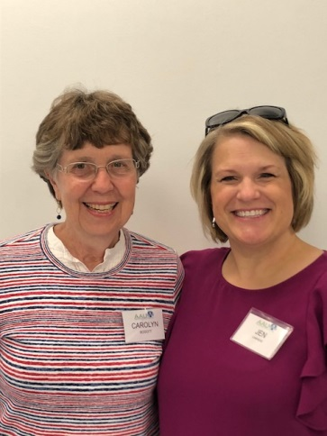
Our Mission: To honor women and girls, empowering them through education, service and leadership development.
Co-President’s Message
“Curiosity” will be this year’s theme for Austin Branch of AAUW.
Curiosity is defined as “the strong desire to know or learn something.” And isn’t that what our branch is all about? Our monthly programs, Travel Group, Great Decisions, Public Policy Updates, Knitting Group are all about learning . Our bringing together people informally like First Friday lunches and potluck meals, give an opportunity to learn about others people’s experiences. And as each of us individually is reacting to things, we are learning about ourselves. Learning about ourselves may be the most important work we can do. Jen gave a good example about her personal “curiosity quest.” She got very upset about something and was able to step back to be curious as to what was behind her reaction to the situation. That helped her come to a reasonable outcome and she understand herself a little more. Jen put the meaning of the following quote into practice:
“If you are curious, you create opportunities, and then if you open the doors, you create possibilities” Mario Testino.
No doubt all of our board members joined the co-presidents in being curious about how this year’s board would fit together when we met for our planning retreat in July. Curiosity, opportunities and possibilities certainly abounded! There are some terrific monthly programs ahead, plus some new ways to serve in the community. And there will be new ways to get to know each other better at each meeting, plus challenges to be more active in community affairs.
Stay tuned and be curious!!!
Carolyn Bogott and Jennifer Lawhead
Co-Presidents, Austin Chapter - AAUW
September Program
AAUW will be starting off the 2018-19 year on Tuesday, September 11 with a potluck at Christ Episcopal Church located at 301 3rd Avenue NW at 6:30 pm. Barb Hunter and Jenni Braaten will discuss the program line up for the year as well as any updates on the small groups members may have. Please bring a dish to pass for the potluck. Paper plates, silverware, napkins and water will be provided by the AAUW branch. It will be a fun evening to share and connect with others!
~Jenni Braaten & Barb Hunter, Program Committee co-chairs
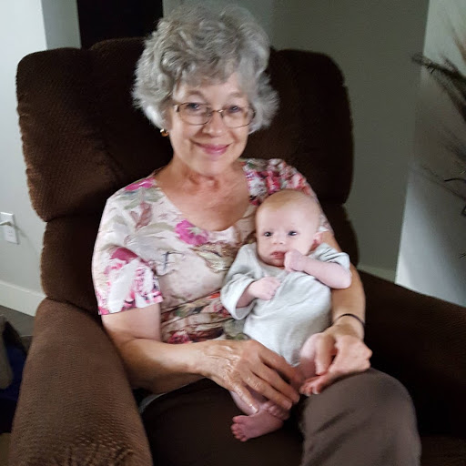
Member Spotlight – Barb Hunter
Barb grew up in Austin, the oldest of 8 children. With the exception of two years after college, she has lived in Austin all her life. She married Jim Hunter in 1981 (who was #7 of 8 children in his family!) They were married 29 years before he died in 2010. She taught elementary school in private and public school settings for 10 years and then stayed home with their three children for several years. Then Barb went back to school to obtain special education licensing and she enjoyed working in that area for 18 year till she retired in 2017.
These days she enjoys reading, sewing, crafts, camping, short tips and spending time with family, particularly with her granddaughter.
Regarding AAUW, Barb says,” I remember coming home after my first AAUW event in 2010 and I announced that I had decided to join. My husband asked me why. I replied, “Because it was for women, had interesting small groups to participate in, as well as the large group, and we don’t gossip. We do things and we want to create a better world for all women.”
Barb summed up our organization well! We are so fortunate to have her as a member and to have her serving on the board this year as Co-Vice President of Programs.

Small Groups
PM Book Group
We will be meeting at the home of Angie Ruhter on September 17th at 7 PM to discuss our September selection, Lilac Girls by Martha H. Kelly. Please RSVP to Angie at ajruhter@gmail.com. We will meet at 7 PM on October 15th at the home of Judy Pesonen to discuss The Bookman’s Tale by Charles Lovett.
AM Book Group
We will meet at Perkins at 9:00 AM on September 20th. Our guest will be Judy Bergen, author of LONGING TO BELONG. She will share with us her writing craft.
First Friday
First Friday will be this Friday, September 7th at 11:30 at The Old Mill. Please RSVP to Dorothy Krob by noon on Thursday atsdkrob@live.com.

Travel Group
The Travel Club will be meeting at the home of Sandy Folk (1509-16th Ave. SW) on Thursday, September 20th at 1:30 P.M. We will be making plans for this year. Please remember to bring your calendar and ideas for programs. I look forward to seeing you on the 20th. If you have any questions, please email or call DedaRae at 433-7897. Thank you.
Great Decisions
We will meet at Riverland at 1:00 PM on September 24th. Room TBD. We will be discussing U.S. GLOBAL ENGAGEMENT AND THE MILITARY.

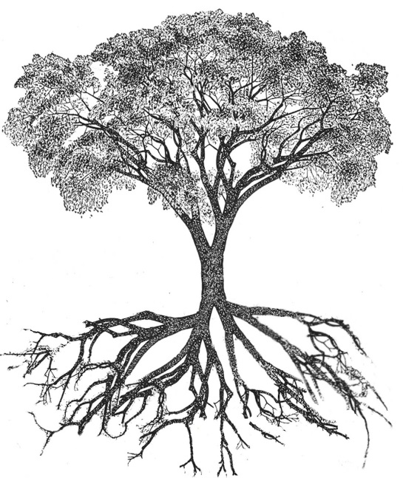
AAUW PUBLIC POLICY
Evelyn Guentzel

DEEP ROOTS, STRONG BRANCHES
Welcome back for another year of stimulating programs and time for socializing with longtime friends and becoming acquainted with new members.
My role is to share information with all of you about the purpose of AAUW and to share some of the important activities that the national tier of our organization is conducting.
Public Policy is the foundation on which we build our understanding of and appreciation for who we are as national and state members and local branches. Our priorities are established every two years by every-member votes. The main areas of focus are education, the economy, civil rights and Title IX. Within each of these areas the following are considered: viability, critical need, strong member support, and the potential for making “distinctive contributions”. At the national level all four areas are addressed as critical needs and strong advocacy efforts are in place to lobby for Congressional support for its initiatives, Major concerns continue to be public education, pay equity, violence against women and girls, social and cultural diversity and Title IX. Within this framework, local branches choose their program topics that may reflect local concerns and advocacy efforts. They are supported by significant information from National AAUW.
As the year progresses you will be informed more specifically about AAUW’s national initiatives, we will see how our topics relate to public policy. Members are encouraged to visit the TAKE ACTION website and to take advantage of the TWO MINUTE ACTIVIST which makes it easy to let your legislators know your thoughts about issues. The ACTION NETWORK is the e-advocacy “cornerstone”.

Austin Branch AAUW
Board Retreat
July 18, 2018
Austin Public Library

Those in attendance included Barbara Hunter, Jeni Braaten, Jennifer Lawhead, Nicole Cizik, Carolyn Bogott, Catherine Haslag, Jill Maxfield, Evelyn Guentzel, Kerri Bartlett and Peggy Benzkofer.
The meeting was called to order at 4:30 by co-presidents, Carolyn and Jennifer. Introductions followed. The co-presidents announced that the theme for the year will be “curiosity”. It is defined as “the strong desire to know or learn something”. “If you are curious, you create opportunities, and then if you open the doors, you create possibilities” Mario Testino.
Peggy read the minutes of the May dinner meeting of the general membership as it included the election of officers. Barb made a motion to approve the minutes, seconded by Nicole. The motion passed.
The treasurer’s report was presented by Nicole and included the proposed budget. An extensive discussion followed. The budget will be presented for approval at the next meeting.
It was announced that the Historian position still needs to be filled. Anyone interested should contact the presidents.
A review of the member survey taken at the dinner was held. The majority of members prefer the 6:30 start time for meetings. Most members expressed support for a social time at the meetings but said we don’t need snacks. An equal number supported social time before and after the meeting. It will be held after with the board meeting held immediately before the meeting.
Jenni and Barb led a discussion of the programs planned for the next year. All months are planned except for April. The Library is the first choice for a meeting place with Riverland West Building second.
Jenni and Kerri gave a membership update. There are 47 members as of the meeting date with 16 people not responding who were members last year. Board members volunteered to contact people who had not rejoined. There is one new member. There will be an event in August for prospective members. Jenni and Kerri will plan and contact the membership. Members will be invited to come and bring a prospective member.
The board decided to continue the Women’s History Month activities and the Notable Women column in the Austin Daily Herald.
Carolyn suggested that it might be helpful for our group to mentor scholarship winners through encouraging notes, cookies etc. Catherine and Sue Grove will be asked about this idea.
Discussion of the Sandy Anderson proposal was postponed until the next board meeting.
Discussion was held of the Pillars of the Community project and the desire to have more women honored. A list of women for selection was shared and everyone was encouraged to nominate a woman for this honor. The deadline is the end of December and forms are available on the city website.
Fundraising ideas were shared. Fortunately, the book sale was very successful so we have a “cushion” going into the year. Among the ideas shared for another fundraiser was a Story Show which has been successful in Albert Lea. The suggestion was made to begin planning for the next House Tour although it will not be held until 2019.
The next board meeting will be held on August 14th. Thanks to Jill Maxfield for providing the delicious snacks for this meeting.
Respectfully submitted by Peggy Benzkofer, Secretary

Minutes of Austin Branch of AAUW
May 8, 2018

A general meeting of the members of the Austin Branch of AAUW was held on May 8, 2018. The annual dinner meeting was held and past members of the board were honored. The winners of the Women’s History Month event at Austin High School attended and spoke briefly.
The election of officers was held with Carolyn Bogott and Jennifer Lawhead elected to a two-year term as co-presidents. Program vice presidents elected were Jenni Braaten and Barbara Hunter. Kerry Bartlett and Jenni Braaten were elected membership vice presidents. Both positions are two-year terms. Nicole Cizik has agreed to continue as treasurer.
Respectfully submitted: Peggy Benzkofer, Secretary

Mission Statement: AAUW advances equity for women and girls through advocacy, education and research.
Vision Statement: AAUW will be a powerful advocate and visible leader in equity and education through research, philanthropy, and measurable change in critical areas impacting the lives of women and girls.

Southern Highlights Editor: Rae Dawn Rao rao_raedawn@yahoo.com Minnesota State Website: http://www.aauwmn.org Association Website: http://www.aauw.org Association e-mail: info@aauw.org

______________________________________________________________

AAUW Southern Highlights
1001 22nd Ave. SW
Austin, MN 55912

