Our Mission: To honor women and girls, empowering them through education, service and leadership development.

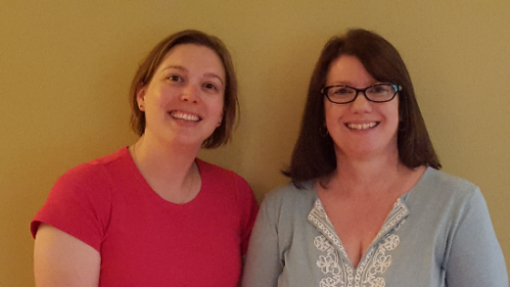Co-President’s Message

This is our last co-president’s address.  It has been an honor serving the Austin Branch in this manner for the past 2 years.  You are an amazing group of women and we are grateful for the trust you have put in us as your co-presidents.  We are excited to see how this branch grows and continues to positively impact Austin as new leadership enters in the fall and more members actively engage in our organization.

 Please don’t forget:  voting on changes/proposals to AAUW bylaws is open.  It is very important that members participate in this process.  More information about this can be found at <https://www.aauw.org/resource/national-election/>.  Please participate and exercise your voice.

 We are looking forward to seeing you all at the Spring Banquet on May 8.  We have a lot to celebrate this past year. A special thanks to all members who have stepped up and taken an active role in our branch!  We continue to move forward because of your work and dedication.

~Jill Maxfield and Catherine Haslag, Co-Presidents

**C:\Program Files\Microsoft Office\MEDIA\CAGCAT10\j0212661.wmfMay Program**

**May 8th Meeting**

**5:30 PM at The Hormel Historic Home**

Our AAUW spring banquet will be at The Hormel Historic Home on May 8. A special note that the winners from the Women’s History Month contest will be joining us for the evening! Social time begins at 5:30 p.m. Dinner will be served at 6:00 p.m. A cash bar will be available. The cost is $20.00. Pre-payment is welcome or you can pay that evening, but if you do not cancel before May 3, you are responsible for payment because we must pay for all dinners reserved.

Anyone attending must RSVP on or before May 3. You may email Marijo at marijoalexander@yahoo.com or Sue at sue.grove@riverland.edu. When you arrive at the Hormel Historic Home, please check in with us.

We hope to see you on May 8!

~Sue Grove and Marijo Alexander, Program Committee co-chairs

**BOOK SALE SUCCESS!**

Thank you to those members who were available to help with the sorting, arranging and set up for the library used book sale!  This is the most important part of a successful sale.  The sale days go very smoothly when all the set-up is completed.  The help on the sale days was terrific.  Without great volunteers, this would never be a successful fundraising project for AAUW.

Thanks to all of you, Joyce and Laura, Co-chairs

**Update on AAUW Dues**

As has been the tradition in years past, dues for the forthcoming year will be collected at the upcoming spring banquet on May 8. For the first time in a decade, there will be a $10 increase in annual dues. According to the AAUW website, "AAUW Board of Directors voted in June 2017 to increase the dues from $49 to $59. Annual dues currently account for 13 percent of AAUW's annual budget. They help sustain and grow AAUW's programs and work that advances equity for women and girls. A combination of dues, donations, and corporate and foundation funding is critical to supporting AAUW’s salary negotiation workshops, groundbreaking research, advocacy efforts, campus leadership programs and so much more. "  Below there is a link to AAUW's Board Chair, Julie Brown, and Chief Excuetive Officer, Kimberly Churches, speaking regarding the decision to increase dues.

Our local Austin branch recognizes this may cause a financial burden to some of our members. However, it is our sincere hope that each of you will renew your membership and continue to be members of this important and wonderful organization. There have been many friendships, laughs, connections and fun had through the AAUW Austin branch over the years and we hope this will carry into the future years ahead despite the increase. The good news is the state and branch dues will remain the same. The break down of dues is: $59 National AAUW, $9 Minnesota AAUW and $7 to the Austin Branch for a total amount of $75. And, please keep in mind $56 of AAUW National dues are tax deductible which may benefit members next tax season.  We hope to see you at the banquet in May!

Catherine Lemons and Jenni Braaten

Membership Co-chairs

[www.youtube.com/watch?time_continue=3&v=3H-Ii2SvftU](http://www.youtube.com/watch?time_continue=3&v=3H-Ii2SvftU)

|  |  |  |
| --- | --- | --- |
| [https://i.ytimg.com/vi/3H-Ii2SvftU/maxresdefault.jpg](http://www.youtube.com/watch?time_continue=3&v=3H-Ii2SvftU) | [Dues Increase Message](http://www.youtube.com/watch?time_continue=3&v=3H-Ii2SvftU)  [www.youtube.com](http://www.youtube.com/)   |  | | --- | | [YouTube](http://www.youtube.com/)  [www.youtube.com](http://www.youtube.com)  Enjoy the videos and music you love, upload original content, and share it all with friends, family, and the world on YouTube. | |

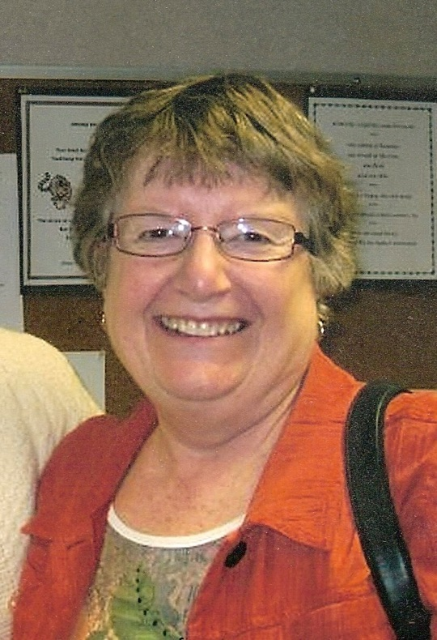**Member Spotlight – Peggy Benzkofer**

Peggy Benzkofer, our branch secretary, has been a faithful and active branch member for many years.

“I grew up on a farm in northwest Iowa and attended Briar Cliff College in Sioux City, IA which was a Catholic women’s college. It is now a co-ed university. Alas, both changes occurred after I graduated.

We moved to Austin for Dick’s work and three of our four children were born here. I became involved with our AAUW branch in the 70’s when I was a stay-at-home mom with three children close in age. It has been an activity just for me and a great source of mental stimulation and close friendships. I have held almost every office including book sale co-chair in the bad-old-days when we stored books in members’ garages and then hauled them to the sale. In my case, that was down the stairs to the basement at St. Olaf church.

Professionally, I have done freelance writing from the time the children were little and then worked part time for the Austin Daily Herald and the school district. I retired as executive director of the Austin Public Education Foundation and Math Masters of Minnesota. Both were challenging and rewarding positions.

AAUW has been, and continues to be, very important to me. Not only do I feel that AAUW helps me to have an effect on public policy but the members have been a major support for me in the worst of times and during the good times too.”

Peggy’s current AAUW activities, besides serving on the board, are participation in Great Decisions and Evening Book Group and First Friday lunches. She was on the founding steering committee of the Science Fair Mentoring Project and has worked with the Women’s History Month celebration contest and assembly at AHS since its beginning twelve years ago.

We applaud your long membership and participation, Peggy!

**AAUW Meeting Minutes**

**April 10, 2018**

Catherine Haslag called the meeting to order at 5:30. The following officers were present: Catherine Haslag, Jill Maxfield, Jennifer Lawhead, Marijo Alexander,Jenni Braaten, Catherine Lemons, and Nicole Cizik.

**Treasurer’s Report:**

Nicole Cizik stated that there is no new activity since the newsletter was sent out.

**Program Report:**

The Women’s History Project winners have a conflict tonight, so they will present at our May meeting.

Marijo Alexander reported that the cost of the banquet in May is $20.00, and she is collecting money tonight.

**Membership Report:**

Catherine Lemons reported that there are no new members at this time. There was a question about the cost of dues this year, and Nicole was going to follow-up and let the board know.

(Update from Nicole: To follow up from our conversation regarding membership dues for this next

year, I received confirmation that there was no increase to state dues. This means annual dues will be $75, up $10 from last year. The $75 is made up of $59 national + $9 state + $7 branch dues.) An update about the dues will be in the May newsletter.

**Women’s History Month Report:**

Carolyn Bogott reported that Dylane Ulwelling did an amazing job speaking to the High School students. She felt like Dylan had a great connection with the students and the assembly was a success. Carolyn thanked Sue Grove for introducing Dylane and presenting the awards. Carolyn is already thinking about possible speakers for next year.

**Science Fair Mentoring Project Report:**

Catherine Haslag reported that 29 students are going to the Regional Science Fair in Mankato on April 28th.

**AAUW State Convention Report:**

Sue Grove and Marijo Alexander are planning to attend the State Convention, and will be the delegates from our branch. Catherine Haslag reported that we have spots for 5 delegates, so we could send three more if anyone else is interested. Marijo Alexander reported that this year she is collecting money for the silent auction basket instead of donating a basket at State Convention.

**Nominating Committee for Officers Report:**

Co-Presidents – Carolyn Bogott and Jennifer Lawhead, Membership – Kari Bartlett and Jenni Braaten, Programs – Barb Hunter, Treasurer – Melissa Siebke

**New Business Report:**

Catherine Haslag gave an update regarding the meeting that some of our AAUW members attended with Sandy Anderson. Sandy is interested in starting a leadership cohort with some of the women in Austin from our immigrant population. Sandy would provide mentoring, support and training to these women. She is looking for financial support for this leadership opportunity. The board agreed to wait for more information from Sandy, and then talk about this again during the board retreat this summer.

**Library Book Sale Report:**

During the regular meeting, Laura Tjomsland reported that donations for the Library Book Sale will start on April 12. Volunteers for sorting are needed from April 16 – April 26 anytime the library is open. A sign-up sheet for volunteers to work during the book sale was passed around. Books that are not sold will be donated to Thrift Book Global.

Catherine Lemons motioned to adjourn the meeting and Marijo Alexander seconded the motion.

 Respectfully submitted by:

Jill Maxfield (in absence of Secretary Peggy Benzkofer)

|  |  |  |
| --- | --- | --- |
| **AAUW Monthly Financial Report** | | |
| **February 1 - April 30, 2018** | | |
|  |  |  |
| **Period: 2/1/18 - 4/30/18** |  |  |
|  |  |  |
| **Opening Balance:** |  | **$10,179.39** |
|  |  |  |
| **Income:** |  |  |
| Luncheon | 347.88 |  |
|  |  |  |
| **Total Income:** | **$347.88** | $10,527.27 |
|  |  |  |
| **Disbursements:** |  |  |
|  |  |  |
| Luncheon (speakers meal) | 359.21 |  |
| Women's History Speaker | 200.00 |  |
| Women's History Awards | 200.00 |  |
| Science Fair Mentoring Awards | 102.50 |  |
|  |  |  |
| **Total Disbursements:** | **$861.71** |  |
|  |  |  |
| **Closing Balance 4/30/18** |  | **$9,665.56** |

**Small Groups**

**PM Book Group**

We will be meeting at the home of Sue Grove on May 21st at 7 PM to discuss our May selection, *Letters from the Sky* by Jessica Brockmole. Please RSVP to Sue at [sue.grove@riverland.edu](mailto:sue.grove@riverland.edu). We will meet at 7 PM on June 18th at the home of Judy Pesonen to make our selections for the 2018-2019 year.

**AM Book Group**

We will meet next on May 17th at Perkins Restaurant at 9:00 A.M. *Longing To Belong*, by Judi Bergen is a “beautifully written story about a young woman struggling to fit in. Gerry Rustad will lead discussion.  In June we will discuss *Hill Billy Elegy* by J. D. Vance.  Evelyn Guentzel will lead and it will be at Perkins again.   In July, we will meet to choose books for next year.

**First Friday**

The First Friday Luncheon will be at The Old Mill at 11:30 on Friday, May 4th. Contact Dorothy Krob at [sdkrob@live.com](mailto:sdkrob@live.com) by next Thursday for a reservation.

**Travel Group**

We postponed our April Meeting because of the snowstorm and a few other reasons.  We will be meeting on Thursday, May 17th at 1:30 PM at the home of Gail Minerich.  Gail and Annie Warner will be sharing information of their recent trip to Egypt.  We look forward to hearing about this interesting adventure.  If you would like to join us, please let me know before May 16th.  Thank you.

~ DedaRae Graber ([drgraber@charter.net](mailto:drgraber@charter.net))

**Great Decisions**

The Great Decisions meeting date is still to be determined due to the Memorial Day holiday falling on our regularly scheduled meeting date. Look for more information to come!

*Mission Statement*: AAUW advances equity for women and girls through advocacy, education and research.

*Vision Statement:* AAUW will be a powerful advocate and visible leader in equity and education through research, philanthropy, and measurable change in critical areas impacting the lives of women and girls.

**Southern Highlights Editor:** Rae Dawn Rao [rao_raedawn@yahoo.com](mailto:rao_raedawn@yahoo.com) **Minnesota State Website:** <http://www.aauwmn.org> **Association Website:**  <http://www.aauw.org> **Association e-mail: info@aauw.org**



______________________________________________________________

AAUW Southern Highlights

1001 22nd Ave. SW

Austin, MN 55912