Our Mission: To honor women and girls, empowering them through education, service and leadership development.

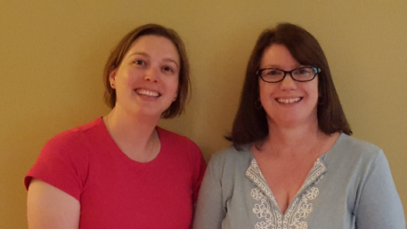
Co-President’s Message
With the end of our program year coming to a close, we have a lot of business to attend to:
The AAUW State Convention is scheduled for April 27-28 in Faribault. Austin can send up to 5 delegates to the convention. There is no limit on the number of members who can attend state convention, but only 5 are official delegates of our branch. It is really important that we fill all of our delegates. If you would like to serve as a delegate, please let us know by April 10.

Voting on changes/proposals to AAUW bylaws will open at the end of April. More information about this can be found at https://www.aauw.org/resource/national-election/. Please participate and exercise you voice.

We are looking forward to seeing you all at the April 10th meeting. Please let us know if you have any questions.

~Jill Maxfield and Catherin Haslag, Co-Presidents
Upcoming Programs
April 10th Meeting
6:30 PM at Riverland Community College – B116 West Building
Our April meeting is traditionally where we get to meet the winners of the Women’s History Project from Austin High School, and we hope that this year will be no exception!! However, at the time we are writing this, the students are uncertain if they can be there because of school obligations. The winners are: Eleanor Hinchcliff and Sarah Bachmeier and Brock Lawhead and Charles Kanne. If they cannot attend in April, they will hopefully be able to share with us in May.
Never fear, however, if they cannot be there in April, we have another interesting program up our sleeves! We all love a mystery, right? So, please come to see what we have in store. We will be in the West Building at Riverland. You can enter the Main Entrance (south side of building) and go down the hall to the left.

May 8th Meeting
5:30 PM at The Hormel Historic Home
Our AAUW spring banquet will be at The Hormel Historic Home on May 8. Social time begins at 5:30 p.m. Dinner will be served at 6:00 p.m. A cash bar will be available. The cost is $20.00. Pre-payment is welcome or you can pay that evening, but if you do not cancel before May 3, you are responsible for payment because we must pay for all dinners reserved. Marijo and Sue will receive your checks at the April 10th meeting if you wish to pay in advance.
Anyone attending must RSVP on or before May 3. You may email Marijo at marijoalexander@yahoo.com or Sue at sue.grove@riverland.edu. When you arrive at the Hormel Historic Home, please check in with us.
We hope to see you on May 8!
~Sue Grove and Marijo Alexander, Program Committee co-chairs

Women’s History Events Were Great Successes
Thanks to branch members Katie Ulwelling, Sue Grove, Peggy Benzkofer and Marijo Alexander for judging the Women’s History Project Contest. The winners were Sarah Bachmeier and Eleanor Hinchcliffe, and Brock Lawhead and Charlie Kanne. Each student was awarded $50 at the Women’s History Month assembly on March 22.
That assembly was a huge success despite its timing on the morning of the Packers State Semi Finals game. Dylane Ulwelling Wallat, sheriff’s deputy with the St. Paul Ramsay Sheriff’s Department, and daughter of our branch member, Katie Ulwelling, gave an amazing presentation about her life story.
Dylane thoroughly engaged the students, speaking from her heart about taking charge of one’s life and working hard. She used power point slides, showing her presentation outline, plus photos from her experience in the National Guard in Iraq, and video of sheriff department training. Principal Andrea Malo told us this was the best presentation we have brought to the high school in its meaningfulness to students, both male and female. Dylane was given a $200 honorarium as a token of our appreciation.
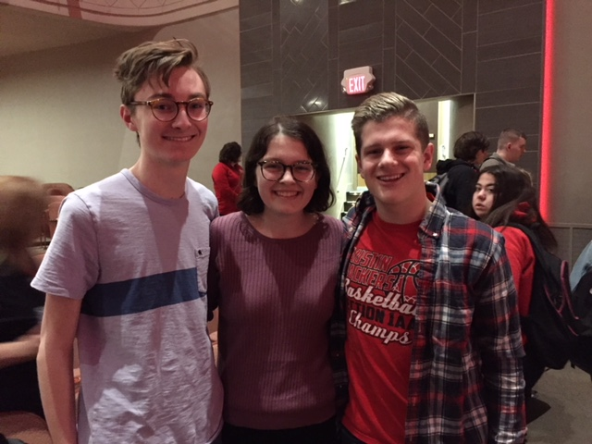
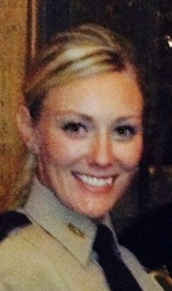

Dylanne Ulwelling Wallat

Pictured above: Charlie Kanne, Eleanor Hinchcliffe and Brock Lawhead

AAUW Inspiring Scientist Award
The Austin Branch of the AAUW has been offering the AAUW Inspiring Scientist Award for 3 years at the STEAM Expo (science fair). This award is given to students who demonstrate proper use of the scientific method, creativity and originality in developing their project, and was able to clearly explain their findings and meaning. This year, 5 students were given this award. Along with a framed certificate, students were given a copy of Build-It-Yourself Science Laboratory so they can continue their experimentation.
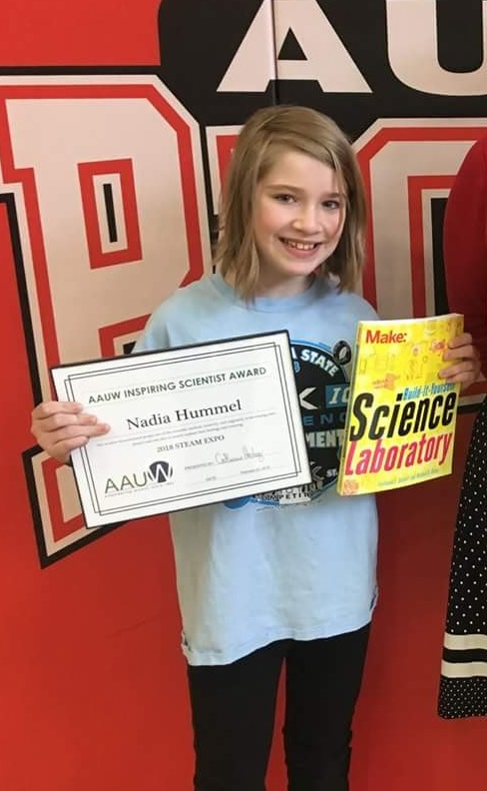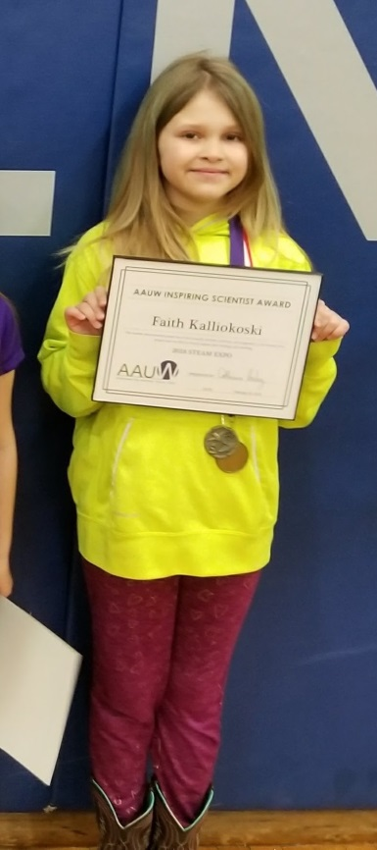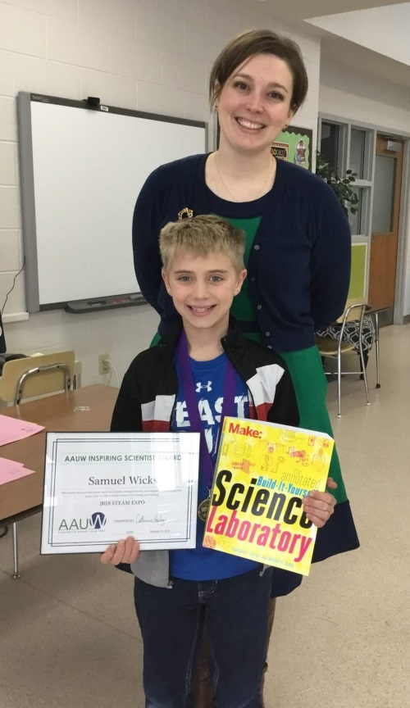
This year’s winners are Nadia Hummel from IJ Holton (left), Faith Kalliokoski from Neveln Elementary School (center), Samuel Wicks from Southgate Elementary School (right) and Monica Toscano and Qu-Mikalania Samuel from Banfield Elementary School (not pictured).
Congratulations to these inspiring scientists!

Nominations Committee Report
We are pleased to announce that we have a slate of Austin Branch Officer Candidates for 2018-19 to bring to the membership for a vote at the April meeting.
Co Presidents: Jennifer Lawhead
Carolyn Bogott

Co Vice Presidents for Program: Jenni Braaten
Barb Hunter

Co Vice Presidents for Membership: Kerry Bartlett
Jenni Braaten (This not a mistake. She is willing to do both.)
Treasurer: Melissa Siebke
(Peggy Benzkofer will continue to serve as Secretary)
Thanks to all these women who are willing to serve in leadership.

PUBLIC POLICY
Evelyn Guentzel

Happy Spring!
This has been a great season so far for women and children—The Women’s March and The March for Our Lives. AAUW will continue to march on with its policies. Thanks to Austin Branch for its contribution to the celebration of Women’s History Month.

Spring Used Book Sale Approaches!
The Spring Used Book Sale is set for April 27, 2018 10 a.m. - 5 p.m. AND April 28th 10 a.m. - 5 p.m. Bag Sale 3:30 - 4:30. Donations will be accepted starting on April 12th. Sorting and arranging in large room begins April 16th. YOUR HELP IS NEEDED FOR SORTING! You can help anytime that the library is open. ALL HANDS NEEDED! Sign up sheets will be available at the April 10th meeting. Be prepared to sign up. Shifts are 2 hours beginning at 10 a.m. We will also be collecting printer paper boxes with lids for packing after the sale.

AAUW Monthly Financial Report
February 1 - March 30, 2018
Period: 2/1/18 - 3/30/18
Opening Balance: |  | $10,179.39
Income:
Luncheon | 347.88
Total Income: | $347.88 | $10,527.27
Disbursements:
Luncheon (speakers meal) | 359.21
Women's History Speaker | 200.00
Women's History Awards | 200.00
Science Fair Mentoring Awards | 102.50
Total Disbursements: | $861.71
Closing Balance 3/30/18 |  | $9,665.56

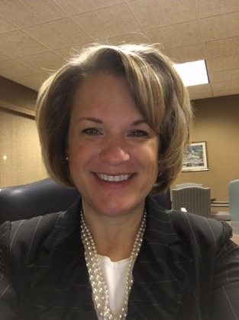
Member Spotlight
Jennifer Lawhead
Jennifer has been serving as our Branch historian for the past year. She joined AAUW after giving us a presentation in the spring of 2016. She says, “When I was there, I felt like I was with ‘my people’. The women just felt like home to me. So I asked to join. Clearly the vision of AAUW aligns with my values, but really it was because I felt I’d found a place where I belonged.”
Growing up in Minneapolis, Jennifer absolutely loved libraries and school. That naturally led to her pursuing a Master of Arts in Teaching from St. Thomas, after her undergraduate degree from St Olaf in Sociology and Women’s Studies. She went on to earn a Gifted Education Certificate from St. Mary’s and a Specialist Degree and K-12 Principal’s License from Mankato. She has been a teacher and school administrator since 1995, serving in Burnsville, Rochester and Austin. She has often given presentations to parents and teachers on topics related to the special needs of gifted students. She has been awarded the Post Bulletin Teacher of the Month Award, and nominated for the Austin School Teacher of the Year, as well as the WEM Outstanding Educator Award. Wow! That background certainly was great preparation for her present job.
Jennifer is currently Executive Director of Austin Aspires, “working toward the vision that Austin will be recognized as a leader in education with a culture of educational excellence, cradle to career, embraced in every aspect of our community.” This involves her serving on many committees in the community.
Beyond her work, she volunteers for the Science Fair mentoring Project and has sung with the Austin Symphony Chorus. She and her husband, Brandon, have three children, Brock, a junior, Tammara in eighth grade, and Will in sixth grade. Jennifer attends all their music and sporting events and often volunteers in the concession stands or hosting pizza parties for their teams.
We are so glad that Jennifer found that she “belongs” with us. She has much to share with us in our AAUW work toward a bright future for women!
Small Groups
Great Decisions
Great Decisions meets Monday, March 26, at Riverland (room TBD) at 1:00 P.M. to discuss Russia’s foreign policy.

PM Book Group
Evening book group will meet on Monday, April 16th at 7 PM at the home of Angie Ruhter to discuss the selection All the Gallant Men by Donald Straton. Please RSVP to Angie at ajruhter@gmail.com. Our May selection is Letters from the Sky by Jessica Brockmole.

First Friday
First Friday Luncheon will be at El Patron Mexican Grill (by Walmart) on April 6th at 11:30. Please email Dorothy Krob at sdkrob@live.comfor your reservation.

Travel Group
The Travel Club will be meeting at the home of Gail Minerich on Thursday, April 19th, at 1:30 PM. Gail and her sister, Annie, will be sharing information about their recent trip to Egypt. They had a wonderful time and we look forward to hearing all about their adventure. Please let me know if you would like to join us. Thank you.
~DedaRae Graber
Great Decisions
Great Decisions will be on April 23rd in Rm C110 in Riverland East Bldg. We will be reading Chapter 3.

Mission Statement: AAUW advances equity for women and girls through advocacy, education and research.
Vision Statement: AAUW will be a powerful advocate and visible leader in equity and education through research, philanthropy, and measurable change in critical areas impacting the lives of women and girls.

Southern Highlights Editor: Rae Dawn Rao rao_raedawn@yahoo.com Minnesota State Website: http://www.aauwmn.org Association Website: http://www.aauw.org Association e-mail: info@aauw.org

______________________________________________________________

AAUW Southern Highlights
1001 22nd Ave. SW
Austin, MN 55912

