Our Mission: To honor women and girls, empowering them through education, service and leadership development.

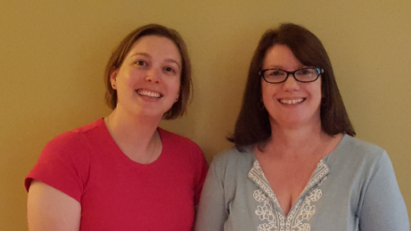
Co-President’s Message
With the doldrums of winter slowly starting to dissipate, it is time to turn our attention to the election of officers and the upcoming AAUW State Convention.
We are still looking for people to serve our branch as an officer or on the committee to find candidates for branch offices, please let us know. Please consider serving our branch in one of these ways. The future of our branch depends on it.
The AAUW State Convention is scheduled for April 27-28 in Faribault. Austin can send up to 5 delegates to the convention. There is no limit on the number of members who can attend state convention, but only 5 are official delegates of our branch. If you would like to serve as a delegate, please let us know by April 10. We will share more information about state convention as it becomes available.
A booklet is produced for each state convention that allows branches to highlight what they have been doing and note favorite books their groups have read. If you would like to submit anything for the Branch Hi-lights and Favorite Books submission for state convention, please email your submission to me by March 5. We can submit up to 3 favorite books. Please be sure to include the book title, author, and a short story summary (2-4 sentences) with your submission. We will organize all of your contributions together into the format they request and submit it for publication.
Please let us know if you have any questions!
~Jill Maxfield and Catherin Haslag, Co-Presidents
Upcoming Programs

We do not have a meeting or program scheduled for March. Our next meeting will be April 10th when the winners from the Women’s History Month competition will present their projects.

Marijo Alexander and Sue Grove, Program Vice Presidents

Women’s History Month Project
For our twelfth year, our branch is sponsoring a Women’s History Project contest, with the cooperation of Dennis Schwab, Honors American History teacher. Among the topics Dennis gave his students were:
- Changes due to Title IX
- Women in the military
- First women to be elected to office in Minnesota and especially Mower County
- Sexual harassment
- Comparing opportunities for women 40 years ago and now

Four branch members will be helping with the judging on February 26: Sue Grove, Marijo Alexander, Peggy Benzkofer, and Katie Ulwelling. Thanks go to these four for being willing to give their time to this project.
This year’s all school Women’s History Month Assembly will be held on March 22 at 9 AM in Knowlton auditorium. The speaker will be Dylane Wallat (Our branch member, Katie Ulwelling’s daughter) who is a deputy sheriff with the St. Paul Ramsey Sheriff’s Department. Many of you will remember Dylane’s outstanding presentation to our branch two years ago.
We think she will connect well with the high school audience as well. The cash awards to the project contest winners will be made at this assembly. You are welcome to attend the assembly. Seating for us is always in the center front. The contest winners will present their projects at our program for the April 10th meeting.

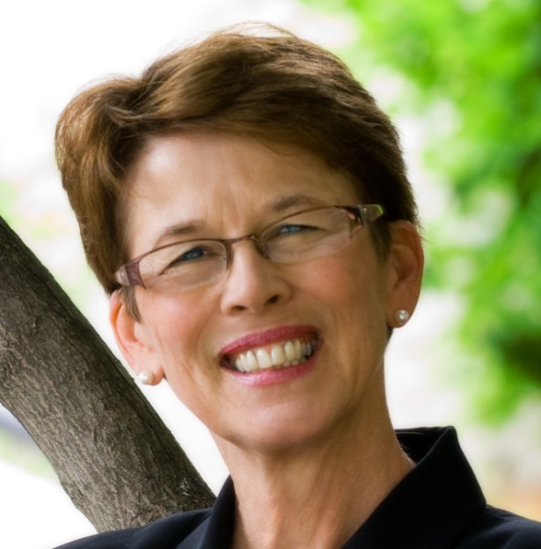
Member Spotlight
Bonnie Rietz has been an Austin Branch AAUW member for more than 30 years. She is probably our best-known member in the community of Austin, witness all her contributions listed below.
She is currently co-chair with Nicole Cizik of our branch’s Scholarship Committee. After reading applications from students, she helps choose our scholarship recipients. Being a member of the Board of Directors of the Riverland Community College Foundation puts her in a wonderful position to do this role for our branch.
Bonnie has always been interested in working with those new to our country and was deeply involved in Amis Austin, a group that helped to settle refugees in Austin during the 1980’s. This was a kind of forerunner to our Welcome Center mentioned below. For these activities, Bonnie was awarded the AAUW Division International Relations award in 1991. Many of us remember with pleasure and pride Bonnie’s terms as an Austin City Council Member and her ten years as Austin’s Mayor. Her grace, plus her amazing ability to get diverse people to work cooperatively, brought many projects for the betterment of Austin to completion, including the library, the flood abatement program and the downtown flower baskets.
Her other contributions to Austin compile quite a list.
- The Austin Area Drug Task Force was started with her help, and she continues to chair this group. They helped to start APAC, which uses positive norms to educate the community about the challenges of alcohol and drug use.
- Apex Austin was another effort she helped to begin. She chairs this group that started the Welcome Center. It now serves all newcomers to our town, but especially those who come from other countries.
- Page Turners was another of her ideas and she continues to co-chair this group with Peggy Benzkofer, encouraging everyone in the city to read and learn about a Minnesota author and their work.
- Austin ArtWorks Festival also has had Bonnie’s influence from its inception. She continues to co-chair this endeavor.

Bonnie is also currently Vice-Chair of the Board of Directors of the Hormel Foundation. Two of the many projects there that that are near and dear to her heart are the scholarships granted to first generation college students through a program called Cycles for Success and the new MacPhail Music Center Building, which is slated to begin in 2019.
As a member of the Board of Trustees of the Blandin Foundation Bonnie also has special areas of interest. The top of her list of issues for that board is dealing with diversity, equity and inclusion, plus the leadership program.
(Member Spotlight Cont.)
Bonnie also loves a good time. Playing pickle ball, jogging, biking, cross-country skiing, traveling, reading and knitting are among her activities for fun.
She and her husband, Tim, have 3 daughters and 7 grandchildren. Her mom, Viola, a resident of Sacred Heart, turned 100 on February 24. Twenty-two family members came to help Viola celebrate her centennial birthday.
Our AAUW Branch, as well as all of Austin, is honored and enriched by Bonnie’s presence!

Save the Date!
Start saving up those used books now! The spring Used Books Sale at the Austin Public Library will be here before we know it! Mark your calendars for May 4-6. A sign up will be available at the next meeting for volunteers to assist with this important fundraiser for our organization!

AAUW Monthly Financial Report
February 1 - March 30, 2018
Period: 2/1/18 - 3/30/18
Opening Balance: |  | $10,244.39
Income:
Luncheon | 347.88
Total Income: | $347.88 | $10,592.27
Disbursements:
Luncheon (speakers meal) | 359.21
Total Disbursements: | $359.21
Closing Balance 3/30/18 |  | $10,233.06

Small Groups
Great Decisions
Great Decisions meets Monday, March 26, at Riverland (room TBD) at 1:00 P.M. to discuss Russia’s foreign policy.

AM Book Group
Morning Book Group meets March 15 at 9:00 A.M. to discuss Lost Horizon by James Hilton. This novel is about a British diplomat who finds peace and purpose in Shangra-La. The leader is Lois McConnell.

PM Book Group
Evening book group will meet on Monday, March 19th at 7 PM at the home of Peggy Benzkofer to discuss the Page Turners’ selection Give a Girl A Knife by Amy Thielen. Please RSVP to Peggy at pjbenzko@gmail.com.

First Friday
Bella Victoria is our choice for this month’s First Friday lunch. We will meet at 11:30 AM this Friday, March 2nd. Please RSVP to Dorothy Krob at sdkrob@live.com by this Thursday noon.

Travel Group
The Travel Club is not going to meet in March. We will meet again in April.

PUBLIC POLICY
Evelyn Guentzel

What an interesting time to live, and AAUW persists in staying alert to the variety of issues that continue to affect women and girls in America. It is a reason to belong this organization “empowering women since 1881”!
This season I have looked at the strategic plan put together: Mission, Value Promise, Vision Statement, and Diversity Statement. This month I have looked at the meaning of the Vision Statement: “AAUW empowers all women and girls to reach their highest potential”. Within the perimeters of our resources we can consider our efforts. Below are some random comments from -- AAUW has outlined in a publication about how women can continue to reach their potentials and fulfill our vision. What opportunities there are!
*Men directed 86 percent of all television episodes in 2013 and 2014 --Nearly two Thirds of bylines, on camera, and producer credits were listed to men while women constituted a third of these contributors.
*Even among the top-grossing G-rated family films, girl characters are outnumbered by boy characters three to one.
*AAUW advocates for all women to achieve economic security and self-sufficiency in the areas of health care, pay equity, paid leave, retirement security and social security.
*AAUW supports vigorous Title IX and other civil rights pertaining to education. --In 2014, about 30 percent of TV news directors were women. This was a low number at the time, but a record high. Anecdotal evidence marks more progress.
*The United States is the only industrialized nation not to have paid leave for mothers with newborns.
*Almost one in five (19 percent) of families headed by single women are “food Insecure”.
*The pay gap involves more than wages. Employers are less likely to offer health insurance, retirement savings plans, and access to paid leave to women workers.
*Women earn only 18 percent of computer science bachelor’s degrees, 19 percent of engineering bachelor’s degrees and 19 percent of physics bachelor’s degrees. Overall, women earn the majority of undergraduate degrees and STEM may result in more changes. AND YET, WE PERSIST. In 2017: --17,000 learned to negotiate salary increases through AAUW workshops.
*3.7 million was awarded to women and community projects.
*270,000 messages were sent to lawmakers by AAUW supporters.

Mission Statement: AAUW advances equity for women and girls through advocacy, education and research.
Vision Statement: AAUW will be a powerful advocate and visible leader in equity and education through research, philanthropy, and measurable change in critical areas impacting the lives of women and girls.

Southern Highlights Editor: Rae Dawn Rao rao_raedawn@yahoo.com Minnesota State Website: http://www.aauwmn.org Association Website: http://www.aauw.org Association e-mail: info@aauw.org

______________________________________________________________

AAUW Southern Highlights
1001 22nd Ave. SW
Austin, MN 55912

