Our Mission: To honor women and girls, empowering them through education, service and leadership development.

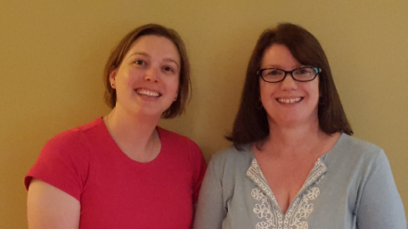
Co-President’s Message
Welcome to February! Dreary January is over and sunset is finally after 5pm. Spring will be here in no-time. Please note: “no-time” falls somewhere in late April to early June.
This month, we are having small potlucks in members’ homes. This gives us a wonderful chance to get to know other AAUW members we may not have otherwise had the chance to really talk with. At last year’s February potluck, we greatly enjoyed getting to really know the incredible women that belong to our branch. Please get involved in this event by hosting or bringing a dish and being a part of the conversation at another member’s home.
We are also looking for 2 more members to serve on the nominating committee for officer elections in April. This 3-person committee would be responsible for finding nominees for the offices up for election in April. If you are interested in serving, please contact us.
~Jill Maxfield and Catherin Haslag, Co-Presidents

February 13th Program

Our old tradition of February potlucks in individual’s homes was so popular that we are doing it again! These are a great way to get to know other members in a smaller venue. We have started a list of those who would be willing to host and those who would like to co-host but could use a few more. A host provides the house and beverages. The co-host helps call people assigned to her house and works out what people would like to bring for food. (This will ensure that not everyone brings dessert, for example.) We will be calling people to make arrangements, but if you would like to be a host or co-host, please email Sue: sue.grove@riverland.edu. Also, if you know that you are able (or not able) to attend, it would help to know before we start calling. So, you could email Sue as well. The gatherings will occur on Tuesday, February 13th usually starting about 5:30.

Marijo Alexander and Sue Grove, Program Vice Presidents

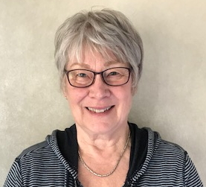
Member Spotlight
Sonia joined AAUW in Austin in the 1970’s and was very active early on, including two years as president. For many years, she has been a key person in finding and making the requests for the homes for the house tour. She is always on the lookout for an interesting house to feature
As with many members, she values the people she has met through AAUW. “I’ve always enjoyed the other members and have formed many wonderful friendships in AAUW.”
Sonia earned a BA in music from Eastern Washington University. After having her family, she went on to complete a Masters of Fine Arts Degree at the University of Minnesota.
Sonia’s career has been in music, teaching piano and voice, and directing choirs including Riverland, St, Olaf and MacPhail Center for Music and the Austin Symphony Orchestra. For the symphony chorus programs she does all the recruiting as well as rehearsing the chorus. She has worked with the symphony to present “The Messiah” several times, as well as other works. She also is an accomplished watercolor artist, an avid hiker, and she loves to travel. Her latest trip was to Sydney, Australia, early in January. We’ll be anxious to hear all about it!
Small Groups
Great Decisions
On February 26th at 1PM, we will begin a new series of thoughtful discussions. The first topic is The Waning of Pax Americana? Peggy will have the new books for everyone. This is a reschedule of our January meeting, which was canceled due to weather. The location is to be determined.

AM Book Group
AM book group will meet next on February 15th at 9 AM at Perkins. Ellen Stark will lead the discussion of the Pageturners’ selection: Give a Girl a Knife by Amy Thielen.

PM Book Group
Evening book group will meet on Monday, February 19th at 7 PM at the home of Kathy Parada to discuss Major Pettigrew’s Last Stand by Helen Simonson. Please RSVP to Kathy at k.parada@hotmail.com.

First Friday
First Friday Luncheon will be at Steve's Pizza on Friday, Feb. 2nd at 11:30. RSVP to Dorothy Krob at sdkrob@live.com if you would like to attend.

Travel Group
The Travel Club did not meet in January because of the bad weather. Therefore, the February Meeting is what we had planned for January.
We will be meeting at the home of Ann Odegaard on Thursday, February 8th, at 1:30 PM. The topic is, “Traveling with Viking River and Ocean Cruises.” We hope you can join us. Please let me know via email or phone (433-7897) by Wednesday, February 7th. Thank you.
DedaRae Graber

Mission Statement: AAUW advances equity for women and girls through advocacy, education and research.
Vision Statement: AAUW will be a powerful advocate and visible leader in equity and education through research, philanthropy, and measurable change in critical areas impacting the lives of women and girls.

Southern Highlights Editor: Rae Dawn Rao rao_raedawn@yahoo.com Minnesota State Website: http://www.aauwmn.org Association Website: http://www.aauw.org Association e-mail: info@aauw.org

______________________________________________________________

AAUW Southern Highlights
1001 22nd Ave. SW
Austin, MN 55912

