HOUSE 1

Sonia Larson

2206 5th Avenue **NW**

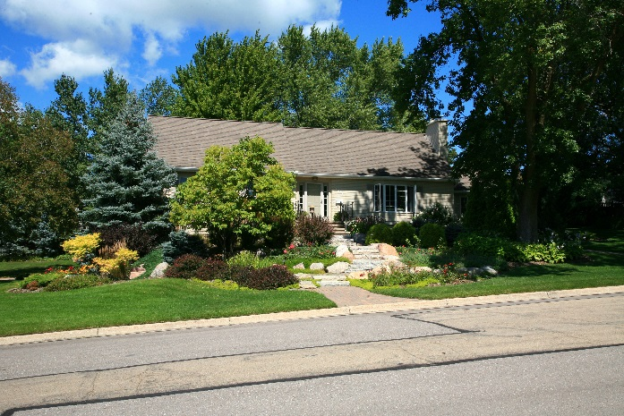

* This cozy home was built in 1971.
* The home features beautiful landscaping and mature trees.
* The kitchen and main floor bathrooms were remodeled in 2007.
* The traditional décor features art from Minnesota artists and travel mementos.
* The home’s furnishings include everything from new to hand-me-down to antique.
* The main floor sun room has a view of the large deck and beautiful water feature.

HOUSE 2

Scott Reinartz and Brent Fankhauser

711 4th Street SW

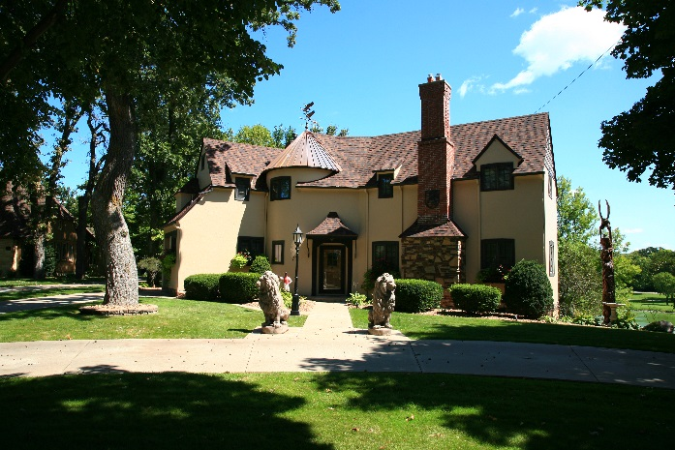

* This home was built in 1928.
* The current owners purchased the home in 2013.
* This classic home atop Skinner’s Hill overlooks Band Shell Park.
* The owners updated the entire house leaving it as original as possible with a modern feel.
* The home features new fireplaces and a custom made light fixture in the living room.
* This is a “forever home”, perfect for family gatherings.

HOUSE 3

Jeannie and Greg Bird

2304 8th Avenue SW

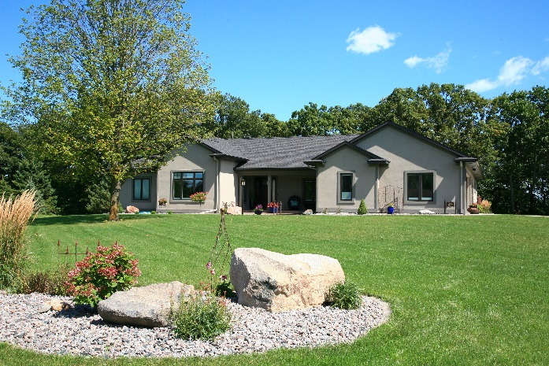

* This home was built in 2015 by Hanson Construction.
* This home is located on a beautiful lot overlooking Turtle Creek.
* The home is designed with an open concept living area.
* The kitchen has custom cabinetry and a unique large island.
* Floor to ceiling windows frame the gorgeous view.
* The scenic private patio is located at the back of the home.
* The main floor game room features custom made furniture.

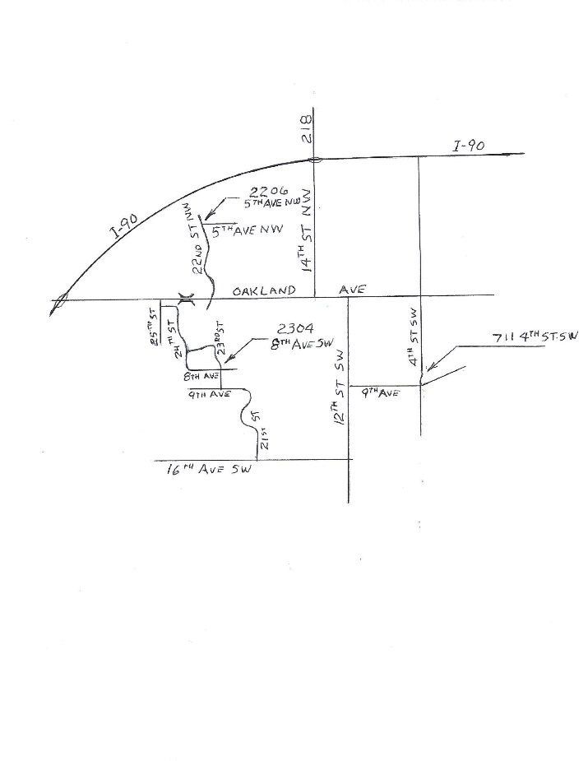

**Guidelines**

**No Photos**

**Remove shoes-bring footlets**

**No bare feet, please**

**No gum**

**Do not open closed doors**

**All homes are smoke free**

**No children under age 10**

The AAUW Educational Foundation advances equity for women and girls through advocacy, education and research.

AAUW Membership is open to anyone earning a two year degree or certificate or a four year degree or certificate from an accredited University or College.

For membership information, call:

Catherine Lemons at (612) 708-0183

**Map of Homes**



**2017**

**Scholarship**

**Tour of Homes**

**October 8th**

**1:00 – 5:00 p.m.**

Sponsored by

American Association of

University Women,

Austin Branch

AAUW Home Tour

proceeds help fund our

Scholarship Commitment

**$15.00**

**This is your ticket**

**1 2 3**

