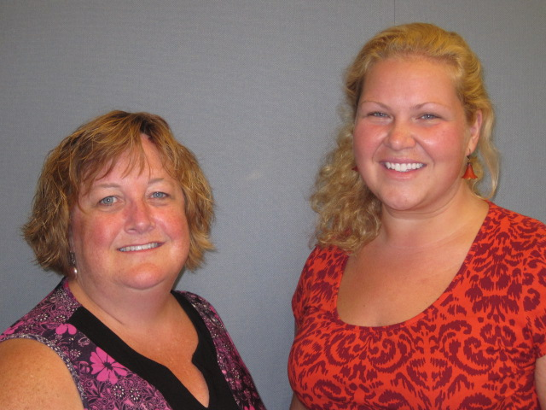
Our Mission: To honor women and girls, empowering them through education, service and leadership development.

Co-President’s Message
Happy New Year! January is the time to enter a new year and make those resolutions to improve our AAUW community. This year I hope many will think about inviting a new member to a meeting or group event. We have a very active and wide variety of interest groups. Also we encourage anyone with a new idea to form a new group. When speaking to members at meetings I find many of our existing members say they joined us for a particular interest group. Some of us joined because of our concerns for specific issues: women’s rights, children’s literacy, domestic violence, international women’s issues, girl’s self image, and so on. Informal recruiting and word of mouth bring people in. Almost all of us have joined because a friend. We offer opportunities for leadership roles. With our wide variety of groups, events, initiatives and administrative duties, there is ample opportunity for leadership growth. Membership can enhance personal and professional skills. We are nurturing of our members and genuinely care about each other. At events we try to be warm and welcoming to newcomers. People remain because they have bonded with each other and enjoy each other’s company. Let’s make 2015 our best year yet for the AAUW.
~Courtney Wyant, Co-President
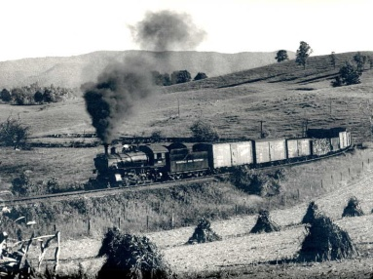
Upcoming Programs
David Wolff is the Gifted and Talented Coordinator for the Austin Public Schools and has been the lead on the STEAM Expo (science fair) for the district. David will be speaking to us about the Gifted and Talented program and the STEAM expo and how these programs benefit our students. We will be meeting on Tuesday, February 10th at the Austin Public Library in the large meeting room. Social time will begin at 6:30 PM with the program beginning at 7 PM.
Small Groups
Arts & Entertainment
We will meet on Sunday, February 8th at 4:00 PM at Our Savior’s Lutheran Church for a viewing of the silent film Phantom of the Opera, accompanied by Rochester organist Andrew Galuska. Please contact Carla Anderson-Diekmann or Courtney Wyant if you plan to join. See elsewhere in the newsletter for further details!
AM Book Group
I Know Why the Caged Bird Sings by Maya Angelo is the book selection for our morning book group. Ellen Stark will lead the discussion and also host the group at her home (1809 25th St. SW) on Thursday, February 19th at 9 AM. We will read the Pageturner's selection, Vacationland by Sarah Stonich, when we meet in March.
PM Book Group
The evening book group will be discussing Ethan Frome by Edith Wharton on Tuesday, February 17th. We will meet at the home of Peggy Benzkoffer at 7 PM. Please RSVP to Peggy at pjbenzko@gmail.com. Our March selection is also the Pageturner’s selection Vacationland by Sara Stonich.

First Friday
First Friday Luncheon is February 6th at Steve's Pizza at 11:30 AM. Contact Dorothy Krob at sdkrob@charter.net to make a reservation.

Knitting & Handiwork We continue to meet most Saturdays at the Coffee House on Main at 9:30 AM. You need not be able to knit/ do handiwork to attend!

Great Decisions
Great Decisions discussions have begun at Riverland. The first discussion on January 26th (fourth Monday) was about "Russia and the Near Abroad". The next discussion will be February 23, and will be about "Privacy in the Digital Age". Watch for more newsletter
information.
Travel Group
The Travel Club will meet at Liz Richardson’s ) on Thursday, February 12th at 2:00 P.M. Liz will be sharing information from her recent trip to Hawaii. Anyone else is invited to bring and share an experience that they have had from traveling there. This might include a photo or other souvenir related to a trip to Hawaii. If you haven’t traveled to Hawaii, you are invited to join us and learn some new and different information. I hope you can join us and I look forward to seeing you there. Please RSVP to drgraber@charter.net.
Science Fair Mentoring Update
We are looking for volunteers to help the 3rd and 4th graders at Neveln and Sumner prepare their presentations for the science fair. No science knowledge is necessary, just a desire to help our local youth. These students need help preparing their trifold boards and practice talking to others about their projects. Your help is greatly needed and appreciated. We work with these students on Tuesdays, Wednesdays, and Thursdays from 2:30 until 4pm. If you are interested in helping, please contact Catherine Haslag at cshaslag@gmail.com for more information.

AAUW Monthly Financial Report
January 1 - January 31, 2015
Period: 1/1/15 - 1/31/15
Opening Balance: |  | $9,346.91
Income:
Dues Received | 35.00
Total Income: | $ 35.00 | $9,381.91
Disbursements:
Dues Paid | 70.00
Total Disbursements: | $70.00
Closing Balance 1/31/15 |  | $9,311.91

Arts & Entertainment is Back!
The Arts & Entertainment group has risen from the ashes! The goal is to have a monthly activity that AAUW members can attend as a group. If you have questions or ideas for activities, please contact Carla Anderson-Diekmann or Courtney Wyant.

February: On Sunday, February 8 at 4:00 p.m., Our Savior’s Lutheran Church will host a viewing of the silent film Phantom of the Opera, accompanied by Rochester organist Andrew Galuska. Andrew is Director of Music and Organist at Christ United Methodist Church in Rochester and has won prizes for organ performance and improvisation. The performance is presented by the Our Savior’s Recital Series and the Southeast Chapter of the American Guild of Organists. There will be a free-will offering. Address of Our Savior's Lutheran Church: 1600 West Oakland Avenue.

Looking Ahead:
- March: Wine and Canvas Night! (TBD)
- April: Riverland's performance of Legally Blonde

PUBLIC POLICY
Evelyn Guentzel
Happy New Year! Each new year brings new concerns and initiatives in the worlds of AAUW and our state and federal governments. AAUW is our "watchdog" when it comes to issues that concern women and girls. Below are some brief notes about activities and information worth mentioning as the year begins.
IN MINNESOTA: Women ages 25 to 54 are employed at higher rates than women nationally, according to NY Times; Gender inequities continue...checkout the "Status of Women and Girls in Minnesota" according to the MN Humphrey School's Center on Women and Public Policy; Minnesota has earned a grade of B- from the Population Institute on Reproductive Health and Rights ("Not Making the Grade: A 50 State Report Card"). We're better the most states receiving no more
than a "C".
ECONOMY needs vigilance: Republicans focus on tax cuts for Minnesota businesses; Democrats are pushing for free preschool and community colleges; Congress still has not closed the gender pay gap six years after the Lilly Ledbetter Fair Pay Act was passed.

VOTERS CARE: The unemployment rate continues to increase. 3 million workers in 20 states are earning higher minimum wages and in 29 states workers are receiving more than the federal minimum of $7.25 an hour. AAUW advocated for the provision in the National Defense Authorization Act which gives women owned businesses more access to federal contracts and more protection against abuses.
WOMEN'S ISSUES ARE VARIED: The Economist did not acknowledge two influential female economists led by women in 2014--Central Bank of the United States and the International Monetary Fund; AAUW went "back to school" to watch and to celebrate the record number of 104 women being sworn in to Congress--still only 19%. They are making strides, gaining respect and equity; Phyllis Schlafly, a three time-college graduate, in her online column advocates the following--impose gender quotas in college admissions, stop offering student loans and reinstate men's sports teams she says were eliminated by Title IX. All this because more women attending college has increased sexual assaults; AAUW's own Lisa M. Maatz is respected by media outlets. In a recent Huffington Post interview she emphasized the importance of Title IX to hold schools accountable.
EDUCATION ISSUES will be on the front burner, both at the state and federal levels and will have a major impact on what occurs at the local level. Public Policy is watching.

AAUW Board Meeting Minutes
January 13, 2015

AAUW Board met at Riverland Community College. Present were Marijo Alexander, Carla Anderson-Diekmann, DedaRae Graber, Sue Grove, Catherine Haslag, Dorothy Krob, Jill Maxfield, Ruth Monson and Courtney Wyant. Secretary’s report was approved.
Nicole submitted a Treasurer’s report for review. Our balance as of 12/31/14 was $9,346.91.
Thank-you notes were received from scholarship winners Ashley Haugen and Sherri King.
Catherine gave a Program update. The banquet menu is being finalized for the May 12 spring banquet. Next month’s speaker will be David Wolf, who will talk about the Gifted and Talented program.
Carla reported on membership. We now have 69 members in our branch. The February and March newsletters will include a new member invitation.
Courtney spoke with Marie Lechelt about the Branch website. They will work together on updating the website regularly. The Board discussed changing the Branch Facebook page to allow more than one person (currently Sue Grove) control.
Sue and Marijo are working on plans for the State Convention which will take place in Austin on April 10-11 at the Hormel Home. Registration will be done online ($85 registration fee). Volunteers will be needed to work at the registration table, to direct people and for other tasks.
Catherine reported on the Science Fair mentoring project. The mentoring has been going extremely well, but they are look for more volunteers to help with shopping and to help students put together their presentation boards. The Board thanked Catherine for her extraordinary work on this project.
Small groups continue to meet. Courtney and Carla will work together to plan some Arts and Entertainment outings (possibly a trip to see “Phantom of the Opera” at Our Savior’s Lutheran Church on February 8, an art class at the Arts Center, and a trip to see “Legally Blonde” at the college in April). First Friday Lunch will meet at Steve’s Pizza on Friday, February 6 at 11:30 a.m. and Travel Group will meet on February 12 at 2 p.m. at Liz Richardson’s home. Book groups, Great Decisions and Knitting/Handiwork group also continue to meet.
Carla noted some additional events that members can attend: an invitation from the Owatonna AAUW to attend their meeting on Friday, March 20, and an invitation from the Redwing AAUW to view a film about Anita Hill on February 11 at 6:30 p.m. Also, one more member interested in attending the national AAUW Convention in San Diego in June can receive funds from our branch. Anyone interested should see Carla as soon as possible.
The February meeting will be at 6:30 p.m. on Tuesday, February 10 at a location to be announced. The Board will meet at 5:45 p.m. and membership will gather at 6:30 p.m. for social time, with the program beginning at 7:00 p.m.
Respectfully submitted,
Ruth Monson, Secretary
Mission Statement: AAUW advances equity for women and girls through advocacy, education and research.
Vision Statement: AAUW will be a powerful advocate and visible leader in equity and education through research, philanthropy, and measurable change in critical areas impacting the lives of women and girls.

Southern Highlights Editor: Rae Dawn Rao rao_raedawn@yahoo.com Minnesota State Website: http://www.aauwmn.org Association Website: http://www.aauw.org Association e-mail: info@aauw.org

______________________________________________________________

AAUW Southern Highlights
1001 22nd Ave. SW
Austin, MN 55912

