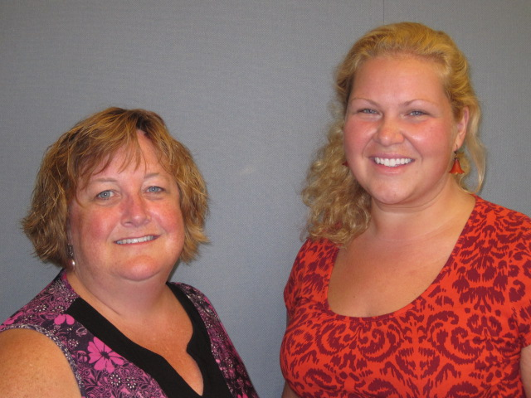
Our Mission: To honor women and girls, empowering them through education, service and leadership development.

Co-President’s Message
We have just concluded a holiday when all of us took a moment to give thanks. I am thankful for this organization, Austin AAUW, where I have met so many outstanding women. As we go from Thanksgiving to anticipating the New Year, I begin to ask myself what I can do differently and how I can make a positive impact on the community in which I live. One change I hope to make is improving our Facebook page to reflect what great things we do. I am hoping all will participate by passing along photos and stories for me to post. I am conscious that if I want to remain relevant in today’s fast paced, technological society, I must make changes in how I think about issues and perform activities. Please also remember to invite one new person to our holiday party, as Austin AAUW needs a new way of attracting a diverse group of women who are willing to work for the overall good of the community. We need women who do not simply want to develop themselves personally, but want to give back to the community and work for the development of the organization. We cannot begin to visualize how great this organization can be when we really commit ourselves.
~Courtney Wyant, Co-President
Upcoming Programs
For our December program, we will be meeting at the Coffee House on Main on December 9th at 6:30 PM for our Christmas social. Christmas treats will be shared and we encourage you to buy beverages from the Coffee House to help support Kyle as he graciously offered this space for our meeting. Please consider inviting a friend to our December holiday party. A convenient invitation is attached! Just print and give! January's program is entitled "Women and Non-Traditional Roles." Dylane Ulwelling will be speaking about her experiences working in a women's correctional facility and other areas of law enforcement. Social time will start at 6:30p and the program will begin at 7pm. The location of the January program will be announced later this month.
Small Groups
AM Book Group Morning book group is reading "Ordinary Grace" by William Kent Kruger. We will meet Thursday, December 18, at 9:00 a.m. at Liz Richardson's, 2207 - 7 Ave. NW. The January read is "The Invention of Wings" by Sue Monk Kidd with Jan Gilbertson leading discussion.
PM Book Group The evening book group will discuss The Book Thief by Markus Zusak on Tuesday, December 16th at 7 PM at the home of Sue Grove. Please RSVP to Sue at sgrove@riverland.edu. Our January selection is Out Stealing Horses by Petterson. We will meet on January 20th at the home of Judy Pesonen. Please RSVP to Judy at rpesonen@smig.net.
First Friday First Friday for Dec. 5th will be at the Brick House at 11:30. Please RSVP to Dorothy Krob at sdkrob@live.com or by phone by Wednesday, December 3rd if you wish to join!

Knitting & Handiwork We continue to meet most Saturdays at the Coffee House on Main at 9:30 AM. You need not be able to knit/ do handiwork to attend!

Great Decisions
Great Decisions will resume in February as we embark on these exciting new topics for 2015: Russia and the Near Abroad; Privacy in the Digital Age; Sectarianism in the Middle East; India Changes Course; U.S. Policy toward Africa; Syria’sRefugee Crisis; Human Trafficking in the 21st Century; and Brazil’s Metamorphosis. Prepare to be challenged!
Travel Group The Travel Club will be meeting on Thursday, December 11th at 2:00 P.M. at the home of DedaRae Graber ( 303- 22nd Street NW) with Ann Odegaard providing a unique Christmas Treat. We will be sharing “A Special Christmas Experience/Event.” We hope that you can join us for this quiet, relaxing time together before Christmas.
Please RSVP to drgraber@charter.net by Tuesday, December 9th.
Science Fair Mentoring Update
The Science Fair Mentoring Project is off to a great start. We have consistently had 70+ students participate at Sumner during the first three mentoring sessions. Many students have already selected their projects and will be submitting their shopping lists soon.
We are expecting 150-160 students to participate at Neveln and will require many, many more mentors, Site Hosts, and shoppers to help meet the needs of this number of students.
If you are interested in helping as a mentor, Site Host, or shopper for this project, please email Catherine Haslag at sciencefairmentormn@gmail.com.
AAUW Gives Thanks!
At this time of Thanksgiving, AAUW’s national public policy team wanted to share its top 6 achievements for which it is thankful for. Please click here for full details: http://salsa4.salsalabs.com/o/50796/p/salsa/web/thank_you_page/public/thankYou.sjs?thank_you_page_KEY=176&killorg=True

1. President Barack Obama Advances AAUW Priorities through Executive Orders - AAUW is thankful that the White House’s “year of action” advanced several AAUW priorities, including two equal pay executive orders for which AAUW members and supporters had been pushing for years.

2. States and Cities Make Progress on Women’s Economic Security – AAUW is thankful that states and cities across the country have made progress on minimum wage, equal pay, paid sick days, and other women’s economic security issues in spite of gridlock in Washington, D.C.

3. White House, Campuses, and Advocates Collaborate to End Campus Sexual Violence - AAUW is thankful for the national conversation on ending campus sexual violence. AAUW and our members have both fueled and led this national teach-in.

4. AAUW Members Enthusiastically Lead 2014 It’s My Vote Campaign – AAUW is thankful for the AAUW members, branches, and state affiliates that invested their hearts and talents into the 2014 It’s My Vote: I Will Be Heard campaign to educate and turn out women voters, especially young women. The numbers are still pouring in, but so far we know that AAUW members hosted more than 230 voter registration and voter education events in at least 36 states!

5. Supreme Court Justice Ruth Bader Ginsburg Is As “Notorious” As Ever – AAUW is thankful for Supreme Court Justice Ruth Bader Ginsburg’s 21 years of service on the Supreme Court and her fierce defense of gender equality, civil rights, and reproductive rights. Ginsburg’s strong dissents in the Hobby Lobby case and a recent order allowing a voter identification law to proceed in Texas remind us of how lucky we are to have such a smart, savvy jurist on our nation’s highest court. She is the “Notorious R.B.G.,” indeed!

6. What a Year for Breaking through the Glass Ceiling We are thankful for all the firsts that happened for women in 2014, including Janet Yellen becoming the first female chair of the Federal Reserve Board; Malala Yousafzai becoming the youngest person to receive the Nobel Peace Prize; Becky Hammon becoming the first female regular season assistant coach in the NBA Adm. Michelle Howard becoming the Navy’s first female four-star officer; Maryam Mirzakhani becoming the first woman to win the Fields Medal; and Rep.-elect Alma Adams (D-NC) becoming the 100th woman member of the 113th Congress — a new record for women’s representation in government!
AAUW Board Meeting
November 11, 2014

AAUW Board met at Christ Episcopal Church. Secretary’s report was approved. Nicole sent in a Treasurer’s report for review. Catherine Haslag gave a brief program update.

The Board discussed ways to bring in new members to the Branch. Catherine Lemons will design an invitation that will be included in the December newsletter. Members can use the invitations to invite new women to the December social event or to the January general meeting.

A discussion took place regarding the branch website and Facebook page. Courtney will contact Marie and ask if Courtney could work on updating events on the calendar. Courtney will also add information, pictures, etc. on the Facebook page.

Marijo and Sue continue to work on plans for the State Convention in April. The Board will look at this more closely after the first of the year.

Catherine Haslag gave an update on the Science Fair Mentoring Project. Because of the large number of students interested in the project, many more mentors are needed. There are also other jobs for people who wish to be involved – serving as site hosts, shopping for supplies, etc.

Because there is no Women’s History Month speaker this year, there are extra funds in the Branch’s budget that are available for use by the Mentoring Project. Carla noted that the National AAUW has a special project grant that can be applied for that may help fund next year’s Mentoring Project.

Carla noted that our Branch is celebrating its 80th anniversary. We have received a certificate from the National AAUW.

A short discussion took place regarding what constitutes a quorum at our Board meetings. It appears that the voting members are the elected members. If two women hold one position, they are allowed one vote.

There will not be a Board meeting in December. The next Board meeting will be held in January. Meeting adjourned.

Respectfully submitted,
Ruth Monson, Secretary

AAUW Monthly Financial Report
September 16 - November 15, 2014
Period: 9/16/14-11/15/14
Opening Balance: |  | $9,495.33
Income:
Dues Received
Fundraiser (Hy-Vee) | 136.58
Banquet
Book Sale
Total Income: | $136.58 | $9,631.91
Disbursements:
Dues Paid
Building rental (ArtWorks) | 100.00
Banquet
Annual branch insurance fee | 175.00
Total Disbursements: | $275.00
Closing Balance 11/15/14 |  | $9,356.91

OH WHAT FUN!

PLEASE JOIN US

for the
AAUW Holiday Social

COFFEE HOUSE ON MAIN
December 9, 2014
6:30 pm

Mission Statement: AAUW advances equity for women and girls through advocacy, education and research.
Vision Statement: AAUW will be a powerful advocate and visible leader in equity and education through research, philanthropy, and measurable change in critical areas impacting the lives of women and girls.

Southern Highlights Editor: Rae Dawn Rao rao_raedawn@yahoo.com Minnesota State Website: http://www.aauwmn.org Association Website: http://www.aauw.org Association e-mail: info@aauw.org

______________________________________________________________

AAUW Southern Highlights
1001 22nd Ave. SW
Austin, MN 55912

