Our Mission: To honor women and girls, empowering them through education, service and leadership development.
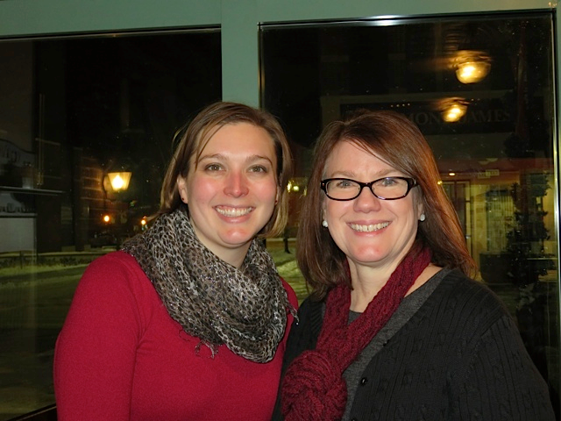
Co-President’s Message
If you haven’t had the chance to read Eleanor Roosevelt’s book “You Learn by Living,” please do. It’s a great read, especially chapter 10 entitled “How Everyone Can Take Part in Politics.” Even back when this book was published in 1960, it was apparent the nation faced some of the same problems it faces now: lack of deep engagement by portions of the voting populace.
In this chapter, she outlines what it means to be an informed citizen who is engaged in our democracy. She discusses Thomas Jefferson’s statement that “Democracy…is the most difficult type of government simply because it requires this kind of [individual] responsibility.” She goes on to state that, “because it is the most highly developed type of government, democracy requires the most highly developed citizens.”
If you are like us, you are probably trying to find a way to balance being informed with keeping your sanity, but please take time to be informed and involved in the matters being discussed and legislated in our government (local, state, and national). Below are a few ways:
- Signup to receive updates through AAUW. Go to http://www.aauw.org/resources/by-type/newsletters/ to see all the options available.
- Keep informed on the bills introduced. Nationally, you can track bills introduced into the house and senate at https://www.govtrack.us/congress/bills/#get-alerts. You can track bills introduced into the Minnesota legislature at https://www.leg.state.mn.us/leg/legis. You can also ask for notifications on bills you are interested in following on both of these sites.
- Call your congressmen. You can text your zip code to 520-200-2223 to get a list of the phone numbers for your state and local representatives. Remember, they work for us and need to know what their constituency thinks so they can properly represent us when voting. Calls make the most impact. Don’t email them, call and call often.
Hope you all have a wonderful March!
~Jill Maxfield and Catherin Haslag, Co-Presidents
March Program
The March meeting will be held beginning at 6:30pm on March 14th at the Austin Public Library – please note this is a change! We are starting earlier because the library now closes at 8:00pm.
Our speaker is Lia Culbert, who is with Mission 21, an organization that works with Human Trafficking in southern Minnesota.
Please plan to attend to learn about this incredibly important topic. Southern Minnesota is impacted because of its location on major interstate highways. It is critical that we all become aware of what is happening.
~Marijo Alexander and Sue Grove, Program Vice Presidents

Small Groups
Great Decisions
Great Decisions will be meeting Monday, February 27th at 1 :00pm in Room C107 at Riverland. We will be starting the 2017 programs.
AM Book Group
Morning Book Group will be reading "All the Light We Cannot See" by Anthony Doerer for our March meeting. Janet Gilbertson will lead the discussion when we meet at Perkins on March 16, 9:00 a.m.

PM Book Group
The evening book group will meet next on March 21st at the home of Judy Peseonen, 1403 16th Ave SW, at 7 PM. The book is LaRose by Louise Erdrich. Please RSVP to Judy at rpesonen@smig.net. Our April selection is Lab Girl by Hope Jahran.

First Friday
First Friday luncheon will be at Steve's Pizza on Friday, March 3rd at 11:30. Please contact Dorothy Krob at sdkrob@live.com if you plan to attend. All are welcomed.

Travel Group
The Travel Club will NOT be meeting in the month of March as many of our members will be gone. We hope you can join us in April.

SPOTLIGHT ON MEMBERS
Dorothy Krob
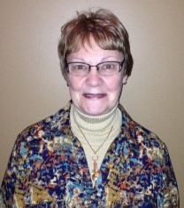

Dorothy Krob is a retired teacher. She taught for 27 years, 20 in the Austin Public Schools. She has a deep interest in the educational excellence in our district. She is active at Our Saviors Church on the mission team. She belongs to two book groups and volunteers at the Art Center, Banfield School, and Sweet Reads Bookstore. Dorothy’s love of photography turned into her business, Turtle Creek Cards. She is a native of Austin, with three generations of AHS graduates in her family. She and her husband, Steve, have three married daughters and five grandchildren.

“When I returned to Austin in 1975, I soon met Sue Grove, who was new to town. We both joined AAUW that year. My life has been greatly enriched by the friendships generated by my participation in AAUW as well as by the wonderful programs. My first position on the board was the publicity chair. I was the historian in the 1990’s. DedaRae Graber now holds that position and I assist her. I have done the publicity for our annual spring book sale six times as well as being house chair for our tour of homes. For several years I have organized the First Friday Luncheons. Evening book group and the travel club are my favorite small groups. I firmly believe in AAUW’s mission and feel privileged to belong to such a group of enlightened women of action.

JOIN US FOR THE WOMEN’S HISTORY ASSEMBLY!
MARCH 10 at 8:45 AM KNOWLTON AUDITORIUM, AHS
Our speaker will be Liza Maatz, AAUW Vice President for Government Relations. Seats for AAUW members will be in the front of the center section.
As AAUW’s top policy adviser, Maatz works to advance AAUW’s priority issues on Capitol Hill, in the White House, and in coalition with other organizations. She is a sought-after speaker across the nation and in our nation’s capital, and has a large and devoted following on Twitter. Lisa also provides leadership to several coalitions working to advance opportunities for women and girls, including the National Coalition for Women and Girls in Education and the Paycheck Fairness Act Coalition.
We brought Liza to AHS 4 years ago and she was extremely well received.

AAUW Monthly Financial Report
February 1 - February 21, 2017
Period: 2/1/17 - 2/21/17
Opening Balance: |  | $9,153.24
Income:
Total Income: | $0.00 | $9,153.24
Disbursements:
Total Disbursements: | $0.00
Closing Balance 2/21/17 |  | $9,153.24

Mission Statement: AAUW advances equity for women and girls through advocacy, education and research.
Vision Statement: AAUW will be a powerful advocate and visible leader in equity and education through research, philanthropy, and measurable change in critical areas impacting the lives of women and girls.

Southern Highlights Editor: Rae Dawn Rao rao_raedawn@yahoo.com Minnesota State Website: http://www.aauwmn.org Association Website: http://www.aauw.org Association e-mail: info@aauw.org

______________________________________________________________

AAUW Southern Highlights
1001 22nd Ave. SW
Austin, MN 55912

