Our Mission: To honor women and girls, empowering them through education, service and leadership development.

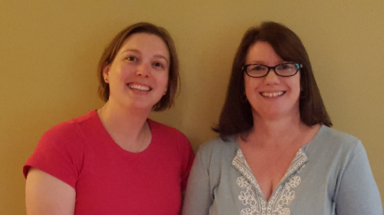
Co-President’s Message
The following was shared by Jennifer Lawhead on Facebook. The origin of this story is unknown, but with everything going on in our nation today, it sets the tone for this coming year.
It’s about female elephants. You know, as all good stories begin. See, in the wild, when a mama elephant is giving birth, all the other female elephant in the herd back around her in formation. They close ranks so that the delivering mama cannot even be seen in the middle. They stomp an kick up dirt and soil to throw attackers off the scent and basically act like a pack of badasses.
They surround the mama and incoming baby in protection, sending a clear signal to the predators that if they want to attack their friend while she is vulnerable, they’ll have to get through 40 tons of female aggression first.
When the baby elephant is delivered, the sister elephants do two things: they kick sand or dirt over the newborn to protect its fragile skin from the sun, and then they all start trumpeting, a female celebration of new life, of sisterhood, of something beautiful being born in a harsh, wild world despite enemies and attackers and predators and odds.
Scientists tell us this: They normally take this formation in only two cases – under attack by predators like lions, or during the birth of a new elephant.
This is what we do, girls. When our sisters are vulnerable, when they are giving birth to new life, new ideas, new ministries, new spaces, when they are under attack, when they need their people to surround them wo they can create, deliver, heal, recover…we get in formation. We close ranks and literally have each others’ backs. You want to mess with our sis? Come through us first. Good luck.
And when delivery comes, when new life makes its entrance, when healing finally begins, when the night has passed and our sister is ready to rise back up, we sound our trumpets because we saw it through together. WE celebrate! We cheer! WE raise our glasses and give thanks.
I have this picture saved in three different places and in a frame. (I also have an elephant ring given to me and my girlfriends from Tara Porter Livesay – it tells me: never alone.) Maybe you need this too. If you’re are closing ranks around vulnerable sister, or if your girls have you surrounded while you are tender, this is how we do it.
There is no community like a community of women.
Our AAUW branch is a community of women. We will keep returning to the spirit of this story throughout this year with our activities and outreach efforts in the community. Carry it with you into our daily lives. This year, let us circle around and stomp and trumpet for each other and the women around us. Kick-up as much dirt as necessary to let observers know we mean business. Hopefully, the sound and spirit will reverberate throughout our community, our state and our world, lifting up and inspiring all women in the process.
~Jill Maxfield and Catherine Haslag, Co-Presidents

September Program
September 12th Meeting
Time: 5:00 Wine Tasting; 6:00 Potluck
Location: Christ Episcopal Church
Where did summer go?! We are gearing up for another busy AAUW year of programs that address current issues that impact women and girls in Austin as well as universally.
The first event will feature a welcome wine and cheese membership event, which provides a perfect opportunity for all of us to invite prospective members. Please invite prospective members to attend and learn more about AAUW. This could be your neighbor, the college student down the street, or even your 4th cousin. Prospective members need to have earned at least an associate degree or be currently enrolled in college. Come for the wine and cheese, stay for the potluck afterwards! Our annual potluck supper will follow the wine and cheese gathering at 6:00 pm. Looking forward to seeing you and meeting new prospective members on September 12!
Because last January’s Saturday luncheon and February’s potlucks in members’ homes were so popular, we are going to bring them back again this year.
~Marijo Alexander and Sue Grove, Program Vice Presidents

Small Groups
Great Decisions
We will next meet on September 25th at Riverland (room TBA) at 1:00 PM. Topic is LATIN AMERICA: POLITICAL PENDULUM. (Can these left-leaning countries deliver on commitments to new social policies, inequalities, and democracy. We see stability and turmoil in this region.) Anyone who is interested should email Evelyn at erguentz@charter.net.

AM Book Group
The Morning Book Group will next meet on September 21st at Perkins at 9:00 AM. Book Title: BEHOLD THE DREAMERS, BY Imbolo Mbue. (This is a debut novel by a young Cameroon woman that illuminates the immigrant experience in America.)

PM Book Group
The evening book group will next meet on September 18th at the home of Carolyn Bogott. We will discuss Ocean At The End of the Lane by Neil Gaiman. Please RSVP to Carolyn at csbogott@charter.net. Our October selection is Great Small Things by Jodi Picoult.
First Friday
First Friday will be Sept. 1st, 11:30 at the Old Mill. Contact Dorothy Krob at sdkrob@charter.net to RSVP.

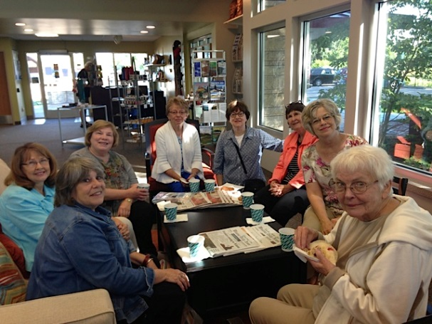
Travel Group
Members of the Travel Club spent Wednesday, August 23rd in Winona. We visited many unique and interesting places in this lovely Minnesota city. It was a perfect day in every way.
The Travel Club will be meeting on Thursday, September 21st, at 1:30 at Kathy Kester’s home. We will be sharing our “Winona Adventure” and planning the events for the next few months.
Adsfafjdafskfl;
AAUW Home Tour  TICKETS ARE $15.00  Proceeds fund Riverland Scholarships  AVAILABLE FROM AAUW MEMBERS, AT HOMES ON DAY OF TOUR, HY-VEE and COFFEE HOUSE ON MAIN or  CONTACT Jill Maxfield: 501-859-6168 |  | House 1 –  Sonia Larson  2206 5th Avenue NW  House 2 –  Scott Reinartz and Brent Fankhauser  711 4th Street SW  House 3 –  Jeannie and Greg Bird  2304 8th Avenue SW  You can visit the homes in any order.  2017  Scholarship  Tour of Homes  October 8th  1:00 – 5:00 p.m.
Tour of Homes Needs You!
This year our Home Tour will be on Sunday, October 8th. We are featuring three homes, and the cost of the tickets is $15.00. We are asking each AAUW member to sell at least 5 tickets to make this event a success. We also need LOTS of help at the homes on the day of the tour. Tickets will be handed out at our September 12th meeting, and sign-up sheets for working will be available. The proceeds from this fundraiser provide scholarships for Riverland. I look forward to working with you to make this fundraiser a HUGE success!
Jill Maxfield

SPOTLIGHT ON MEMBERS
Helen Knutson Is Now a Life Member of AAUW!
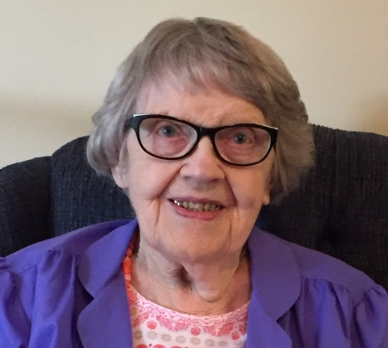
Helen Knutson joined Austin AAUW 50 years ago. She remembers that it has always been a friendly group. The used-book sales are among her many memories of AAUW activities, especially for those years when the sale was held in the open areas at the mall and the books had to be covered with sheets to keep certain people from picking over the books for resale ahead of the sale hours.
Helen was born on a farm near LeRoy. After high school she took a teachers’ training course in Austin and then spent many summers taking classes until she received her B.A. from Luther College in 1956. She then completed an M.A. from the University of Northern Colorado in 1963. She taught elementary age children for ten years in Rural District 179, Taopi, Leroy, and Northfield, and then 32 years at Sumner school in Austin. Her love of teaching young children is so deep that, at 93, she wishes she could still be teaching! She also enjoyed teaching adults and taught Bible classes and presented programs for 20 years at Sacred Heart Care Center and St. Marks.
Travel was a favorite interest, including three trips to Israel and a trip to Norway. She has always been an avid reader and a collector of books. She has donated thousands of her books to AAUW, the Lutheran Student House in Mankato and Youth for Christ.
Helen also is a writer and she contributed a chapter to “Austin Remembers” as well as a chapter called “Angels Fly Around Liquor Stores” in Christy Hanson’s book on miracles. Her honors include “Woman of Achievement” given by Delta Kappa Gamma and the “Pioneer Educator Award” given by the Southeast Minnesota Retired Educators.
Helen currently lives at St. Mark’s Assisted Living and she welcomes visitors. Go and ask her about her liquor store miracle!?!
Public Policy
Evelyn Guentzel

Welcome back to another year of stimulating programs and the fellowship of AAUW members. Public Policy notes will keep you informed about the many activities which AAUW, at the national level, and occasionally the state level engages in not-stop. AAUW’s Mission is “Advancing equity for women and girls through advocacy, education, philanthropy, and research. Some of our local programs will most certainly be a reflection of this mission.
Since 17 like-minded women founded this organization in 1881 AAUW has developed into a powerful network influencing and or shaping debates about educational, social, economic, and political issues. AAUW is a nonprofit organization and strives to be nonpartisan about issues that affect women.

--We have 170,000 members and supporters: 1000 local branches; 800 college and university partners; $3.7 million awarded to 250 recipients of fellowships and grants and nonprofit organizations. Our commitment to encouraging our members to pursue their dreams is a real testimony to our strength.
—We can celebrate the Reauthorization of the Violence Against Women Act. The Lily Ledbetter success speaks to the length of time we spend to ensure that equity becomes more than a word.

AAUW has developed a Strategic Plan: a) Mission (see above); b) Value Promise to break through barriers so that women have a fair chance; c) Vision Statement with the goal of empowering women and girls to “reach their highest potential; d) Diversity Statement guaranteeing there will be no barriers as we seek a more diverse membership. Another time this space will provide more focus on each of these statements. The strategic plan is our national model; its intent is to encourage branches to focus their own missions on what is achievable where they live.
The purpose of this column is to provide up to date information about the inner workings of our dynamic organization. Take time to look at the “Mission in Action” online and when you can, lend your support.

Outreach Opportunity

Hello AAUW friends,

I teach English to adults at the Community Learning Center. This year, we are planning to offer a school store that will be run by the adult English language students. We have offered a small scale store in the past, but school staff have taken care of the logistics of operating it. By operating the store, the students will learn about writing a business plan, using Excel to keep track of inventory and counting money and making change. They will have an opportunity to practice customer service as well as other valuable workplace skills.

The students are given “reward bucks” for attendance, and they can use their reward bucks to purchase items from the store. In the past, the students have been very excited to “purchase” much needed personal and household items from the store using their reward bucks. We were only able to offer a very limited number of those items, and they were “purchased” very quickly.

We have a small budget, but it will not be enough to sustain the store for the school year. We are asking for donations of the following items to help stock the shelves of our store.

- Deodorant
- Shampoo
- Conditioner
- Body Wash
- Soap

- Laundry Soap
- Dryer Sheets
- Dish Soap
- Tooth Paste
- Tooth Brushes

We will have a donation box at the AAUW meetings this year if you are interested in contributing to our store.

Thank you for your support!

Jill Maxfield
AAUW Co-President
Austin AAUW Board Retreat Minutes
July 13, 2017
The meeting was called to order by Catherine Haslag at 4:35 p.m. at the Austin Public Library. Those in attendance included Catherine Haslag, Sue Grove, Joyce Goetz, Catherine Lemons, Nicki Cizik, Mary Jo Alexander, Carolyn Bogott, Jenni Braaten, Jennifer Lawhead and Peggy Benzkofer.
There was no secretary’s report as there wasn’t a quorum presence at the last meeting.
Nicki presented the budget to actual for the last year. She then presented the proposed budget. Mary Jo made a motion to approve the treasurer’s report and budget. Catherine Lemons seconded the motion and the motion passed.
Nicki raised the issue of records for board positions and what could be done with them. A subcommittee of Catherine Haslag, Nicki, Catherine Lemons and Jennifer Lawhead was appointed to determine what records should be moved to the Historical Society.
It was announced that Jenni Braaten is the new membership vice president.
Programs for 2017-18 were discussed with suggestions made. The board meetings will begin at 5:30 with the regular meeting to begin at 6:30.
Catherine Haslag explained that the Adult Basic Education program of which Jill Maxfield is an instructor is in need of personal care items for their store. It was suggested that members be asked to bring items to each meeting to donate.
The suggestion was made to begin a regular column in the Austin Daily Herald highlighting outstanding women in the community. Carolyn Bogott said she would write the column and asks that suggestions for featured women be mailed to her. Sue will contact the Herald to ask for their help.
There are 52 paid members right now with four lifetime memberships. Catherine Lemons asked people to volunteer to contact people who had not paid their memberships.
Catherine Haslag reported on the national convention which was a wonderful experience.

The House Tour will be held on Oct.8. All members need to step up to make this successful.
Kari Miller of MPR has agreed to be the featured guest for the Women’s History Month event at Austin High School. The suggestion was made to include the AP U.S. History class in the projects.
The Science Fair mentoring project now is an independent organization having incorporated and obtained their 501c3 designation. AAUW is no longer their fiscal agent. Approximately 50% of their mentors return from one year to the next. New mentors are always needed. The program will continue at Neveln and Banfield.
Katlynn Schmick had a wonderful time at NCCWSL. She will report at a future meeting and will help to recruit people to apply for next time.
Joyce reported on the book sale. She commented that they would like to be a part of the preplanning. She also said that there was a need for more advertising. She also suggested that fewer people could work on sales days with more people needed during setup time.
Jennifer Lawhead is the new historian. The suggestion was made that volunteers be asked to take pictures at meetings in Jennifer’s absence. Also, it was suggested that a book could be made every two years through a photo service.

The meeting was adjourned.

Respectfully submitted, Peggy Benzkofer, Secretary

AAUW Monthly Financial Report
July 1 - July 31, 2017
Period: 7/1/17 - 7/31/17
Opening Balance: |  | $8,656.77
Income:
Dues Received | 25.00
Total Income: | $25.00 | $8,681.77
Disbursements:
Dues Paid - National | 17.00
Dues Paid - State | 2.00
Scholarships | 2,000.00
Total Disbursements: | $2,019.00
Closing Balance 7/31/17 |  | $6,662.77

AAUW Monthly Financial Report
August 1 - August 31, 2017
Period: 8/1/17 - 8/31/17
Opening Balance: |  | $6,662.77
Income:
Dues Received | 258.00
Memorial | 350.00
Total Income: | $608.00 | $7,270.77
Disbursements:
Dues Paid - National | 196.00
Dues Paid - State | 36.00
Total Disbursements: | $232.00
Closing Balance 8/31/17 |  | $7,038.77

Mission Statement: AAUW advances equity for women and girls through advocacy, education and research.
Vision Statement: AAUW will be a powerful advocate and visible leader in equity and education through research, philanthropy, and measurable change in critical areas impacting the lives of women and girls.

Southern Highlights Editor: Rae Dawn Rao rao_raedawn@yahoo.com Minnesota State Website: http://www.aauwmn.org Association Website: http://www.aauw.org Association e-mail: info@aauw.org

______________________________________________________________

AAUW Southern Highlights
1001 22nd Ave. SW
Austin, MN 55912

