Southern Highlights



**Volume 12 Number 2** **October 2013**

**_____________________________________________________________________________________**

**____ Shaping the World One Woman at a Time__ ___________ ____**

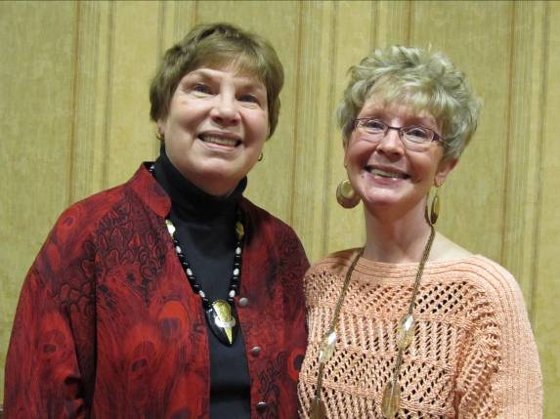

**Marijo Alexander and Sue Grove, Co-Presidents**

## Co-President’s Thoughts

We were thrilled with the turnout at the Prospective Members Wine and Cheese gathering and at the pot luck to kick off our new AAUW program year. I think everyone had a great time.

Welcome to all those who have just joined. We hope that you will find AAUW as rewarding as those of us who have been members for a long time. I think our new logo says it all: “Empowering Women since 1881”.

I cannot wait for our October meeting on the 8th. I have only been in the front office of I.J. Holton Intermediate School, but could sense from that how amazing it is to have this school in Austin. Please join us for the tour and updates from Jean McDermitt.

House Tour is Sunday, October 6th. If you need tickets, call me: 433-5464. It is critical that we sell as many as we can to fund our scholarship program. Turn your money and any unsold tickets into Mary Kay Wilson or me by Friday, Oct. 4th. If you must turn them in the day of the sale, be sure to have them in an envelope, marked clearly with your name and number of tickets sold and amount of money. Otherwise, it gets confusing for the cashiers.

We need everyone who possibly can to work a shift the day of the tour. Friends and family will be welcomed as well.

Thank you, everyone for all you do!



Sue Grove

Co-President

## October Program

Please join us on October 8th at 7:00 p.m. at the I.J. Holton Intermediate School in Austin (1800 4th Ave SE). The board will meet at 5:45 PM. Refreshments begin at 6:30 PM. People can park in the lot east of the school.  The driveway is right across the street from the water tower.  Enter through the east entrance; it’s a short walk through the double doors to the media center.  Refreshments will be in that area.  There is a nice serving area and places to sit.  Jean McDermott, Principal, will start with a presentation at 7 pm, and then we will tour the school.

### Small Groups

These groups are open to any member wishing to attend.

**Morning Book Group**

Morning book group is reading ***Cleopatra's Daughter*** by Michelle Moran for our October 17 meeting.  Our November 21 selection is ***My Antonia*** by Willa Cather, and we will not meet in December.  We will discuss ***Lean In*** by Sheryl Sandberg at our January 16 meeting.

**Evening Book Group**

We will be discussing *The House Girl* by Tara Conklin on Monday, October 7th at 7 PM at the home of Rae Dawn Rao. Please RSVP to Rae Dawn at [rao_raedawn@yahoo.com](mailto:rao_raedawn@yahoo.com) On November 4th we will discuss *Flight Behavior* by Barbara Kingsolver.

**First Friday**

First Friday Luncheon will be at the Austin Country Club at 11:30 on Friday, October 4th.  Contact Dorothy Krob at [sdkrob@live.com](mailto:sdkrob@live.com) if you would like to attend.

##### Travel Group

The Travel Club will meet at the Coffee House on Main on Thursday, Oct. 10 at 2:00 P.M.  We will be discussing and organizing our meetings for this year.  I hope everyone will be able to attend and have lots of great ideas.  Please call (433-7897) or email ([drgraber@charter.net](mailto:drgraber@charter.net)) as to whether or not you are able to join us.  DedaRae Graber

**Great Decisions**

Great Decisions will meet on October 30th from 1:00 to 2:00 in Room C108 in the East Building at Riverland. We will be reading Chapter 7.

**Knitting/ Handiwork Group**

We will begin meeting again on October 19th at 9:30 AM at the Coffee House on Main. Everyone is welcome to join.

|  |  |  |
| --- | --- | --- |
| **AAUW Monthly Financial Report** | | |
| **September, 2013** | | |
|  |  |  |
| **Period: 97/1/13-9/30/13** |  |  |
|  |  |  |
| **Opening Balance:** |  | **$7,188.66** |
|  |  |  |
| **Income:** |  |  |
|  |  |  |
| Dues Received | 593.00 |  |
| House Tour Ticket Sales | 225.00 |  |
|  |  |  |
| **Total Income:** | **$818.00** | $8,006.66 |
|  |  |  |
|  |  |  |
| **Disbursements:** |  |  |
|  |  |  |
| Scholarship | 2,000.00 |  |
| National Dues | 409.00 |  |
| State Dues | 119.50 |  |
|  |  |  |
| **Total Disbursements:** | **$2,528.50** |  |
|  |  |  |
| **Closing Balance 9/30/13** |  | **$5,478.16** |

**Fall House Set for This Sunday, October 6th**



Our bi-annual house tour is upon us! Mark your calendars for Sunday, October 6th from 1-5 PM. We need all members to help out in any way they can. Please sign up via Sue to work a shift during the tour. Friends and family welcome to help also! Please make every effort to **sell your tickets** and return the money and/ or unsold tickets to Sue or Mary Kay by Friday October 4th. We appreciate all your efforts! This is our major fundraiser to help support scholarships!

LIKE AND SHARE SUE’S HOUSE TOUR POSTS ON FACEBOOK!

*Mission Statement*: AAUW advances equity for women and girls through advocacy, education and research.

*Vision Statement:* AAUW will be a powerful advocate and visible leader in equity and education through research, philanthropy, and measurable change in critical areas impacting the lives of women and girls.

**Southern Highlights Editor:** Rae Dawn Rao

rao_raedawn@yahoo.com

**Minnesota State Website:**

http://www.aauwmn.org

**The Pine Editor: LouAnne Hoppe**

**Association Website:**

<http://www.aauw.org>

**Association e-mail: info@aauw.org**



______________________________________________________________

AAUW Southern Highlights

1001 22nd Ave. SW

Austin, MN 55912