Our Mission: To honor women and girls, empowering them through education, service and leadership development.

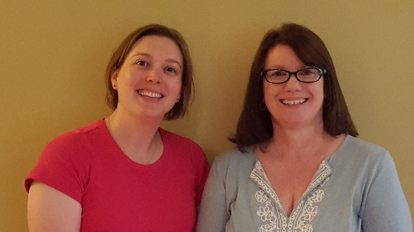
Co-President’s Message
November is here and the presidential election is a week away. Our next meeting will be held on Election Day. Most of you are probably ready for this election to be over. It has been an interesting election year. No matter which candidate you support, please get out and vote. It is one of the ways we can influence the direction our country takes and make our voice heard on women’s issues.
After you have voted, we look forward to seeing you at our meeting. Social time begins at 6:30 PM. A short business meeting will be held at 6:50 PM with the program to follow at 7 PM.
The National Conference for College Women Student Leaders (NCCWSL) will be next summer in Washington DC. This is an opportunity for our branch to encourage a local female college student to develop her leadership skills. We are looking for 4 branch members to volunteer to form a committee to apply for a $500 scholarship to help fund a participant from Riverland to attend and select the conference participant. This is an excellent way to encourage leadership development in the next generation of women. The deadline to submit the selected student’s name and scholarship application to AAUW of Minnesota is February 1, so this committee needs to form and begin this process soon. This is a great way to be more involved in AAUW. Please contact us if you are interested in serving on this committee.
Be sure to read all of this month’s newsletter. Each month, there will be a trivia question at our meetings about the monthly newsletter. If you know the correct answer, you will be entered into a drawing for a prize. You must be present to win.
Looking forward to seeing you all on November 8 (and don’t forget to vote!)
~Jill Maxfield and Catherin Haslag, Co-Presidents
November Program
Richard Lemons will be speaking to us about the Poverty Task Force Project. Did you know that poverty is a significant issue in Austin? Plan to attend to learn what the Poverty Task Force has discovered and how we as a community can come together to look at solutions to this difficult problem.
We will be meeting in the large room at the Austin Public Library starting at 6:30 on Tuesday, November 8th. The library now closes at 8:00 pm, so we will all be home to watch the election results!
Marijo Alexander and Sue Grove, Program Vice Presidents

Small Groups
Great Decisions
Great Decisions will meet next on November 27th in room C124 at Riverland Community College at 1 PM. Our topic this month is climate change.

AM Book Group
Morning Book Group is reading Lab Girl by local author Hope Jahren. Join us at Perkins at 9:00 a.m. on Thursday, November 17 when Evelyn Guentzel will lead our discussion.

PM Book Group
The evening book group will meet at Catherine Lemmons's home on Tuesday, November 15th. We will discuss Moonlight Sonata at the Mayo Clinic by Nora Gallagher. Please RSVP to Catherine at richncath@aol.com. We will not meet in December.

First Friday
First Friday Luncheon will be at the Old Mill on November 4th at 11:30. RSVP to Dorothy Krob at sdkrob@charter.net by Thursday, Nov. 3rd.

Travel Group
The Travel Club will be meeting on Wednesday, November 16th at 1:30 P. M. (PLEASE NOTICE that this is earlier than we usually meet) at the home of Joyce Goetz. We will again be sharing information on a few more National Parks. I hope you will be able to join us. Please let DedaRae know if you plan to attend. Thank you!

SPOTLIGHT ON MEMBERS

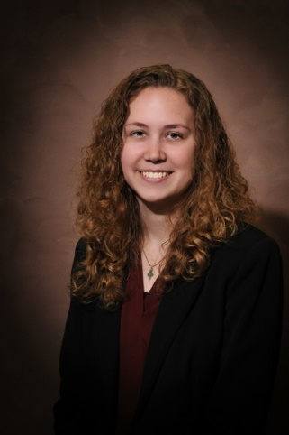

Austin AAUW Welcomes Morgan Carlson!

Morgan Carlson is a new member of AAUW and our featured member this month. She came to Austin to accept employment as an associate attorney at Adams, Rizzi, Sween and enjoys it very much. She has become involved in Austin through memberships in AAUW, P.E.O., Rotoract, the author committee of the Austin Arts Festival and as a board member of the Friends of the Library. She is also president of the Tenth District Bar Association.
Morgan grew up near Theilman, MN, a tiny town near Wabasha and Lake City. She said, “The valley where I grew up is a truly gorgeous place to be and I tend to head back that way most weekends.”
She graduated magna cum laude from St. Mary’s University of Minnesota with a major in Psychology and minors in Criminal Justice and Spanish. She then attended the U. of Minnesota law school graduating cum laude. While there she participated in the school’s play, Theatre of the Relatively Talentless. Between her first and second years, Morgan worked at Community Mediation and Restorative Justice Services providing alternatives to the juvenile justice system.
Morgan stated, ‘I enjoy reading (so many amazing books out there, and I definitely couldn’t name a favorite), four-wheeling, relaxing in front of the TV (so many great shows out there – Pitch is probably my favorite new show), going to a new movie with a good friend/ family (don’t get to go often but it’s that much more fun when it does), trying new food (especially if I don’t need to cook it), and cuddling with my parents’ dogs. In the future, I am looking forward to having a pet of my own to hang out with in Austin. Drinking hot cider in front of a fire (a real one with all of the crackling wood that entails) and chatting with my favorite people is probably my favorite way to relax.
Welcome, Morgan, to the Austin branch of AAUW!

AAUW Monthly Financial Report
October 1 - October 31, 2016
Period: 10/1/16 - 10/31/16
Opening Balance: |  | $5,997.61
Income:
Dues Received | 130.50
House sale proceeds | 3,520.00
Total Income: | $3,650.50 | $9,648.11
Disbursements:
Wine & cheese networking event | 88.24
Expenses for house tour | 90.00
Dues Paid - National | 57.50
Dues Paid - State | 21.00
Insurance | 185.00
Stamps | 9.40
Total Disbursements: | $451.14
Closing Balance 10/31/16 |  | $9,196.97

Austin AAUW General Meeting Minutes
October 11, 2016
AAUW board met at Riverland Community and Technical College. Present were Catherine Haslag, Jill Maxfield, Nicole Cizik, Marijo Alexander, Dorothy Krob, Katie Ulwelling and Peggy Benzkofer.
Jill and Catherine called the meeting to order. Jill commented that the member feature in the newsletter was a good addition. A concern was expressed about members not reading the newsletter. Jill offered to bring hard copies to the meetings. She also suggested a trivia quiz based on information in the newsletter. There will be a small prize. There was good feedback on the sign on the door to direct people to the meeting.
Marijo made a motion, seconded by Dorothy, to approve the minutes of the July board retreat and the September general membership meeting. The motion carried.
Nicole reported an opening balance of $5,997.61 with a closing balance of $9346.37.
The program for November will be Richard Lemons talking about the poverty in Austin project which grew out of the Blandin training. In December we will have our Christmas party at the Coffee House on Main. It was suggested that we bring mittins, socks, hats etc. for children in the elementary schools who are ill equipped for winter.
There are 69 paid members with three new members at the wine and cheese event.
By laws updates and website update were tabled until the next meeting.
Jill reported on the House Tour. Proceeds totaled $3,605.50. Jill commented on what a group effort it was. She said that three members have not replied with proceeds or unsold tickets. Each home owner received a thank you card, picture of the home and $25 in Chamber bucks. Jill reported that two houses are committed for next year so we will have another tour then instead of waiting two years. Jill said she will chair it again.
Women’s History Month Update tabled until next month.
Catherine Haslag reported on the Science Fair Mentoring project. An addition this year is a cooperative project with the Austin Public Library. The first session will be November 17th from 10:15 – 11:15. Each child will receive a science experiment in a bag. Also, Austin Rotary and Worlein Funeral Home are donating money so each child in the Science Fair Project will receive a copy of the Mad Margaret book. A sticker in each book will recognize the donors.
NCCWSL (National Conference for College Women Student Leaders) brings together college women for all over the country. Our branch can sponsor a student leader. We will ask for a committee of four to work on this.
After the board meeting, members enjoyed a brief social time followed by a short general membership meeting. Catherine Haslag presented the program which described the Science Fair project and plans for this year.
Respectfully submitted
Peggy Benzkofer, Secretary

Don’t Forget to

November 8th!

Mission Statement: AAUW advances equity for women and girls through advocacy, education and research.
Vision Statement: AAUW will be a powerful advocate and visible leader in equity and education through research, philanthropy, and measurable change in critical areas impacting the lives of women and girls.

Southern Highlights Editor: Rae Dawn Rao rao_raedawn@yahoo.com Minnesota State Website: http://www.aauwmn.org Association Website: http://www.aauw.org Association e-mail: info@aauw.org

______________________________________________________________

AAUW Southern Highlights
1001 22nd Ave. SW
Austin, MN 55912

