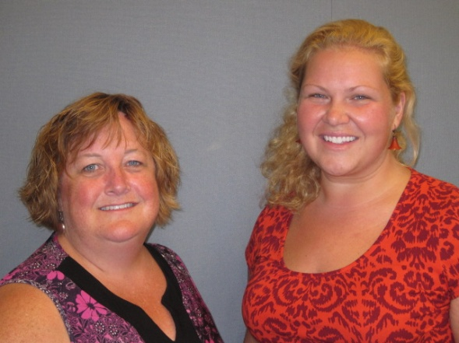
Our Mission: To honor women and girls, empowering them through education, service and leadership development.

Co-President’s Message
Spring is in the air, and we are having our final event the Spring Banquet this month and wrapping up another AAUW program year. But before talking about those, I want to thank everyone who participated in our recent State Convention, “Full “STEAM” Ahead!” I do not yet have the final tally on how much we netted, but thanks to all of you who bought tickets or contributed at the event, we made a profit and had a fun event. I want particularly to thank Marijo Alexander and Sue Grove who put together this wonderful event. Whatever would I have done without you! Thanks are also to all the volunteers who helped with registration and the silent auction. Our next branch event is the Spring Banquet on May 12, and that should be a lovely – and delicious – event.
~Courtney Wyant, Co-President
May Program
The Spring Banquet will be held at the Hormel Historic Home on May 12. The theme this year is "Spring Fling." Social time begins at 5:30 with dinner at 6pm. Dinner will be catered by Hy-Vee. We will be serving ham, roast-herb chicken, catalina vegetables, garlic parmesan mashed potatoes, and a green spring salad. Musical entertainment will also be provided during the meal. Tickets are $17. Please RSVP to Catherine Haslag at cshaslag@gmail.com by May 6. We look forward to seeing you at the Spring Banquet!

Small Groups
AM Book Group
And the Mountains Echoed by Khaled Hosseini is the book that morning book group is reading for our May meeting. We will meet at Liz Richardson's, 2207 NW 7 Ave., at 9:00 a.m. on Thursday, May 21.

First Friday
First Friday will not meet in May as the library used book sale is occurring on our regularly scheduled meeting date. We hope you will be able to pitch in at the sale instead!

PM Book Group
Evening book group will be at Rae Dawn Rao's home at 1001 22nd Ave SW on May 19th at 7:00 p.m. We will discuss The Interestings by Meg Wolitzer. Please RSVP to Rae Dawn at rao_raedawn@yahoo.com.
Knitting & Handiwork We continue to meet most Saturdays at the Coffee House on Main at 9:30 AM. You need not be able to knit/ do handiwork to attend!

Travel Group
The Travel Club will be meeting at Sandy Folk’s home (1605 - 8th Ave. N.W.) on Wednesday, May 13th at 1:00 P.M. Please notice that this is a change to both the usual day and time. Sandy will be sharing information on the, “Road Scholars Travel Programs.” In addition to this, we will be discussing the possibility of doing a Day Trip during the summer. Dorothy Krob will share interesting information about traveling to Winona and Mason City. Please let me know if you plan to join us on May 13th.
Thank you very much.
DedaRae Graber

Board Election Approaches

Elections for the following positions will be held at the Annual meeting-which will be held during our regular meeting and banquet on May 12th.

Program Vice President: Jill Maxfield
Membership Vice President: Catherine Lemons

If anyone else would like their name added to the ballot for either of these positions, please contact Carla Anderson-Diekmannn before May 1.

In addition, we are looking for someone to volunteer as House Tour Chairperson. Please contact Carla Anderson-Diekmann or Sue Grove if interested.

Used Book Sale Friday & Saturday
It’s beginning to look a lot like a Book Sale!!! Thanks to all of you that have donated books, helped to sort books and have volunteered to help with the sale. There is still room for you to help. The book sale is Friday, May 1st from 10:00-5:00 and Saturday, May 2nd from 10:00-5:00 with the bag sale on Saturday beginning at 3:30. Q. “Where can you get a full bag of books for $5.00?” A. “The Austin Public Library Used Book Sale.” See you there!

Co-chairs, Joyce Goetz and Laura Tjomsland

State Convention Recap
The 86th Annual State Convention of Minnesota’s AAUW was indeed a ‘steaming’ success! Well over 100 attendees convened from across the state (and nation!) to gain a better understanding of what AAUW is all about. Speakers from the national office, Kate Farrar and Mark Hopkins, gave us insight into what lies ahead for AAUW. Kathy Bull, former head coach of women’s tennis at Ball State University, gave a very moving talk on how AAUW’s LAF (Legal Advocacy Fund) is hard at work making a difference for all women. Informative breakout sessions also covered on-trend topics like STEAM Schools, Science Fair Mentoring, and Paying it Forward. Well done Austin AAUW! Photos are courtesy of Vern Grove.
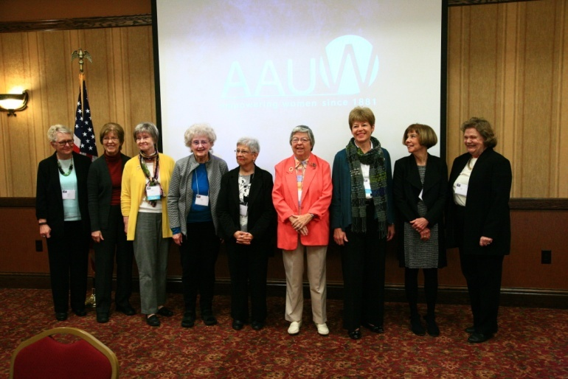
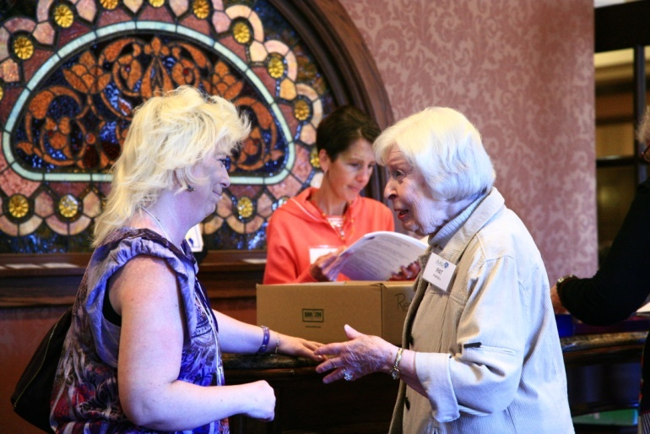
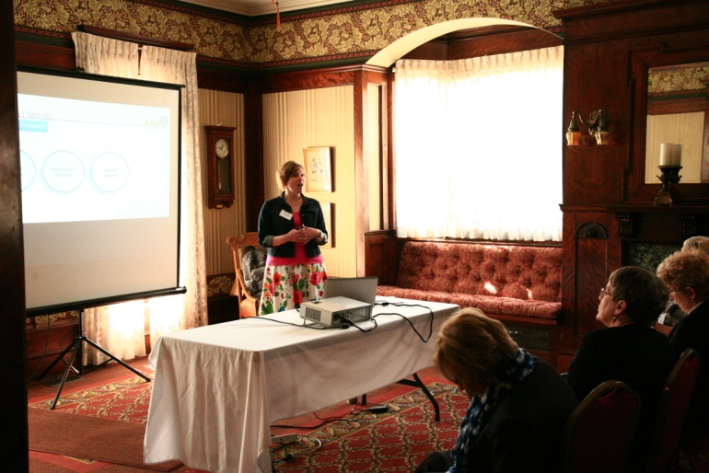
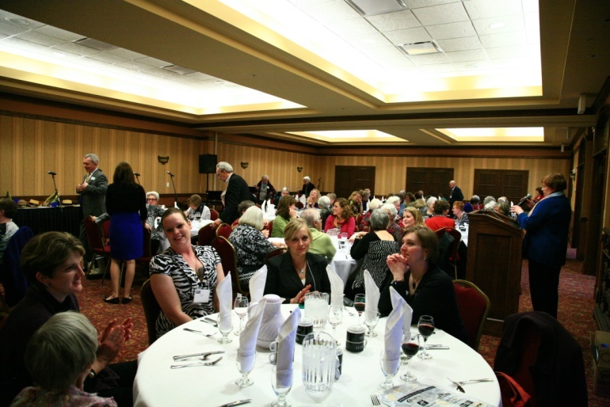
AAUW Monthly Financial Report
March 21 - April 20, 2015
Period: 3/21/15 - 4/20/15
Opening Balance: |  | $9,393.91
Income:
Dues Received
Banquet
Total Income: | $ - | $9,393.91
Disbursements:
Scholarship funding | 2,000.00
Dues Paid
Banquet
Stamps | 9.80
Total Disbursements: | $2,009.80
Closing Balance 4/20/15 |  | $7,384.11

AAUW Board Meeting
April 14, 2015

AAUW Board met at Riverland Community College. Present were Marijo Alexander, Carla Anderson-Diekmann, Nicole Cizik, DedaRae Graber, Sue Grove, Evelyn Guentzel, Catherine Haslag, Dorothy Krob, Catherine Lemons, Jill Maxfield, Ruth Monson, and Courtney Wyant.
Secretary’s report from the March meeting was approved. Nicole gave a Treasurer’s update. $2,000 for scholarship funding was paid this month. Treasurer’s report was approved.
Catherine Lemons reported on Membership. There are currently 72 members in the branch.
Courtney reported on the website and Facebook page. Catherine Haslag requested having a space on the website for information related to the Science Fair mentoring project. Courtney will ask Marie about this.
Sue reported on the State Convention held over the past weekend in Austin. She received many positive comments about the event. Due to an unintended error there was an additional $600 charge from HyVee. Motion made and passed to pay this charge from the convention earnings.
Catherine Haslag reported on the upcoming banquet in May. HyVee will cater the event with the menu including ham and chicken, vegetables, potatoes, salad and dessert. Tickets for the dinner will be $17 per person. Catherine Haslag will take care of reservations, and needs to have reservations in by May 6th. This year, members can write one check for $82 to cover both the cost of the dinner ($17) and membership dues for 2015-16 ($65).

A short discussion took place regarding the membership directory. It was suggested that an electronic version of the membership contact information be sent to members, with periodic updates. Also, DedaRae suggested that if new people join during the year, stickers (with their contact information) could be distributed to members to add to their directories.
Carla discussed the local board elections that will take place at the May meeting. Both Jill (Program VP) and Catherine Lemons (Membership VP) have agreed to be on the ballot for another year. There is still a vacancy for the appointed position of House Tour Chair. Jill has also agreed to stay another year in the appointed position of Hospitality Chair.
There was a discussion about Women’s History Month. Sue offered to look into asking Kathy Bull to speak about gender equity in women’s sports. Discussion about other Women’s History Month activities was tabled for another time.
Carla also reported that the national AAUW election will take place soon. Members will receive a link to vote in an email. There will be some other issues on the ballot – one that will be asking about changing the degree requirement for membership in AAUW.
The May meeting (Spring Banquet) will take place at the Hormel Historic Home starting with a social time at 5:30 p.m., followed by dinner at 6:00. Meeting adjourned.
Respectfully submitted,
Ruth Monson, Secretary

Mission Statement: AAUW advances equity for women and girls through advocacy, education and research.
Vision Statement: AAUW will be a powerful advocate and visible leader in equity and education through research, philanthropy, and measurable change in critical areas impacting the lives of women and girls.

Southern Highlights Editor: Rae Dawn Rao rao_raedawn@yahoo.com Minnesota State Website: http://www.aauwmn.org Association Website: http://www.aauw.org Association e-mail: info@aauw.org

______________________________________________________________

AAUW Southern Highlights
1001 22nd Ave. SW
Austin, MN 55912

