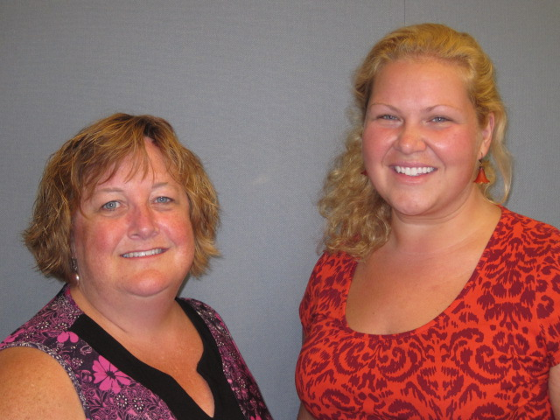
Our Mission: To honor women and girls, empowering them through education, service and leadership development.

Co-President’s Message
What a winter it has been for the AAUW! We have a couple of great events coming up that I hope you will be able to attend. Our branch needs the support of all of us in order to be successful. Our big branch event for March will be at the Austin Public Library and will feature Dylane Ullwelling’s presentation “Women in Non-Traditional Roles.” I would also like to jump ahead into April; the month is going to be a busy one for Austin AAUW members. It begins with us hosting the State Convention. Please make sure to give a big thank you to our former co-presidents Sue Grove and Marijor Alexander for working so hard on putting this convention together. We need volunteers for the State Convention please contact Sue or Marijo if you are interested in volunteering for this wonderful event. We invite all members to join us in active participation on our team to take a role in these and future branch efforts. There is no job too small. Whatever your interest or expertise will be appreciated.

~Courtney Wyant, Co-President
March Program
Dylane Ulwelling will talk about Women in Non-Traditional Roles during the March program. Dylane has experience in both corrections and law enforcement and served a tour of duty in Iraq. She will discuss her experiences as a women working in these traditionally male-dominated fields. This month's program will be held on March 10th in the large meeting room in the library. Social time will begin at 6:30 with the program beginning at 7pm.

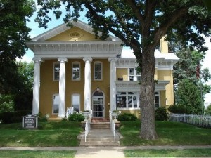
AAUW State Convention Update
We are well on our way with preparations for the AAUW State Convention that our branch is hosting April 10 and 11th.
We will need volunteers to help with things like the Registration Table, monitoring the Silent Auction, and just greeting people. During the business meeting, we will need a time keeper and pages and tellers. Also, it would be great to have a few people available at I.J. Holton starting about 3:00 on Friday, the 10th to greet those who are going on the tour of the school.
So, if you possibly can, please contact either Marijo or Sue to let them know that you are available.
We also encourage everyone to consider registering for the Convention to see how our state organization serves women and girls.
All the information is available on the AAUW Minnesota website at:
http://aauw-mn.aauw.net.
This is an exciting event for our branch to be hosting, so please get involved.

Marijo Alexander and Sue Grove
Small Groups
Arts & Entertainment
The Arts & Entertainment group has planned the "Uncork & Create: Lake Sunset" class at the Austin Artworks Center. Cost is $35 if you are a member of the Artworks center, $40 for non-members. Space is limited and open to the public, so sign up soon, either by calling the Artworks Center at 434-0934, or by registering online at this link: http://www.austinareaarts.org/create/2015/3/12/uncork-create-lake-sunset
We will also be meeting before the class at 4:45 pm at El Mariachi for supper/appetizers, so please let Carla know after you have registered for the class so we can reserve space for that too if you are interested. (If you just want to join us at El Mariachi, that would be great too!)

AM Book Group
Morning Book Group will meet at Barley's at 9:00 a.m. on Thursday, March 19th. Lois McConnell will lead discussion on the book, "Vacationland" by Sarah Stonich.

First Friday
Our AAUW First Friday for March will be Friday, March 6th at 11:30 at King Buffet. King Buffet is across from Aldi's and Joanne Fabrics. Contact Dorothy Krob at sdkrob@charter.net if you plan to attend.

PM Book Group
The evening book group will be discussing the Pageturner’s selection Vacationland by Sara Stonich on Tuesday, March 17th. We will meet at the home of Peggy Benzkoffer at 7 PM. Please RSVP to Peggy at pjbenzko@gmail.com. Our April selection is Mountain of Crumbs by Elanor Gorokhova.

Knitting & Handiwork We continue to meet most Saturdays at the Coffee House on Main at 9:30 AM. You need not be able to knit/ do handiwork to attend!

Great Decisions
We will meet next on February 23rd and will be discussing "Privacy in the Digital Age". Time and place are to be announced soon.

Travel Group
The AAUW Travel Club will be meeting on Thursday, March 12, at 2:00 P.M. at the home of Lois McConnel. We invite everyone to join us as we, “March into Spring!” We encourage each person to bring a helpful “Travel Tip” to share with the group. We will also be working on organizing and planning our calendar with future events. Please let me know via email or call (433-7897) if you plan to attend. I hope you can join us and I look forward to seeing you there. Please RSVP to drgraber@charter.net

AAUW Sponsored Scholarships Awarded
AAUW Sponsored two scholarships for young women at Riverland Community College this year.

Ashley Haugen was one of the recipients. She is currently in the MANE Nursing Program and is also a member of Phi Theta Kappa. She is a single mom, caring for her two young daughters.

The other recipient is Sheree King. She was involved in many activities in high school, including FFA, Spanish Club, and Yearbook. Her mom spent some time in prison because of drugs. Sheree's mom now struggles to get jobs that can support her family. Therefore, Sheree is grateful for our scholarship as it reduces the financial burden on their family.

Congratulations to these two young women!

AAUW Monthly Financial Report
February 1 - February 20, 2015
Period: 2/1/15 - 2/20/15
Opening Balance: |  | $9,311.91
Income:
Reclassify Austin Daily Herald expense to Science Fair Project | 75.00
Total Income: | $75.00 | $9,386.91
Disbursements:
Total Disbursements: | $0.00
Closing Balance 2/20/15 |  | $9,386.91

Used Book Sale Approaches!
Save the date, Spring Used Book Sale will be the first weekend in May, 2015. Start cleaning your book shelf now and be ready for the sale.
We will need lots of help the week before the sale and to help the days of the sale. Sign up schedule will be available at the March meeting, so check your schedule now and be prepared to sign up to help several different times. This is a group effort!

Book Sale Co-chair, Laura Tjomsland
Don’t Forget!
AAUW State Convention
April 10-11, 2015
Hormel Historic Home
FULL STEAM AHEAD!
Science, Technology, Engineering, Arts, and Math
Now and into the Future!

Register today at:
http://aauw-mn.aauw.net/

PUBLIC POLICY
Evelyn Guentzel
AAUW is diligently watching both the federal and Minnesota initiatives in 2015. The issues run the gamut from education, to STEM opportunities, budgets, women's issues, trafficking, and pay equity. The last one, pay equity, has had major coverage in recent weeks and the countdown is on to April 14, which is Pay Equity Day. It seems as though this topic has been on our radar for years, but some of the same issues keep repeating. In the last day I have heard that Walmart
is raising pay for some workers to $9.00 an hour and a primary reason is more competition for workers. Well, it's a step in the right direction, but here are some facts which haven't changed:
-For the most part, over their lifetimes men are paid more than women.
-The pay gap has not budged by much in the last decade, meaning in 2013 women working full time were being paid 78 percent of what men were paid.
-In all the states women experience the pay gap but some states are better or worse than others. For example, in Washington, D.C. women were paid 91 percent of what men were paid; In Louisiana, women earn 60 percent of what men earn.
-Women of color have a worse shortfall. Hispanic women for example earn 54% of white men's earnings. Interestingly, Asian women have the smallest pay gap compared to white men's earnings--90 percent.
-Pay gaps occur in nearly every occupation. Comparable worth determinations are not practiced generally.
-The pay gap grows with age, depending on the occupations.
-More education is not always an effective tool against the gender pay gap. At higher academic levels the gender gaps persist. Education is helpful to everyone, but the outcomes are not equitable. Some of this
is geographic; some of it is due to work assignments; some of it is truly baffling. AAUW's study, "Graduating to a Pay Gap" revealed that women working full time were earning 82% of what men were earning.
-Some CEOs are committed to paying workers fairly; AAUW urges companies to actively audit salaries paid.
-Women can learn more about negotiation strategies to ensure pay gap closure.
-AAUW's "Simple Truth" is that pay equity continues to be an issue and awareness can lead to more action on a personal level and a legislative level.

AAUW Board Meeting Minutes
February 10, 2015
AAUW Board met at the Austin Public Library. Present were Carla Anderson-Diekmann, DedaRae Graber, Sue Grove, Catherine Lemons, Jill Maxfield, Ruth Monson and Courtney Wyant.
Secretary’s report was approved. There was no Treasurer’s report, but the Board discussed the question of a $75 payment to the Austin Daily Herald. Carla will follow up and report back to the Board.
Jill reported on the Program Schedule. She and Catherine Haslag are working on a menu and entertainment for the spring banquet and will present their findings to the Board at the next meeting.
Jill and Catherine Haslag suggested a change for the April general meeting. They will present a brainstorming session called “Spice Up Your Programming” based on an AAUW webinar on programming for the local branch meetings. The scheduled speaker, Jay Haymond, will be asked to return at a later date.
Catherine Lemons reported that the branch now has 70 members. New members may join for half price during the month of February, and beginning in March, new members can pay for a membership that will extend through next year.
There was a discussion about the chapter website, and it was agreed that the website needs to be updated on a monthly basis. Courtney will speak with Marie about more frequent updates, and will ask to be trained to be able to post updates. Courtney also invited small groups to send her pictures that she will then post on the Facebook page.

Sue Grove gave an update on the State Convention which will be held in Austin on April 10-11. She and Marijo Alexander wrote an article for the Minnesota AAUW Pine, with a link to registration information. They are looking for volunteers for registration and for the silent auction.
Courtney Wyant and her mother Carla will be attending the National AAUW Convention in San Diego in June, and will receive funding from the branch.
Laura Tjomsland contacted Carla regarding branch publicity in the Austin Daily Herald. Ruth will give Laura information about the March, April and May meetings.
Newsletter items need to be submitted to Rae Dawn on or before Friday, February 20th and Board agenda items need to be submitted to Carla and Courtney on or before the first Tuesday of the month.
Jill reported that she has nominated Catherine Haslag to be a highlighted community volunteer in a feature article in the Austin Daily Herald, and said that Catherine was chosen to appear in the article.
The March meeting will be at 6:30 p.m. on March 10 at the Austin Public Library. The Board will meet at 5:45 p.m. and membership will gather at 6:30 p.m. for social time, with the program beginning at 7:00 p.m.
Meeting adjourned.

Respectfully submitted,
Ruth Monson, Secretary

Mission Statement: AAUW advances equity for women and girls through advocacy, education and research.
Vision Statement: AAUW will be a powerful advocate and visible leader in equity and education through research, philanthropy, and measurable change in critical areas impacting the lives of women and girls.

Southern Highlights Editor: Rae Dawn Rao rao_raedawn@yahoo.com Minnesota State Website: http://www.aauwmn.org Association Website: http://www.aauw.org Association e-mail: info@aauw.org

______________________________________________________________

AAUW Southern Highlights
1001 22nd Ave. SW
Austin, MN 55912

