Our Mission: To honor women and girls, empowering them through education, service and leadership development.

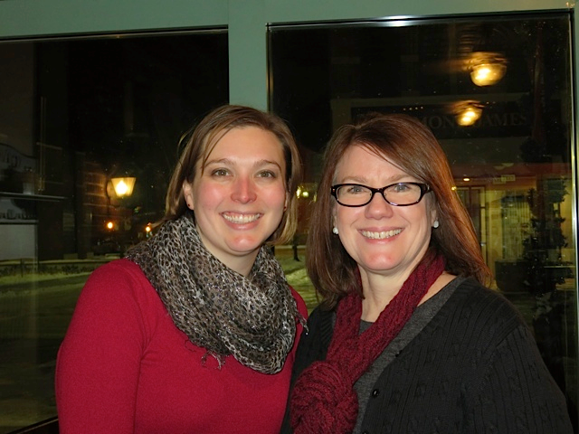
Co-President’s Message
Happy New Year! It might be February, but since there is not January newsletter, this is our first column of the new year. We hope 2017 finds you all happy and healthy.
There is a lot going on right now in our nation. Some of you may have marched in January the day after the inauguration to bring attention to women’s issues. Others might be contacting your senators and representatives to tell them how you feel about what is going on in the state and national legislature. Still others may be donating more to organizations that support women’s issues. Whatever you are doing, keep doing it. If you aren’t as involved as you would like to be, visit http://www.aauw.org/get-involved/ for more ideas on how to get involved.
Looking forward to what 2017 has in store for our chapter, our community, and our nation.

~Jill Maxfield and Catherin Haslag, Co-Presidents

February Program
We are excited to bring back an old tradition: February potlucks in individual’s homes. These are a great way to get to know other members in a smaller venue.
We have started a list of those who would be willing to host and those who would like to co-host, but could use a few more. A host provides the house and beverages. The co-host helps call people assigned to her house and works out what people would like to bring for food. (This will ensure that not everyone brings dessert, for example.)
We will be calling people to make arrangements, but if you would like to be a host or co-host, please email Sue: sue.grove@riverland.edu
Also, if you know that you are able (or not able) to attend, it would help to know before we start calling. So, you could email Sue as well. The gatherings will occur on Tuesday, February 14th with various start times between 5:30-6:30 PM.
~Marijo Alexander and Sue Grove, Program Vice Presidents

Small Groups
Great Decisions
GREAT DECISIONS: "The Future of Europe". Monday, February 27, 2017, 1:00 P.M., Room 107 at Riverland.

AM Book Group
Morning Book Group will be discussing "Good Night, Mr. Wodehouse" when we meet on Thursday, February 16. We will meet at 9:00 a.m. at Perkins and Liz Richardson will lead the discussion. This is the Pageturner's selection for the year.

PM Book Group
The evening book group will meet next on February 21st at the home of Rae Dawn Rao, 1001 22nd Ave SW, at 7 PM. The book is The Martian by Andy Weir. Please RSVP to Rae Dawn at rao_raedawn@yahoo.com. Our March selection is LaRose by Louise Erdrich (rescheduled from January).

First Friday
First Friday Luncheon will be at El Marachi. We will meet at 11:30 this Friday, February 3rd. All AAUW members are welcome to attend. Please RSVP to Dorothy Krob at sdkrob@charter.net by Thursday if you would like to join us.

Travel Group
The AAUW Travel Club will be meeting at the home of Sandy Folk on Thursday, February 16th at 2:00 P.M. We will be sharing information on different National Parks. We always learn new and interesting information each month. If you would like to join us, please let me know via email or call
me (433-7897).
Thank you, DedaRae Graber

SPOTLIGHT ON MEMBERS
Lisa Schlotterhausen
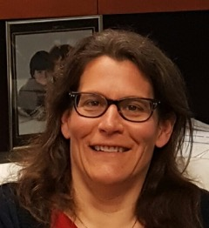

Lisa was born and raised on Long Island, NY and went to NJ for her undergraduate degree. She then attended Drew University and majored in Anthropology and Biology. After graduating, she went to South India to study language, music and research Indian movies. After that year, she began her graduate studies in Anthropology at New York University. She returned to southern India several more times for language and research, for a total of 4 years. Her doctoral research was a socio-ecological study comparing 2 groups of monkeys and included an examination of the cultural significance of monkeys.
After teaching for several years in NY, NJ, and GA, she began a career in international student services at Stony Brooklyn University, NY. In 2005, she moved to MN and started working at North Hennepin Community College, first as an advisor and then as the Dean of Institutional Effectiveness. In 2011, she moved to Century College, and was there until September 2016. That is when she came to Riverland Community College as interim Dean of Academic Affairs. Here she works with faculty in the Liberal Arts and Sciences as well as supervising the Student Success Center.
She has been actively engaged in diversity and social justice work for years, both personally and professionally. She was chair of the board of her congregation and led their long-range planning efforts. Crocheting, traveling, riding her motorcycle, bicycling, yoga, and any other fitness class she can find, are her hobbies. She also likes to participate in the occasional trapeze or other circus performance class.

She says, “While I’ve known of AAUW for many years, I’ve never had the chance to join before coming to Austin. I am hoping my schedule will allow me to participate in more activities and events. I enjoyed meeting many of you at the September potluck and hope to see you again soon.”

WOMEN’S HISTORY ASSEMBLY SET FOR MARCH 10
PUT THE DATE ON YOUR CALENDAR!
Our speaker will be Liza Maatz, AAUW Vice President for Government Relations.
As AAUW’s top policy adviser, Maatz works to advance AAUW’s priority issues on Capitol Hill, in the White House, and in coalition with other organizations. She is a sought-after speaker across the nation and in our nation’s capital, and has a large and devoted following on Twitter. Lisa also provides leadership to several coalitions working to advance opportunities for women and girls, including the National Coalition for Women and Girls in Education and the Paycheck Fairness Act Coalition. Recently featured in the book Secrets of Powerful Women, Lisa has developed a reputation for her strategic approach to legislation and advocacy. She has done similar work for the NOW Legal Defense and Education Fund and the Older Women’s League, and was a legislative aide to U.S. Congresswoman Carolyn Maloney (D-NY). Her grassroots advocacy career began when she was the Executive Director of Turning Point, a battered women’s program recognized for excellence by the Ohio Supreme Court.
Lisa has been with AAUW since 2003. During that time, she also spent 16 months serving concurrently as the interim director of the AAUW Legal Advocacy Fund.
We brought Liza to AHS 4 years ago and she was extremely well received.
WE NEED YOUR HELP FOR THE WOMEN’S HISTORY CONTEST FEBRUARY 17!
Our branch’s annual Women’s History Project Contest for the Honors American History class at AHS is scheduled for February 17. We need branch members to view the projects that morning and give the teacher, Dennis Schwab, input as to their quality. He will supply a rubric (which in “educationalese” is a document that articulates the expectations for an assignment by listing the criteria, or what counts, and describing levels of quality from excellent to poor.) We AAUW members use this as a guide, but our job is just to interview the students and evaluate the quality of the projects in a general way. Mr. Schwab uses our input, but he makes the decisions about grades and winners.
The judging will take place in the student commons at AHS during the following school periods:2nd (8:40-9:40), 5th (11:35-12:25) and 6th (12:55-1:45).
Those who have helped before have greatly enjoyed this activity.
The winners will be announced on March 10th at the Women’s History Assembly at Knowlton Auditorium at AHS (see related story) and our branch’s cash prizes will be awarded. Then the winners will present their projects at the branch meeting on April 11th.
Please contact Sue Grove is you are willing to help with this rewarding activity. (sue.grove@riverland.edu or 507-433-5464)

AAUW Monthly Financial Report
January 1 - January 31, 2017
Period: 1/1/17 - 1/31/17
Opening Balance: |  | $9,176.97
Income:
January luncheon | 314.05
Total Income: | $314.05 | $9,491.02
Disbursements:
January luncheon* | 337.78
Total Disbursements: | $337.78
Closing Balance 1/31/17 |  | $9,153.24
*Net expense $23.73 speaker's lunch

Mission Statement: AAUW advances equity for women and girls through advocacy, education and research.
Vision Statement: AAUW will be a powerful advocate and visible leader in equity and education through research, philanthropy, and measurable change in critical areas impacting the lives of women and girls.

Southern Highlights Editor: Rae Dawn Rao rao_raedawn@yahoo.com Minnesota State Website: http://www.aauwmn.org Association Website: http://www.aauw.org Association e-mail: info@aauw.org

______________________________________________________________

AAUW Southern Highlights
1001 22nd Ave. SW
Austin, MN 55912

