Southern Highlights



-

**Volume 12 Number 4** **December 2013**

**_____________________________________________________________________________________**

**____ Shaping the World One Woman at a Time__ ___________ ____**

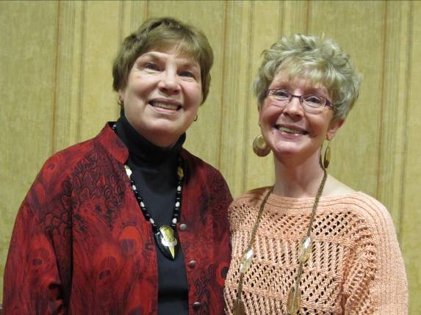

**Marijo Alexander and Sue Grove, Co-Presidents**

## Co-President’s Thoughts

As we enter the holiday season, Marijo and I send all our best wishes for much happiness to each of you. We hope that you will take time to come to our Christmas meeting at the Coffee House on Main on December 10th. It is always a festive time down on Main Street with the Christmas lights and wonderful treats and, of course, coffee or tea from the Coffee House. Bring your friends to meet all of us. There is no agenda except to have fun!

This year, we are asking everyone to bring something for the Personal Care Shelf at the Welcome Center. During our November meeting, Jake Vela explained that they have taken over this needed service from the Red Cross.

We look forward to our many adventures in the coming year: more excellent programs, book discussions, travel adventures, Great Decisions, and Saturday mornings at the Coffee House! Take care and be good to yourselves.

Sue Grove and MarijoAlexander



Co-Presidents

## December Program

Our December 12th meeting will be held at the Coffee House on Main. There will not be a presenter but we ask that you bring something for the “Personal Care Shelf”, organized by the Welcome Center of Austin. Items that can be donated include: shampoo, conditioner, toothpaste, toothbrushes (adult and child), deodorant, mouthwash, brush/combs, soap, body wash, laundry & dish soap, toilet paper, Kleenex, feminine hygiene items, shaving cream, razors, lotion, baby ointments, baby lotion, baby shampoo and baby wipes. Monetary donations are also appreciated. Full size items are most welcomed. For more information please visit:  <http://www.austinwelcomecenter.org/careshelf.html>

Christmas treats will be shared and we encourage you to buy beverages from the Coffee house to help support Kyle as he graciously offered this space for our meeting.

See you there!

Carla and Yesenia

**January Program**

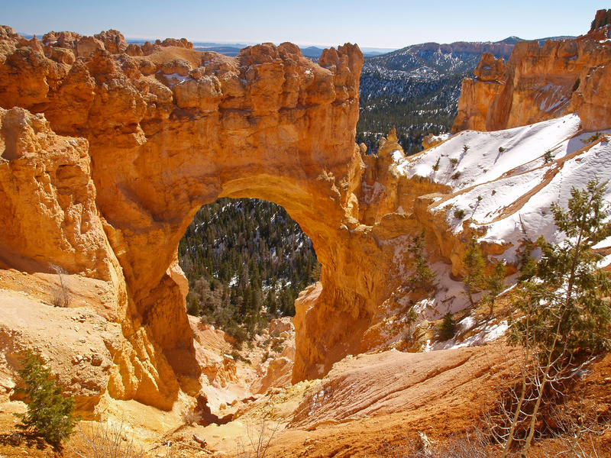

Our January 14th meeting will be held at the Public Library. Our guest presenter is Kathryn Colestock-Burke; she will share with us her experience as a Park Ranger at Canyonlands National Park. Canyonlands National Park is a U.S. National Park located in southeastern Utah near the town of Moab and preserves a colorful landscape eroded into countless canyons, mesas and buttes by the Colorado River, the Green River, and their respective tributaries. Please join us as Kathryn takes us into her adventurous presentation!  
  
Yesenia and Carla

### Small Groups

**Morning Book Group**

Morning book group will not meet in December.  Our January read is *An Invisible Thread* by Laura Schroff.  We will meet at Barley's at 9:00 a.m. on Thursday, January 16.

**Evening Book Group**

We will be discussing *Gone Girl* by Gillian Flynn on Monday, December 2nd at 7 PM at the home of Sue Howard. Please RSVP to Sue at [sshoward@charter.net](mailto:sshoward@charter.net). On January 6th we will be discussing *Me: Stories of My Life* by Katharine Hepburn at the home of Peggy Benzkofer. Please RSVP to Peggy at [pjbenzko@gmail.com](mailto:pjbenzko@gmail.com).

**First Friday**

First Friday Luncheon will be at the Brick House Friday, Dec. 6th at 11:30 and Friday, January 3rd at 11:30.  Email Dorothy at sdkrob@live.com by the 1st Wednesday of the month if you would like to attend.

**Knitting/ Handiwork Group**

We are still meeting every Saturday at 9:30 AM at the Coffee House on Main. Everyone is welcome to join even if you just want to enjoy a cup of coffee!

##### Travel Group

The AAUW Travel Club will be meeting in December at Pat Purcell's home on Thursday, December 12th at 2:00 P.M.  We will be sharing special Christmas Memories. Please either call (433-7897) or email me ([drgraber@charter.net](mailto:drgraber@charter.net)) on or before Wednesday, December 11th if you plan to attend.

In January, the Travel Club will be meeting at my home on Thursday, January 9th at 2:00 P.M.  I will be sharing photos and experiences from our trip to New Zealand.  Please either call (433-7897) or email me ([drgraber@charter.net](mailto:drgraber@charter.net)) on or before Wednesday, January 8th if you plan to join us. DedaRae Graber

**Great Decisions**

Great Decisions will start up again in February.

**Public Policy**

National AAUW gives thanks in this season of giving!

We are thankful President Barack Obama signed a comprehensive Violence Against Women Reauthorization Act (VAWA) into law. We're proud to have helped lead the fight for VAWA’s passage!

We are grateful for the contributions of the five women who received the 2013 Presidential Medal of Freedom, including astronaut Sally Ride, activist and 2003 AAUW Achievement Awardee Gloria Steinem, and media icon Oprah Winfrey.

We are thankful Obama elevated the issue of pay equity in his inaugural address and State of the Union address.

We are thankful Congress finally came to its senses and ended the federal government shutdown before it inflicted more damage on women and our economy.

**AAUW Board Meeting Minutes**

**November 12, 2013**

AAUW Board met at the Welcome Center. Present were Marijo Alexander, Sue Grove, Evelyn Guentzel, Kathy Kester, Dorothy Krob, Catherine Lemons, Yesenia Mendoza, Ruth Monson and Mary Kay Wilson.

Secretary’s report was approved.

A complete Treasurer’s report can be found in the newsletter. Mary Kay reported that the net profit from the house tour was $3,315.

Catherine gave a membership update. Currently, the branch has 70 paid members. New members are Andrea Bobrick, Mary Davenport, Jenna Obernolte, Katie Ulwelling, Julia Wagner and Diane Wangsness. The branch has been awarded three free national memberships that can be given to new members (to be used by June 30).

Marijo distributed the updated 2013-14 program schedule. The Board briefly discussed meeting more often at the library (rather than RCC) because of the convenient parking.

Sue reported on the possibility of our branch hosting the 2015 AAUW State Convention, which will take place on a Friday evening through a Saturday evening in the spring. The Austin Convention & Visitors Bureau will assist with reserving hotel rooms, providing gift bags, etc. for a possible 120 people. Motion made and seconded to have our branch serve as host for the 2015 AAUW State Convention. Motion passed.

Sue reported that we are in need of a new webmaster for our website. Members will be encouraged to consider serving in this position.

The Board continued the discussion about creating a Mission Statement for our branch. The goal is to have a completed Mission Statement by May 2014.

Carolyn and Peggy are continuing their work on Women’s History Month.

No Board meeting in December.

The State AAUW is requesting nominations for high school and college women for the “Young Women for Equity” award. They are also taking nominations for sophomore or junior college students who are interested in applying for a scholarship for the National Conference for Women Student Leaders (June 5-7 at the University of Maryland). Sue Grove has more information about these two opportunities.

Newsletter items are to be submitted to Rae Dawn on or before the last Friday of the month. Agenda items are to be submitted to Marijo and Sue on or before the first Tuesday of the month.

Meeting adjourned.

Respectfully submitted,

Ruth Monson, Secretary

|  |  |  |
| --- | --- | --- |
| **AAUW Monthly Financial Report** | | |
| **November, 2013** | | |
|  |  |  |
| **Period: 11/1/13-11/30/13** |  |  |
|  |  |  |
| **Opening Balance:** |  | **$8,578.16** |
|  |  |  |
| **Income:** |  |  |
|  |  |  |
| Dues Received | 146.00 |  |
|  |  |  |
| **Total Income:** | **$146.00** | $8,724.16 |
|  |  |  |
|  |  |  |
| **Disbursements:** |  |  |
|  |  |  |
| National Dues | 98.00 |  |
| State Dues | 27.00 |  |
| Insurance | 170.00 |  |
| Printing & Supplies | 70.75 |  |
|  |  |  |
| **Total Disbursements:** | **$365.75** |  |
|  |  |  |
| **Closing Balance 11/30/13** |  | **$8,358.41** |

*Mission Statement*: AAUW advances equity for women and girls through advocacy, education and research.

*Vision Statement:* AAUW will be a powerful advocate and visible leader in equity and education through research, philanthropy, and measurable change in critical areas impacting the lives of women and girls.

**Southern Highlights Editor:** Rae Dawn Rao

rao_raedawn@yahoo.com

**Minnesota State Website:**

http://www.aauwmn.org

**The Pine Editor: LouAnne Hoppe**

**Association Website:**

<http://www.aauw.org>

**Association e-mail: info@aauw.org**



______________________________________________________________

AAUW Southern Highlights

1001 22nd Ave. SW

Austin, MN 55912