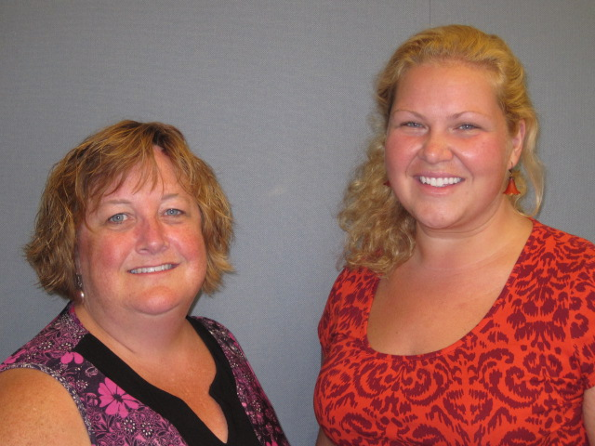Our Mission: To honor women and girls, empowering them through education, service and leadership development.

Co-President’s Message

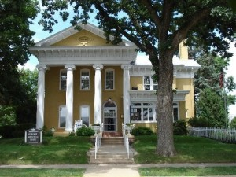As the temperature warms up and the snow melts away we find it easier to attend our activities and gatherings, including our AAUW branch programs. With spring around the corner please remember to attend our 2015 AAUW Minnesota Convention this month, April 10-11, 2015 at the Hormel Historic Home right here in Austin. The theme of the convention is "Full Steam Ahead! Science, Technology, Engineering, Arts, Math, Now and into the Future." Please remember this convention is an opportunity to showcase our wonderful community we serve and to raise funds for our yearly scholarship program. For several years now our branch has proudly sponsored scholarships to Riverland College students. Through the Riverland College student scholarship programs we have been able to help many students achieve amazing academic goals through some unbeatable hardships. Thank you, AAUW members for carrying out our mission to help women.

~Courtney Wyant, Co-President**April Program**

Come join us for “Spicing Up Your Programming” presented by Jill Maxfield and Catherine Haslag on Tuesday, April 14th.  We will meet at the Riverland Campus, Austin East Building, Room C107.  Please park near the theater and come in door E5.  Room C107 will be straight down the hall on the right side. We will explore new ideas for programs and look at how strong programs can strengthen and grow our branch.  We also want to share some fun and entertaining ways we can get to know the members of our branch better!  Social time will begin at 6:30 with the program beginning at 7pm.



**Small Groups**

**AM Book Group**

Morning Book Group will meet at Barley's at 9:00 a.m. on Thursday, April 16.  Bonnie Ripple will lead discussion on *A Boy From C-ll* by Harvey Ronglien.

**First Friday**

There will be NO First Friday Lunch for April.  It is Good Friday on the day that we would normally gettogether, therefore, we feel that many of the members will be with family and/or preparing for the Easter Weekend.  We will meet in May.

**PM Book Group**

Evening book group will be at Dorothy Krob's home at 2203 W. Oakland on April 21st at 7:00 p.m.  We will discuss *A Mountain of Crumbs* by Elanor Gerokhova.  Please RSVP to Dorothy. In May we will be reading *The Interestings* by Meg Wolitzer.

**Knitting & Handiwork** We continue to meet most Saturdays at the Coffee House on Main at 9:30 AM. You need not be able to knit/ do handiwork to attend!

**Travel Group**

The Travel Club will be meeting in April on the 9th.  This is one day before the State AAUW Convention here in Austin.  We are meeting at the Christ Episcopal Church (301 - 3rd Ave. NW) at 2:00 PM.  We will be putting together packets for the Convention.  I hope many of you are able to attend and thus complete our task(s) in a quick and orderly fashion.  Hope to see you there.

**Help Wanted!**

Please consider volunteering to help in any way that you are able for the upcoming State AAUW Convention, April 10-11 at the Hormel Historic Home. Please contact Sue Grove or Marijo Alexander to see how you can help! Also, it is not too late to register at:

[**http://aauw-mn.aauw.net/**](http://aauw-mn.aauw.net/)

**C:\Users\Rae Dawn\Pictures\Microsoft Clip Organizer\na00861_.wmfMay Banquet**

This year's Spring Social will be held on May 12th at the Hormel Historic Home.  Social time will begin at 5:30 with dinner at 6pm.  This year's theme is "Spring Fling."  3B Eatery will be catering the event, serving green salad with dressing, Panko Parmesan Chicken and Pork Tenderloin, Herb Roasted Red Potatoes, California Veggies Medley, and dinner rolls.  Tickets are $17.00.  Please contact Catherine Haslag at [cshaslag@gmail.com](mailto:cshaslag@gmail.com) to RSVP for the event.

**Used Book Sale Approaches!**

The Used Book Sale is fast approaching! May 1 and 2 will be here before you know it. The work shifts are two hours in length, beginning at 9:30 AM until 5:30 PM.  We need everyone of you to help.  There are many, many open spots of Friday and a variety of open places on Saturday.  The week before the sale, you can come and go as your time allows to help sort and arrange the books for the sale.  The sign up schedule will be available at the April meeting.  Hopefully you have gathered up the books you are donating to the sale, drop them off at the Library at any time.

This is an annual fund raising event and we depend on these funds to support scholarships.

Thanks so much for helping with the big project

Laura Tjomsland and Joyce Goetz

Book Sale Co-chairs

**House Tour Chair(s) Needed**

Please consider volunteering to be the House Tour Chairwoman for next year.  The tour takes place every other year in the fall, and someone is needed to coordinate volunteers, plan the advertising, and get community members to open their homes.

This is one of our major fundraisers and is essential in order to continue funding the two $1,000 scholarships we give out each year.

If you would like to know more about his position, please talk to Sue Grove, who was the House Chair Tour for fall of 2013.  If you would like to volunteer for this position, please contact Carla Anderson-Diekmann.

|  |  |  |
| --- | --- | --- |
| **AAUW Monthly Financial Report** | | |
| **February 21 - March 20, 2015** | | |
|  |  |  |
| **Period: 2/21/15 - 3/20/15** |  |  |
|  |  |  |
| **Opening Balance:** |  | **$9,386.91** |
|  |  |  |
| **Income:** |  |  |
|  |  |  |
| Dues Received | 65.00 |  |
| Banquet |  |  |
|  |  |  |
| **Total Income:** | **$ 65.00** | $9,451.91 |
|  |  |  |
|  |  |  |
| **Disbursements:** |  |  |
|  |  |  |
| Dues Paid | 58.00 |  |
| Banquet |  |  |
|  |  |  |
| **Total Disbursements:** | **$58.00** |  |
|  |  |  |
| **Closing Balance 3/20/15** |  | **$9,393.91** |

**AAUW Board Meeting**

March 10, 2015

AAUW Board met at the Austin Public Library. Present were Marijo Alexander, Carla Anderson-Diekmann, Nicole Cizik, DedaRae Graber, Sue Grove, Dorothy Krob, Catherine Lemons, Jill Maxfield, Ruth Monson, and Courtney Wyant. Secretary’s report was approved.

Nicole updated the Treasurer’s report. The payment that was questioned at the last Board meeting ($75 to the Austin Daily Herald) was a payment for advertising for the Science Fair Mentorship program.

Jill gave an update regarding the May banquet. A menu is being finalized and money is available in the budget to hire musicians for the evening. Jill also reported that the next membership meeting will take place at Riverland Community College, Room C-107. Jill and Catherine Haslag will lead a brainstorming session based on an AAUW webinar on programming for local branch meetings.

Nicole spoke with AAUW member services regarding some discrepancies between our branch’s membership roster and the national AAUW membership list. Nicole is working on correcting the problem.

Courtney reported that she has been in contact with Marie regarding the branch’s website and noted that the website has been updated.

Marijo gave a State Convention update. She will be asking members to sign up to help with the convention on April 10-11. People are needed to help with the silent auction, registration table, greeting, etc. Sue Grove will be gathering items for free gift bags and welcomes help. So far, 57 people have registered for the convention.

Several elected and appointed positions may be open for the coming year: Program Vice-President, Membership Vice-President, House Tour Chair, and Hospitality Chair. Carla will contact the current appointed Board members to see if they will continue another year.

Carla gave an overview of the current AAUW Scholarship procedure and criteria:

Recipients must be enrolled at Riverland Community College and maintain a minimum GPA of 3.0. Students involved in volunteer work, community service and extra-curricular activities will be given strong consideration. Preference is given to an Austin area resident.

AAUW awards 2 - $1000 scholarships fall semester. The fall semester scholarship application process begins around May 1st and completed online applications are due on July 15th. About a week or two later the reviewing/scoring process begins. The branch’s Education Committee (currently Nicole Cizik and Bonnie Rietz) reviews the applications and scores them. The reviewing/scoring process takes about 2 weeks and scholarships are then awarded around the end of August. Riverland has a scholarship ceremony/dinner in March.

The April meeting will be at 6:30 p.m. on April 14th at Riverland Community College, Room C-107. Speakers/facilitators will be Catherine Haslag and Jill Maxfield. The Board will meet at 5:45 p.m. and membership will gather at 6:30 p.m. for social time, with the program beginning at 7:00 p.m. Meeting adjourned.

Respectfully submitted,

Ruth Monson, Secretary

*Mission Statement*: AAUW advances equity for women and girls through advocacy, education and research.

*Vision Statement:* AAUW will be a powerful advocate and visible leader in equity and education through research, philanthropy, and measurable change in critical areas impacting the lives of women and girls.

**Southern Highlights Editor:** Rae Dawn Rao [rao\_raedawn@yahoo.com](mailto:rao_raedawn@yahoo.com) **Minnesota State Website:** <http://www.aauwmn.org> **Association Website:**  <http://www.aauw.org> **Association e-mail: info@aauw.org**

horizontalColor_thumb\_\_\_\_\_\_\_\_\_\_\_\_\_\_\_\_\_\_\_\_\_\_\_\_\_\_\_\_\_\_\_\_\_\_\_\_\_\_\_\_\_\_\_\_\_\_\_\_\_\_\_\_\_\_\_\_\_\_\_\_\_\_

AAUW Southern Highlights

1001 22nd Ave. SW

Austin, MN 55912